Faculty of Science
Department of Statistics
Project Report
on
"Long-Term Statistical Analysis and Comparative Multi-Output Weather Forecasting for Bangladesh Using Station-Wise Meteorological Data"
A Project Report Submitted in Partial Fulfillment of the Requirements for the Degree of
Bachelor of Science (Honours) in Statistics
Submitted by
Reg:1165164
Student ID: 201609

Course Title: Statistical Project
Course Code: STAT-4210
Pabna University of Science and Technology

Submission Date: 04 April 2026

DECLARATION
I, Student ID 201609, hereby declare that this project report entitled "Long-Term Statistical Analysis and Comparative Multi-Output Weather Forecasting for Bangladesh Using Station-Wise Meteorological Data" is the result of my own study and analysis carried out under the supervision of Most. Mira Khatun, Assistant Professor, Department of Statistics, Pabna University of Science and Technology. I further declare that this report has not been submitted, in whole or in part, to any other institution for the award of any degree, diploma, or similar academic qualification. Any ideas, data, tables, figures, or statements taken from published or unpublished sources have been properly acknowledged and cited where appropriate.
I also affirm that the analysis, interpretations, and conclusions presented in this report are the outcome of my independent academic work, except where assistance and guidance have been duly acknowledged.

______________________________
Signature of the Student
Student ID: 201609

APPROVAL CERTIFICATE
This is to certify that, Student ID 201609, of the Department of Statistics, Faculty of Science, Pabna University of Science and Technology, has successfully completed the project report entitled "Long-Term Statistical Analysis and Comparative Multi-Output Weather Forecasting for Bangladesh Using Station-Wise Meteorological Data".
The work has been carried out under my supervision and guidance and is approved as suitable for submission in partial fulfillment of the requirements for the degree of Bachelor of Science (Honours) in Statistics. The project demonstrates the student’s ability to conduct an independent study, perform statistical and forecasting analyses, and present the findings in a coherent academic form.
I also certify that, to the best of my knowledge, no part of this report has been previously submitted for any other degree, diploma, or similar academic purpose.

______________________________
Most. Mira Khatun
Assistant Professor
Department of Statistics
Pabna University of Science and Technology
Date: 04 March 2026

ACKNOWLEDGMENT
First and foremost, I express my heartfelt gratitude to Almighty Allah for granting me the strength, patience, and opportunity to complete this project successfully.
I would like to convey my deepest respect and sincere gratitude to my supervisor, Most. Mira Khatun, Assistant Professor, Department of Statistics, Pabna University of Science and Technology, for her continuous guidance, thoughtful suggestions, constructive criticism, and unwavering encouragement throughout the entire course of this study. Her supervision has been invaluable in shaping the direction of this research and improving the quality of the final report.
I am also grateful to the teachers of the Department of Statistics, Pabna University of Science and Technology, for the academic knowledge and inspiration they have provided during my undergraduate studies. Their support has contributed significantly to the successful completion of this work.
I would like to acknowledge my parents and family members for their constant support, sacrifice, and encouragement. Their trust and motivation have always been a source of strength in my academic journey.
Finally, I extend my thanks to all those who contributed directly or indirectly to this project, including those who supported me through suggestions, resources, and encouragement during the preparation of this report.

04 April 2026

TABLE OF CONTENTS
DECLARATION ii
APPROVAL CERTIFICATE iii
ACKNOWLEDGMENT iv
ABSTRACT vii
INTRODUCTION 1
1.1 Background and Context 1
1.2 Statement of the Problem 2
1.3 Aim and Objectives of the Study 3
1.4 Research Questions 4
1.5 Scope of the Study 4
1.6 Significance of the Study 5
1.7 Organization of the Thesis 6
LITERATURE REVIEW 7
2.1 Introduction 7
2.2 Climatic Setting of Bangladesh and the Relevance of Weather Forecasting 7
2.3 Station-Wise Meteorological Data and Weather Datasets in Bangladesh 8
2.4 Long-Term Statistical Analyses of Rainfall and Temperature in Bangladesh 9
2.5 Classical Statistical Forecasting Approaches in Weather Research 11
2.6 Machine Learning and Ensemble Approaches for Weather Forecasting 12
2.7 Deep Learning and Multivariate Sequence Forecasting 13
2.8 Research Gaps and the Position of the Present Study 14
2.9 Chapter Summary 17
METHODOLOGY 18
3.1 Introduction 18
3.2 Research Design Overview 18
3.3 Data Source and Variable Structure 21
3.4 Data Organization and Analytical Datasets 21
3.5 Data Cleaning and Preprocessing 22
3.6 Statistical Analysis Framework 23
3.7 Forecasting Design and Comparative Modelling Framework 24
3.8 Feature Engineering Strategy for Pooled Daily Forecasting 25
3.9 Train-Validation-Test Design 26
3.10 Evaluation Metrics 27
3.11 Software Environment and Reproducibility 27
3.12 Methodological Considerations and Limitations 28
3.13 Chapter Summary 28
RESULTS OF STATISTICAL ANALYSIS 30
4.1 Analytical dataset and station coverage 30
4.2 Descriptive statistics and distributional characteristics 31
4.3 Monthly climatology and seasonal contrasts 34
4.4 Station-wise spatial heterogeneity 37
4.5 Inter-variable dependence and stationarity 40
4.6 National annual variability and long-term trends 41
4.7 Station-wise trend heterogeneity 44
4.8 Seasonal long-term behavior 45
4.9 Extreme-event behavior 46
4.10 Chapter summary 47
RESULTS OF FORECASTING AND MACHINE LEARNING ANALYSIS 49
5.1 Forecasting design and evaluation framework 49
5.2 Pooled next-day multi-output regression results 51
5.3 Interpretation by target variable 56
5.4 Rainfall occurrence classification 57
5.5 Feature-importance analysis in the pooled Random Forest model 59
5.6 Station-specific Bi-LSTM forecasting for Dhaka 60
5.7 Monthly SARIMA versus XGBoost comparison for Dhaka 62
5.8 Chapter summary 69
CONCLUSION, IMPLICATIONS, LIMITATIONS, AND RECOMMENDATIONS 70
6.1 Introduction 70
6.2 Summary of the Study 70
6.3 Major Findings of the Thesis 71
6.4 Answers to the Research Questions 72
6.5 Contributions of the Study 73
6.6 Practical Implications 74
6.7 Limitations of the Study 74
6.8 Recommendations for Future Research and Application 75
6.9 Concluding Remarks 75
REFERENCES 77

ABSTRACT
This project investigates the long-term statistical characteristics and comparative forecasting performance of Bangladesh weather using station-wise meteorological data collected from 35 weather stations across the country. The dataset, obtained from the Bangladesh Meteorological Department, contains daily observations of rainfall, temperature, humidity, and sunshine from the establishment of each station up to 2023. To capture both climatic structure and predictive behavior, the study was designed in two complementary parts. The first part focused on long-term statistical analysis, including descriptive statistics, monthly and seasonal climatology, station-wise and national trend analysis, correlation analysis, stationarity testing, and extreme-event assessment. The second part concentrated on comparative multi-output weather forecasting, where pooled and station-specific models were implemented and evaluated.
The statistical analysis revealed strong seasonality, substantial spatial heterogeneity among stations, and meaningful long-term changes in the four weather variables. Rainfall exhibited the greatest irregularity, with a highly skewed distribution and marked monsoon concentration, whereas temperature and humidity showed comparatively smoother temporal patterns. Forecasting experiments included persistence and rolling-mean baselines, Random Forest, ElasticNet, XGBoost, a rainfall occurrence classifier, and a station-specific Bi-LSTM model for Dhaka. In addition, a monthly SARIMA versus XGBoost comparison was conducted for Dhaka to assess performance at a lower temporal resolution. The results showed that XGBoost was the strongest pooled daily regression model across the forecasting targets, while the rainfall occurrence classifier achieved strong discrimination performance. The Bi-LSTM model performed particularly well for Dhaka temperature forecasting, and the monthly comparison indicated that SARIMA was more suitable than XGBoost for station-specific monthly rainfall and temperature prediction in Dhaka.
Overall, the project demonstrates that the forecasting performance of weather models in Bangladesh is strongly dependent on the temporal scale, the statistical characteristics of the target variable, and the modelling framework applied. The findings provide useful insight for weather forecasting, agricultural decision support, and climate-related planning in Bangladesh.
Keywords: Bangladesh weather, station-wise meteorological data, long-term statistical analysis, multi-output forecasting, XGBoost, Bi-LSTM, SARIMA, rainfall, temperature, humidity, sunshine.

CHAPTER ONE

INTRODUCTION

1.1 Background and Context
Weather and climate are central to the environmental, agricultural, and socioeconomic life of Bangladesh. The country lies within a tropical monsoon regime and is characterized by strong seasonal contrasts in rainfall, temperature, humidity, and sunshine. This climatic structure underpins agricultural production, water management, transport operations, disaster preparedness, and broader development planning. At the same time, Bangladesh remains highly exposed to climate-related hazards, including flooding, heat stress, drought episodes, and rainfall variability, which makes the understanding of both long-term weather behaviour and short-term forecasting performance particularly important in the national context (World Bank Group, 2021; Bosu et al., 2020).
Recent Bangladesh-focused studies have emphasized that weather forecasting is not merely a meteorological exercise; it is directly linked with adaptation, productivity, and risk reduction. Hasan, Hasan, and Rahman (2024) note that reliable forecasting is important in sectors such as transportation, agriculture, tourism, and development, while Zubair et al. (2024b) frame accurate multivariate forecasting as a practical input to agricultural decision support. In parallel, the Bangladesh climate literature shows that rainfall and temperature patterns are already changing in meaningful ways. Using Bangladesh Meteorological Department station observations, Bosu et al. (2020) reported a decreasing tendency in annual rainfall and an increasing tendency in annual temperature over Bangladesh, highlighting the need for continued station-based climate analysis.
The present study is built on a uniquely valuable weather dataset that supports both long-term statistical analysis and predictive modelling. Zubair et al. (2024b) describe the structured Bangladesh weather dataset as an official, high-volume resource obtained from the Bangladesh Meteorological Department and organized around 35 weather stations distributed across the country. The dataset contains four key meteorological variables—rainfall, temperature, humidity, and sunshine—and extends from the establishment of each station to the present. Its station-wise structure makes it especially appropriate for investigating climatic heterogeneity, seasonal regularities, long-run changes, and predictive behaviour across different forecast settings.
At the methodological level, weather forecasting has advanced far beyond traditional univariate extrapolation. The literature now spans classical time-series models, machine-learning approaches, ensemble strategies, and deep-learning architectures. Hasan et al. (2024) compared RNN-LSTM, TensorFlow Decision Forests, and stacking methods for Bangladesh weather forecasting and showed that comparative modelling is essential because model performance depends strongly on how the forecasting problem is formulated. Hussain et al. (2024) demonstrated the usefulness of machine-learning methods in rainfall occurrence, rainfall amount, and temperature prediction using the Bangladesh weather dataset, while Zubair et al. (2024a) showed that stacked Bi-LSTM architectures can be highly effective for multivariate forecasting of rainfall, temperature, humidity, and sunshine. These developments indicate that modern weather forecasting research increasingly requires a comparative perspective rather than reliance on a single modelling family.
Against this background, the present project was designed to integrate two strands of analysis that are often treated separately. The first is long-term statistical examination of the observed climate signal, including descriptive structure, seasonality, trend behaviour, and station-wise variability. The second is comparative forecasting, where different statistical, machine-learning, and deep-learning approaches are assessed in relation to multiple weather targets. Bringing these two strands together is important because the statistical character of a variable strongly influences how well it can be forecast. A highly skewed and intermittent rainfall series does not behave like a smoother temperature series, and a forecasting framework that ignores this distinction is unlikely to produce a convincing interpretation.
The project title—Long-Term Statistical Analysis and Comparative Multi-Output Weather Forecasting for Bangladesh Using Station-Wise Meteorological Data—therefore reflects both the empirical scope of the dataset and the analytical logic of the study. Rather than treating Bangladesh weather as a single uniform time series, the study uses station-wise meteorological data to examine how spatially distributed observations can support both climate interpretation and predictive modelling. The chapter that follows sets out the problem statement, objectives, research questions, scope, significance, and organizational structure of the thesis.

1.2 Statement of the Problem
Bangladesh weather forecasting and climate analysis face a dual challenge. On the one hand, there is a need to understand long-term climatic behaviour in a country where rainfall variability, warming tendencies, humidity regimes, and sunshine changes have direct implications for agriculture, water resources, and climate adaptation. On the other hand, there is a practical need to forecast weather variables accurately enough to support planning and decision-making. Although these two needs are closely related, they are not always studied together in a single coherent analytical framework.
The first dimension of the problem is analytical fragmentation. Existing Bangladesh-oriented studies often focus on only one part of the question. Bosu et al. (2020), for example, concentrated on rainfall and temperature trends, which is valuable for climate interpretation but does not address predictive performance across multiple meteorological variables. Hussain et al. (2024) focused on rainfall occurrence, rainfall amount, and temperature prediction, thereby contributing to forecasting, but not to a broader long-term statistical characterization of rainfall, temperature, humidity, and sunshine together. Hasan et al. (2024) and Zubair et al. (2024b) advanced comparative and deep-learning forecasting, yet their emphasis remained primarily on forecasting architecture rather than on integrating those models with a full statistical reading of the climatic system.
The second dimension of the problem is methodological. Model performance in weather forecasting is not universal across variables, spatial units, or time scales. Rainfall is nonlinear, intermittent, and strongly seasonal; temperature tends to be smoother and more persistent; humidity and sunshine have their own dependence structures and interactions. A model that performs well for one variable may not be optimal for another, and a model that performs well at the daily pooled scale may not remain superior at a monthly station-specific scale. The forecasting literature itself supports this concern: ensemble and boosted methods can perform strongly in nonlinear settings, while seasonal time-series models may remain highly competitive when the target series is strongly periodic (Hasan et al., 2024; Hussain et al., 2024).
A further problem lies in the insufficient comparative treatment of forecast scales and target structures in Bangladesh-focused research. Multi-output forecasting, rainfall occurrence classification, station-specific sequence modelling, and monthly statistical forecasting are often examined separately rather than as related components of the same predictive system. As a result, it becomes difficult to identify whether forecast performance differences arise from the model class, the variable being predicted, the temporal aggregation of the data, or the spatial structure of the dataset.
This study addresses the problem by constructing an integrated framework based on station-wise meteorological data from Bangladesh. It combines long-term statistical analysis with comparative forecasting across daily pooled regression, rainfall occurrence classification, station-specific deep learning, and monthly statistical-versus-machine-learning forecasting. In doing so, it seeks to move beyond isolated model testing and toward a more complete understanding of how the statistical properties of Bangladesh weather relate to the comparative strengths of different forecasting approaches.

1.3 Aim and Objectives of the Study
The broad aim of this project is to conduct a long-term statistical analysis of Bangladesh weather and to compare the performance of multiple forecasting approaches for predicting rainfall, temperature, humidity, and sunshine using station-wise meteorological data.
To achieve this aim, the study pursues the following specific objectives:
1. to describe the long-term statistical characteristics of rainfall, temperature, humidity, and sunshine across Bangladesh using station-wise meteorological observations;
2. to investigate monthly, seasonal, annual, and station-wise climatic patterns in order to identify temporal structure, spatial heterogeneity, and extreme-event behavior;
3. to examine long-term trends and inter-variable relationships in the weather series using appropriate statistical tools;
4. to develop and compare multiple next-day forecasting models, including naïve baselines, machine-learning methods, and deep-learning models, for multi-output weather prediction;
5. to evaluate rainfall occurrence as a separate classification problem in recognition of the zero-inflated and intermittent character of rainfall;
6. to assess whether station-specific sequence modelling through a Bi-LSTM framework can recover useful predictive structure for a representative station;
7. to compare monthly SARIMA and XGBoost forecasting performance for Dhaka in order to determine how model suitability changes with temporal aggregation;
8. to identify the most influential predictive features and to interpret forecasting performance in relation to the statistical properties of the target variables.

1.4 Research Questions
In line with the objectives above, the study is guided by the following research questions:
1. What are the major long-term statistical characteristics of rainfall, temperature, humidity, and sunshine in Bangladesh when these variables are examined using station-wise meteorological data?
2. How do the four variables differ in terms of seasonality, spatial heterogeneity, trend behavior, and extreme-event structure?
3. Which forecasting models perform best for next-day pooled multi-output prediction of rainfall, temperature, humidity, and sunshine?
4. Can rainfall occurrence be predicted effectively as a binary classification problem, and how does that task differ from rainfall amount prediction?
5. How does a station-specific Bi-LSTM model behave when it is applied to a representative station such as Dhaka?
6. Does a classical seasonal time-series model such as SARIMA remain competitive, or even superior, to XGBoost when monthly station-specific forecasting is considered?
7. How should the forecasting results be interpreted in light of the underlying statistical behavior of the weather variables?

1.5 Scope of the Study
The study is based on station-wise meteorological data collected from 35 weather stations in Bangladesh. The temporal span of the dataset extends from the establishment year of each station up to 2023, which provides a long historical window while also implying that the station records are not perfectly uniform in length. Four meteorological variables are analyzed: rainfall, temperature, humidity, and sunshine. These variables were selected because they are both climatologically important and directly relevant to weather forecasting, agriculture, and climate-sensitive decision-making in Bangladesh (Zubair et al., 2024a; Zubair et al., 2024b).
The analytical scope of the study covers two interconnected parts. The first part concerns long-term statistical analysis and includes descriptive distributional analysis, monthly and seasonal climatology, national and station-wise trend assessment, correlation analysis, stationarity checking, and extreme-event evaluation. The second part concerns comparative forecasting and includes next-day pooled multi-output regression, rainfall occurrence classification, station-specific Bi-LSTM forecasting for Dhaka, and a monthly SARIMA versus XGBoost comparison for Dhaka.
The geographical scope is national in the statistical and pooled forecasting parts, since all available stations contribute to the main dataset. However, the deep-learning and monthly forecasting extensions include a focused station-specific component for Dhaka, which was selected as a representative and data-rich station for more detailed sequence and monthly forecast comparison.
The scope of the study also has clear boundaries. The analysis is limited to observed historical meteorological data and does not extend to climate projection scenarios such as CMIP-based future simulation. Likewise, although the results have implications for agriculture, water management, and climate services, the project does not build a full operational advisory system. Instead, it concentrates on establishing the statistical and forecasting evidence that such downstream applications may later use. The study is therefore interpretive and comparative in nature rather than operational in the policy or deployment sense.

1.6 Significance of the Study
The significance of this study lies in both its practical relevance and its methodological contribution. From a practical perspective, Bangladesh is highly dependent on accurate and interpretable weather information. Agriculture remains climate-sensitive, and the usefulness of weather and climate forecasts for agricultural planning has been emphasized in both the institutional and research literature on Bangladesh (FAO, n.d.; World Bank Group, 2021). More broadly, rainfall and temperature variability also matter for flood preparedness, drought awareness, water resource planning, transport, and public safety. A study that improves understanding of long-term weather behavior while also evaluating forecasting models can therefore contribute meaningfully to climate-sensitive planning.
From a scientific perspective, the study is significant because it uses a large official station-wise dataset and analyzes the four major variables together. Zubair et al. (2024b) describe this dataset as highly structured and suitable for both statistical and machine-learning applications, yet the literature still contains relatively few studies that integrate long-term descriptive analysis with comparative multi-output forecasting in one framework. By combining these strands, the present work shows not only how Bangladesh weather behaves statistically, but also how those statistical features affect model performance.
The comparative element of the study is also important. Rather than assuming that one model family is universally best, the study evaluates different forecasting philosophies under different conditions: naïve temporal baselines, regularized linear modelling, tree-based nonlinear machine learning, station-specific deep learning, and monthly seasonal time-series modelling. This design makes it possible to identify where model superiority is robust and where it depends on the target variable, station context, or forecast scale. That kind of comparative evidence is valuable for both statistical understanding and methodological decision-making.
The study also contributes to Bangladesh-focused weather forecasting research by highlighting station heterogeneity and temporal-scale sensitivity. Results based only on national aggregates can conceal important station-level variation, while results based only on daily forecasting can obscure the fact that monthly aggregation may favor different models. By explicitly examining these issues, the study offers a more nuanced account of forecasting suitability than would be possible from a single-model or single-scale analysis.
Finally, the project is significant in an academic sense because it demonstrates how statistical reasoning and modern forecasting methods can be linked within a single undergraduate research framework. The statistical chapter establishes the empirical behavior of the variables, while the forecasting chapter tests model behavior against that empirical structure. This linkage strengthens the thesis by making the modelling choices interpretable rather than purely technical.

1.7 Organization of the Thesis
The remainder of this thesis is organized as follows. Chapter Two presents the literature review and synthesizes prior studies relevant to Bangladesh climate analysis, weather forecasting, machine learning, deep learning, and comparative time-series modelling. Chapter Three describes the data source, preprocessing steps, variable construction, and methodological framework used for both the statistical and forecasting components of the study.
Chapter Four reports the results of the long-term statistical analysis. It presents descriptive summaries, monthly and seasonal climatology, station-wise and national trend analyses, inter-variable relationships, and extreme-event behavior. Chapter Five reports the forecasting and machine-learning results. It evaluates pooled multi-output regression, rainfall occurrence classification, station-specific Bi-LSTM forecasting for Dhaka, and monthly SARIMA versus XGBoost comparison for Dhaka, with emphasis on interpretation of model performance in relation to the structure of the target variables.
The final chapter synthesizes the findings, discusses their broader implications, identifies limitations, and offers recommendations for future research and application. Together, these chapters aim to provide a coherent account of how long-term statistical behavior and comparative forecasting performance can be understood jointly in the context of Bangladesh station-wise meteorological data.

CHAPTER TWO

LITERATURE REVIEW

2.1 Introduction
This chapter reviews the body of literature most relevant to the present study and uses it to position the research within the broader fields of climate analysis, weather forecasting, and data-driven environmental modelling. Because the project combines long-term statistical analysis with comparative multi-output forecasting, the literature review must do more than list previous studies. It must explain how the available evidence has approached Bangladesh’s weather dynamics, what analytical traditions have shaped the field, and where important methodological and empirical gaps remain.
The chapter is therefore organized around five interrelated themes. First, it considers the climatic context of Bangladesh and the reasons why weather analysis and forecasting are especially important in this setting. Second, it reviews the development and value of station-wise meteorological datasets for Bangladesh. Third, it examines the literature on long-term statistical analysis of rainfall and temperature patterns, with particular attention to seasonality, spatial variability, and long-run change. Fourth, it reviews classical statistical forecasting approaches and their suitability for weather time series. Fifth, it evaluates the rise of machine learning, ensemble learning, and deep learning approaches for weather forecasting, including multivariate and sequence-based models. The chapter concludes by identifying the main gaps in the existing literature and by explaining how the present study addresses them.
In keeping with the title and scope of this thesis, special emphasis is given to studies that use Bangladeshi weather data, compare alternative forecasting frameworks, or address multivariate prediction problems involving rainfall, temperature, humidity, and sunshine. The review draws primarily on peer-reviewed studies and authoritative dataset papers, while also incorporating selected institutional and methodological sources where they clarify the applied significance of the problem or the rationale for a particular modelling family.

2.2 Climatic Setting of Bangladesh and the Relevance of Weather Forecasting
Bangladesh occupies a distinctive climatic position within South Asia. Its low-lying deltaic landscape, dense river network, proximity to the Bay of Bengal, and tropical monsoon regime combine to produce a weather system marked by strong seasonality, high humidity, and substantial spatial variation in rainfall and temperature. Bosu et al. (2020) describe Bangladesh as a country with clear meteorological seasons—pre-monsoon, monsoon, post-monsoon, and winter—in which rainfall is concentrated overwhelmingly in the monsoon months while temperature remains high for much of the year. Their analysis of Bangladesh Meteorological Department (BMD) station data for 1981–2019 showed that average rainfall is highest in July and lowest in January, whereas annual temperature has exhibited a long-run increase over the same period.
The importance of this climatic setting is not merely descriptive. It has direct implications for agriculture, water resources, infrastructure, public health, and disaster management. Bangladesh remains highly exposed to floods, riverbank erosion, cyclones, heat stress, and rainfall irregularity, all of which are amplified when short-term weather anomalies interact with longer-term climatic change. The World Bank Climate Change Knowledge Portal characterizes Bangladesh as a humid tropical monsoon country whose development sectors are closely tied to rainfall and temperature variability, while the IPCC (2022) identifies South Asia, including Bangladesh, as highly vulnerable to compound climate risks affecting food production, livelihoods, and human well-being. In this context, accurate weather analysis and forecasting are not only scientific exercises; they are essential inputs for adaptation and decision-making.
Recent Bangladesh-focused forecasting studies reinforce the same point. Hasan et al. (2024), working with historical weather data from 1963 to 2022, argue that reliable forecasting is crucial for sectors such as transportation, tourism, agriculture, and infrastructure planning. Hussain et al. (2024) similarly emphasize that rainfall and temperature prediction are central to water-dependent activities and to the mitigation of weather-related economic losses. Zubair et al. (2024a) extend this argument into the agricultural domain by showing that multivariate weather forecasting can support context-sensitive agricultural recommendation systems in Bangladesh. Together, these studies make it clear that the relevance of forecasting in Bangladesh arises from the interaction between climatic variability and socioeconomic dependence on weather-sensitive systems.
From a literature-review perspective, the importance of Bangladesh’s climatic setting lies in two methodological implications. First, no forecasting model can be judged properly without reference to the strong seasonal structure of the country’s weather. Second, national averages may obscure substantial regional and station-level differences. A useful Bangladesh weather study must therefore engage with both the temporal structure of weather and its spatial heterogeneity. This consideration is central to the present research, which uses station-wise observations rather than relying solely on aggregated national series.

2.3 Station-Wise Meteorological Data and Weather Datasets in Bangladesh
A major constraint in weather forecasting research has historically been the uneven availability, accessibility, and structure of high-quality meteorological data. This issue is especially significant in developing-country contexts, where many studies have had to rely on small samples, short time horizons, or heavily aggregated climate records. For Bangladesh, an important recent contribution in this regard is the weather dataset paper by Zubair et al. (2024b), which documents a structured real-world dataset obtained from the Bangladesh Meteorological Department. The dataset contains daily observations from 35 strategically located weather stations and has been reorganized into four principal variables—rainfall, temperature, humidity, and sunshine—making it suitable for statistical analysis, climate research, and machine-learning applications.
The value of this dataset is methodological as well as practical. Zubair et al. (2024b) emphasize that the records extend from the establishment of each station to the present and that the data were restructured into machine-trainable formats after extensive preprocessing. This is highly relevant to the present study, which similarly works with station-wise data and distinguishes between daily, monthly, annual, pooled, and station-specific forecasting tasks. The availability of a long-span, multi-station, multi-variable dataset makes it possible to compare not only forecasting methods but also scales of analysis, climatic regimes, and temporal resolutions.
The station-wise nature of the data deserves special attention. In environmental modelling, station-level data serve at least three functions. First, they preserve spatial heterogeneity, allowing researchers to identify how local climates differ across regions. Second, they make it possible to compare pooled models with individual-station models. Third, they facilitate the separation of national climatic patterns from local station behavior. The Bi-LSTM study of Zubair et al. (2024a) shows the importance of this distinction explicitly. That study trained models separately for each of the 35 stations and found that station-specific Bi-LSTM forecasting substantially outperformed a combined all-station model. Their result suggests that weather processes in Bangladesh may contain enough local specificity that a single pooled architecture does not always dominate station-wise modelling.
At the same time, station-wise datasets also introduce challenges. The starting years of stations differ, data lengths are not identical, and missing values or differences in observational continuity can affect comparability. Bosu et al. (2020) noted that some BMD stations were established after 1981 and therefore contributed shorter series to long-term trend calculations. This is not a trivial point. It means that any high-standard analysis of Bangladesh weather data must pay close attention to coverage periods, missing-value treatment, aggregation rules, and the choice between common-period analysis and full-available-series analysis. The present study engages directly with these issues by separating the data into statistical and modelling subsets and by maintaining transparency about data preparation choices.
The literature therefore suggests that high-quality station-wise data are both an opportunity and a responsibility. They make richer analysis possible, but only when researchers respect the spatial and temporal structure of the observations. This is one reason why the present study places strong emphasis on preprocessing, station-specific exploration, and scale-sensitive model evaluation.

2.4 Long-Term Statistical Analyses of Rainfall and Temperature in Bangladesh
Long-term statistical analysis remains one of the most important foundations of climate and weather research. Before forecasting models are built, the statistical behavior of the underlying series must be understood in terms of central tendency, dispersion, seasonality, persistence, extremes, and trend. In Bangladesh, several studies have examined long-run rainfall and temperature dynamics using station observations and have consistently shown that the country’s climatic behavior is both strongly seasonal and regionally differentiated.
Among the most relevant contributions is the work of Bosu et al. (2020), who compared CMIP5 model outputs with BMD station observations for 1981–2019. Their results showed that annual rainfall exhibited a decreasing trend in the observed station data, while annual temperature increased over the same period. They also documented strong monthly seasonality, with rainfall peaking during the monsoon and temperatures reaching their lowest point in January. Importantly, their spatial discussion highlighted that northeastern Bangladesh receives the highest annual rainfall, indicating that any national discussion of rainfall must be sensitive to east–west and regional gradients rather than relying solely on aggregate averages.
More recent trend-oriented studies have extended this picture. Roy et al. (2024) reported that rainfall behavior across stations is not spatially uniform and that different regions of the country display distinct trend structures, including both monotonic and non-monotonic change patterns. Likewise, Suhan and Adhikary (2025) showed that rainfall and temperature trends can differ substantially across stations even within the same broad climatic zone in coastal Bangladesh. These findings are important because they support the idea that national-scale trend interpretation should always be complemented by station-wise or region-wise analysis.
The statistical literature also shows that rainfall and temperature do not behave in the same way analytically. Rainfall is highly skewed, intermittent, and often dominated by extremes, particularly when examined at daily resolution. Temperature, by contrast, is smoother, more persistent, and more strongly governed by regular annual cycles. This difference has methodological consequences. A variable with high intermittency and extreme values may require different transformations, robust measures, or forecasting strategies than a variable with stable seasonal oscillation. The literature therefore provides a strong justification for analyzing the statistical properties of each weather variable separately before combining them in a multi-output forecasting framework.
Another important theme in the statistical literature concerns the relationship between weather trends and applied decision-making. Studies of rainfall and temperature in Bangladesh frequently connect long-run climatic changes to agricultural planning, water management, and disaster preparedness. This applied relevance is especially visible in the BMD-linked and Bangladesh-focused studies, where descriptive climatology is presented not as an end in itself but as a basis for anticipating stress on crops, infrastructure, and livelihoods. In other words, long-term statistical analysis does more than characterize the past; it also informs the conditions under which forecasting becomes necessary and useful. The present thesis follows that logic by treating the statistical analysis chapter and the forecasting chapter as complementary rather than separate strands of inquiry.
Despite these contributions, the long-term statistical literature in Bangladesh still has limitations. Many studies focus primarily on rainfall and temperature and give less attention to humidity and sunshine. Some emphasize annual or seasonal patterns but do not carry those insights forward into forecasting design. Others rely on climatic trend detection without linking their findings to model choice or predictive difficulty. The present study addresses these limitations by extending the descriptive-statistical lens beyond rainfall and temperature alone and by explicitly connecting the observed statistical structure of the variables to their subsequent forecasting performance.

2.5 Classical Statistical Forecasting Approaches in Weather Research
Classical statistical forecasting approaches continue to play an important role in environmental time-series analysis. Among these methods, the Box–Jenkins family of autoregressive integrated moving average (ARIMA) and seasonal ARIMA (SARIMA) models remains especially influential because of its transparent handling of trend, differencing, autocorrelation, and seasonality. Hyndman and Athanasopoulos (2021) note that ARIMA-type models are often effective when time-series dynamics are driven by linear temporal dependence and where the analyst can identify stable correlation structure through the autocorrelation and partial autocorrelation functions. In weather and climate applications, these models are particularly attractive for monthly or seasonal series where regular cycles dominate the data-generating process.
The Bangladesh literature confirms that ARIMA-type models remain relevant. Chowdhury et al. (2024), in a study of seasonal monsoon rainfall forecasting over Bangladesh, observe that earlier national forecasting efforts relied heavily on statistical and empirical methods, including regression models and ARIMA approaches, for rainfall and temperature prediction. More recently, Siddique et al. (2025) applied ARIMA models to rainfall and air temperature forecasting in Mymensingh and reported that the best-fitting models produced interpretable forecasts with clear seasonal implications for aquaculture management. These studies indicate that classical time-series methods remain useful where the primary signal is strong seasonality and where interpretability is valued alongside predictive performance.
The strengths of classical statistical models are well known. They are parsimonious, transparent, and relatively easy to diagnose. Their assumptions can be inspected directly through residual analysis, white-noise testing, and stationarity checks. For monthly rainfall or temperature series with recurring seasonal cycles, SARIMA models often provide a natural benchmark because they exploit exactly the type of temporal regularity such series contain. This explains why monthly rainfall forecasting in Bangladesh has historically been a domain in which ARIMA and SARIMA methods were frequently used.
However, the limitations of classical models are equally important. Their predictive structure is fundamentally linear, and their standard formulation is most natural in univariate settings. When weather processes involve nonlinear relationships, interactions among multiple predictors, threshold effects, or high-dimensional feature spaces, ARIMA-type approaches may fail to capture the full structure of the data. This limitation becomes especially significant in daily forecasting tasks, where abrupt rainfall occurrences, rapidly changing humidity conditions, and interactions among contemporaneous weather variables are not always well represented by linear autoregressive dependence alone.
For this reason, the present study does not treat classical statistical methods as obsolete, nor does it assume that they will dominate. Instead, it follows the comparative forecasting literature by using them where they are most conceptually appropriate and by evaluating them against machine-learning alternatives. This position is methodologically stronger than either dismissing classical models or adopting machine learning uncritically, because it allows the forecasting problem itself to determine which model family is most suitable.

2.6 Machine Learning and Ensemble Approaches for Weather Forecasting
The last decade has seen a marked expansion in the use of machine learning for weather prediction. In contrast to classical statistical models, machine-learning algorithms are designed to learn complex patterns directly from the data, often without requiring explicit assumptions about linearity or a fixed parametric structure. Tree-based methods, support vector techniques, ensemble learners, and neural networks have all been used in weather applications to capture nonlinear relationships and interactions among meteorological variables. The appeal of these methods is especially strong in situations where the target variable is influenced by multiple correlated predictors and where the underlying process contains nonlinear or regime-dependent behavior.
Within the Bangladesh-focused literature, one of the clearest examples is the study by Hussain et al. (2024), which examined rainfall occurrence prediction, rainfall amount prediction, and daily average temperature prediction using the Bangladesh weather dataset. Their study combined classification and regression tasks and showed that ensemble-based approaches consistently improved predictive performance. They argued that classifier algorithms such as random forests, decision trees, support vector classifiers, and logistic models are well suited to rainfall occurrence because the task is naturally binary, while regressor models are appropriate for rainfall amount and temperature because those targets are continuous. This distinction is highly relevant to the present study, which also separates rainfall occurrence classification from rainfall amount regression in the daily forecasting stage.
Hasan et al. (2024) offer another important Bangladesh-focused comparative contribution. Using a 60-year historical record including rainfall, humidity, average temperature, and sea level pressure, they compared RNN-LSTM, TensorFlow Decision Forests, and stacking models for weather forecasting. Their results suggested that stacking performed best for average temperature prediction, while TFDF outperformed RNN-LSTM in validation. The broader significance of that study is not limited to the individual models tested. It demonstrates that comparative design is essential: forecast skill depends not only on the algorithm itself but also on the variable being predicted, the evaluation metric, and the structure of the training data.
The machine-learning literature also provides a strong rationale for ensemble methods. Ensemble strategies combine the outputs of multiple base learners to reduce variance, improve robustness, and mitigate the weaknesses of individual models. Hussain et al. (2024) explicitly frame the ensemble classifier as a consensus-based mechanism that can improve rainfall occurrence prediction by balancing the strengths of multiple classifiers. In broader forecasting research, ensemble and boosted-tree methods such as XGBoost are often attractive because they handle nonlinearities, interactions, and heterogeneous feature importance more effectively than many single-model alternatives. They are also comparatively interpretable in the sense that variable importance and partial contribution measures can be extracted and examined.
Yet the machine-learning literature also raises important cautions. Superior predictive performance in one context does not imply universal superiority. A model that performs well for daily pooled rainfall may not perform best for monthly temperature, and an approach that excels on one station may weaken when all stations are combined. The present thesis builds directly on this insight. Rather than relying on a single modelling philosophy, it adopts a comparative framework in which the forecasting problem is examined from multiple temporal and structural perspectives, including pooled daily modelling, rainfall occurrence classification, station-specific deep learning, and monthly station-level comparison.

2.7 Deep Learning and Multivariate Sequence Forecasting
Deep learning has introduced a further development in weather forecasting by enabling models to learn from sequential dependence directly, rather than through manually engineered lag structures alone. Recurrent neural networks (RNNs), long short-term memory (LSTM) networks, gated recurrent units (GRUs), and bidirectional extensions have become common in sequence-based forecasting because they can represent long-range temporal patterns more flexibly than standard regression or tree-based approaches. Their importance is especially pronounced when the forecasting task is multivariate and when multiple atmospheric variables evolve together over time.
The Bangladesh literature contains a particularly relevant example in the multivariate weather-forecasting study of Zubair et al. (2024a). That work proposed a stacked Bi-LSTM framework to forecast rainfall, temperature, humidity, and sunshine for Bangladesh and emphasized that conventional statistical models and standard supervised regression approaches often struggle to capture the intricate patterns of weather time series. A central contribution of that study was its direct comparison between individual-station and combined-station modelling. The authors reported that the combined model performed poorly, whereas station-specific Bi-LSTM models were markedly better, leading them to adopt the station-specific approach for operational forecasting. This result has direct conceptual relevance for the present study, which also evaluates a station-specific Bi-LSTM for Dhaka instead of assuming that a pooled deep-learning model will necessarily perform best.
The same study also illustrates another important feature of deep-learning-based weather forecasting: the move from single-target to multivariate prediction. Forecasting rainfall, temperature, humidity, and sunshine jointly is not simply a matter of convenience. It reflects the fact that these variables are physically and statistically connected. Multivariate models can potentially exploit cross-variable dependence, but they also increase the difficulty of learning because the model must handle targets with different scales, distributions, and degrees of forecast ability. This explains why multi-output forecasting should not be evaluated solely in terms of aggregate averages; each target variable must be assessed separately by relevant performance metrics.
A broader methodological lesson emerges here. Deep learning is most useful when the temporal structure of the problem is central and when sufficient data are available to learn complex sequential relationships. But it also comes with costs: larger computational requirements, greater sensitivity to architecture choice, and reduced transparency compared with simpler models. Recent global and operational discussions, including those highlighted by the World Meteorological Organization (2025), suggest that AI-based forecasting is rapidly expanding across timescales from nowcasting to sub seasonal prediction. Even so, the literature increasingly stresses that model choice should remain tied to purpose, data structure, and verification, rather than to algorithmic novelty alone. This caution is highly relevant to the present thesis, which evaluates deep learning as one part of a broader comparative framework rather than as an assumed endpoint of methodological progress.
In summary, the reviewed deep-learning studies support three propositions that are central to the present research. First, sequence models are well suited to multivariate weather forecasting. Second, station-specific modelling may outperform pooled modelling in Bangladesh when local weather behavior is highly distinctive. Third, deep learning is most informative when it is evaluated comparatively and interpreted alongside simpler baselines and classical methods. These propositions directly inform the design of the forecasting analyses reported later in this thesis.

2.8 Research Gaps and the Position of the Present Study
Although the literature on Bangladesh weather analysis and forecasting has expanded substantially in recent years, several important gaps remain. The first gap is one of integration. Many studies concentrate either on climatic trend analysis or on predictive modelling, but relatively few link the two in a single analytical framework. As a result, the statistical structure of the data is often discussed separately from the forecasting problem, even though the degree of seasonality, skewness, stationarity, and extremity in the underlying variables strongly influences model behavior.
The second gap concerns variable coverage. Much of the Bangladesh forecasting literature focuses primarily on rainfall and temperature, with less consistent attention to humidity and sunshine. Yet in practical forecasting and environmental decision-making, humidity and sunshine are not secondary variables. They are integral to crop planning, heat stress, cloudiness interpretation, and the joint understanding of weather states. A literature base that emphasizes only rainfall and temperature therefore captures only part of the predictive problem. The present study addresses this limitation by incorporating rainfall, temperature, humidity, and sunshine together in both the statistical and forecasting components.
The third gap involves the distinction between forecasting scales and structures. Existing studies have shown the usefulness of station-wise deep learning, ensemble machine learning, and ARIMA-type models, but the literature rarely places these within one coherent comparative design that spans daily pooled forecasting, binary rainfall occurrence prediction, station-specific deep learning, and monthly classical-versus-machine-learning comparison. Consequently, the field still lacks clear evidence on how model suitability changes with temporal resolution, variable type, and spatial pooling strategy. The present thesis responds directly to this gap by treating forecasting performance as scale-sensitive rather than universal.
The fourth gap concerns station heterogeneity. Bangladesh is climatically diverse enough that a single national modelling strategy may obscure meaningful local behavior. Yet many studies do not explicitly analyze the tension between pooled and station-specific modelling. By combining national statistical analysis, pooled daily machine-learning forecasting, a station-specific Bi-LSTM for Dhaka, and a monthly SARIMA versus XGBoost comparison for Dhaka, the present study examines this issue more directly than most of the existing literature.
Finally, there is a gap in interpretive synthesis. Comparative forecasting papers often report accuracy metrics without linking them back to the climatic or statistical behavior of the variables being predicted. In contrast, one of the aims of the present thesis is to interpret forecasting success and failure in relation to the underlying nature of rainfall, temperature, humidity, and sunshine. This makes the research not only predictive but also explanatory. It seeks to show why some variables are easier to forecast, why some models work better at one timescale than another, and why station-specific settings may produce different conclusions from pooled national analyses.
In this sense, the present study is positioned at the intersection of climate statistics and data-driven forecasting. It is informed by the existing Bangladesh literature, but it moves beyond it by integrating long-term descriptive analysis with comparative modelling across multiple targets, model families, temporal scales, and spatial structures.
Table 2.1 synthesizes selected Bangladesh-focused studies and closely related sources that informed the thesis. The comparison highlights differences in data scope, variable coverage, model design, and remaining gaps relative to the present study.

Study | Data / scope | Variables | Method(s) | Main contribution | Limitation relative to this thesis
Bosu et al. (2020) | 34 BMD stations, 1981–2019 | Rainfall, temperature | Trend and comparative climate analysis | Documents decreasing rainfall, increasing temperature, and strong seasonal structure | Does not integrate multi-variable forecasting with long-term statistical interpretation
Hasan et al. (2024) | Bangladesh historical data, 1963–2022 | Rainfall, humidity, average temperature, sea-level pressure | RNN-LSTM, TFDF, stacking | Provides comparative forecasting evidence for Bangladesh weather | Primarily forecasting-oriented and less focused on station-wise climate structure
Hussain et al. (2024) | Bangladesh weather dataset | Rainfall occurrence, rainfall amount, temperature | Machine learning and ensemble models | Separates rainfall occurrence from rainfall amount and shows value of ensemble methods | Covers fewer target variables and is not integrated with long-term climate statistics
Zubair et al. (2024a) | 35-station Bangladesh weather data | Rainfall, temperature, humidity, sunshine | Stacked Bi-LSTM for multivariate forecasting | Shows the value of station-specific sequence modelling | Centres on deep-learning forecasting rather than a full descriptive-plus-comparative framework
Zubair et al. (2024b) | Structured BMD dataset paper | Rainfall, temperature, humidity, sunshine | Dataset construction and documentation | Provides the structured station-wise data foundation used in later forecasting work | Does not itself provide an integrated thesis-level statistical and forecasting analysis
Present study | 35 stations, establishment year to 2023 | Rainfall, temperature, humidity, sunshine | Long-term statistics + pooled forecasting + rainfall classification + Dhaka Bi-LSTM + monthly SARIMA/XGBoost | Integrates climate interpretation and comparative forecasting across variable type and temporal scale | Limited to observed meteorological variables and does not include external atmospheric predictors
Table 2.1. Synthesis of selected studies most relevant to the present thesis.
Taken together, the reviewed literature indicates that the main gap addressed by this thesis lies in the limited integration of long-term station-wise climate analysis with comparative forecasting across variable type, model class, and temporal scale. The present study is therefore positioned not as a replacement for existing Bangladesh-focused work, but as an effort to bring these strands together within one coherent analytical framework.

2.9 Chapter Summary
This chapter reviewed the literature relevant to the present study from four principal perspectives: the climatic setting of Bangladesh, the emergence of structured station-wise meteorological datasets, the statistical analysis of long-term rainfall and temperature behaviour, and the comparative forecasting literature covering classical statistical, machine-learning, ensemble, and deep-learning approaches. The review showed that Bangladesh’s weather system is strongly seasonal, spatially heterogeneous, and increasingly relevant to climate-sensitive planning. It also showed that forecasting research in Bangladesh has advanced rapidly, particularly through ensemble methods and multivariate deep learning, but remains fragmented across variables, timescales, and modelling philosophies.
The key conclusion of the literature review is that no single modelling tradition is sufficient on its own to answer the full set of questions addressed in this thesis. Long-term statistical analysis is necessary to understand the structure of the data, classical time-series models remain relevant for seasonal univariate series, and machine-learning and deep-learning methods provide powerful tools for nonlinear and multivariate forecasting. The research gap therefore lies not in the absence of prior work, but in the limited integration of these strands into one coherent station-wise Bangladesh study. The next chapter responds to this gap by describing the data, preprocessing steps, statistical procedures, and forecasting frameworks used in the present research.

CHAPTER THREE

METHODOLOGY

3.1 Introduction
This chapter presents the methodological foundation of the thesis. It explains the source and structure of the Bangladesh Meteorological Department weather records, the construction of daily, monthly, and annual analytical datasets, the preprocessing workflow, the statistical analysis framework, the comparative forecasting design, the feature-engineering strategy, the train-validation-test logic, the evaluation metrics, and the software environment used to implement the study. The central methodological principle of the thesis is that long-term climate interpretation and weather forecasting should be treated as connected analytical tasks rather than as isolated exercises.
The chapter is organized to move from data foundation to analytical execution. It first describes the official station-wise weather data and the variables retained for the thesis. It then explains how the cleaned records were reorganized into scale-specific datasets for descriptive analysis, pooled daily forecasting, station-specific sequence modelling, and monthly classical-versus-machine-learning comparison. The chapter concludes with the evaluation framework, reproducibility structure, and methodological limitations that define the scope of the thesis.

3.2 Research Design Overview
Figure 3.1 summarizes the overall methodological logic of the study. The workflow begins with station-wise daily meteorological observations obtained from the Bangladesh Meteorological Department, proceeds through structural cleaning and conservative data preparation, and then branches into a two-part design consisting of long-term statistical analysis and comparative forecasting. This structure ensures that the descriptive and predictive parts of the thesis remain analytically connected.
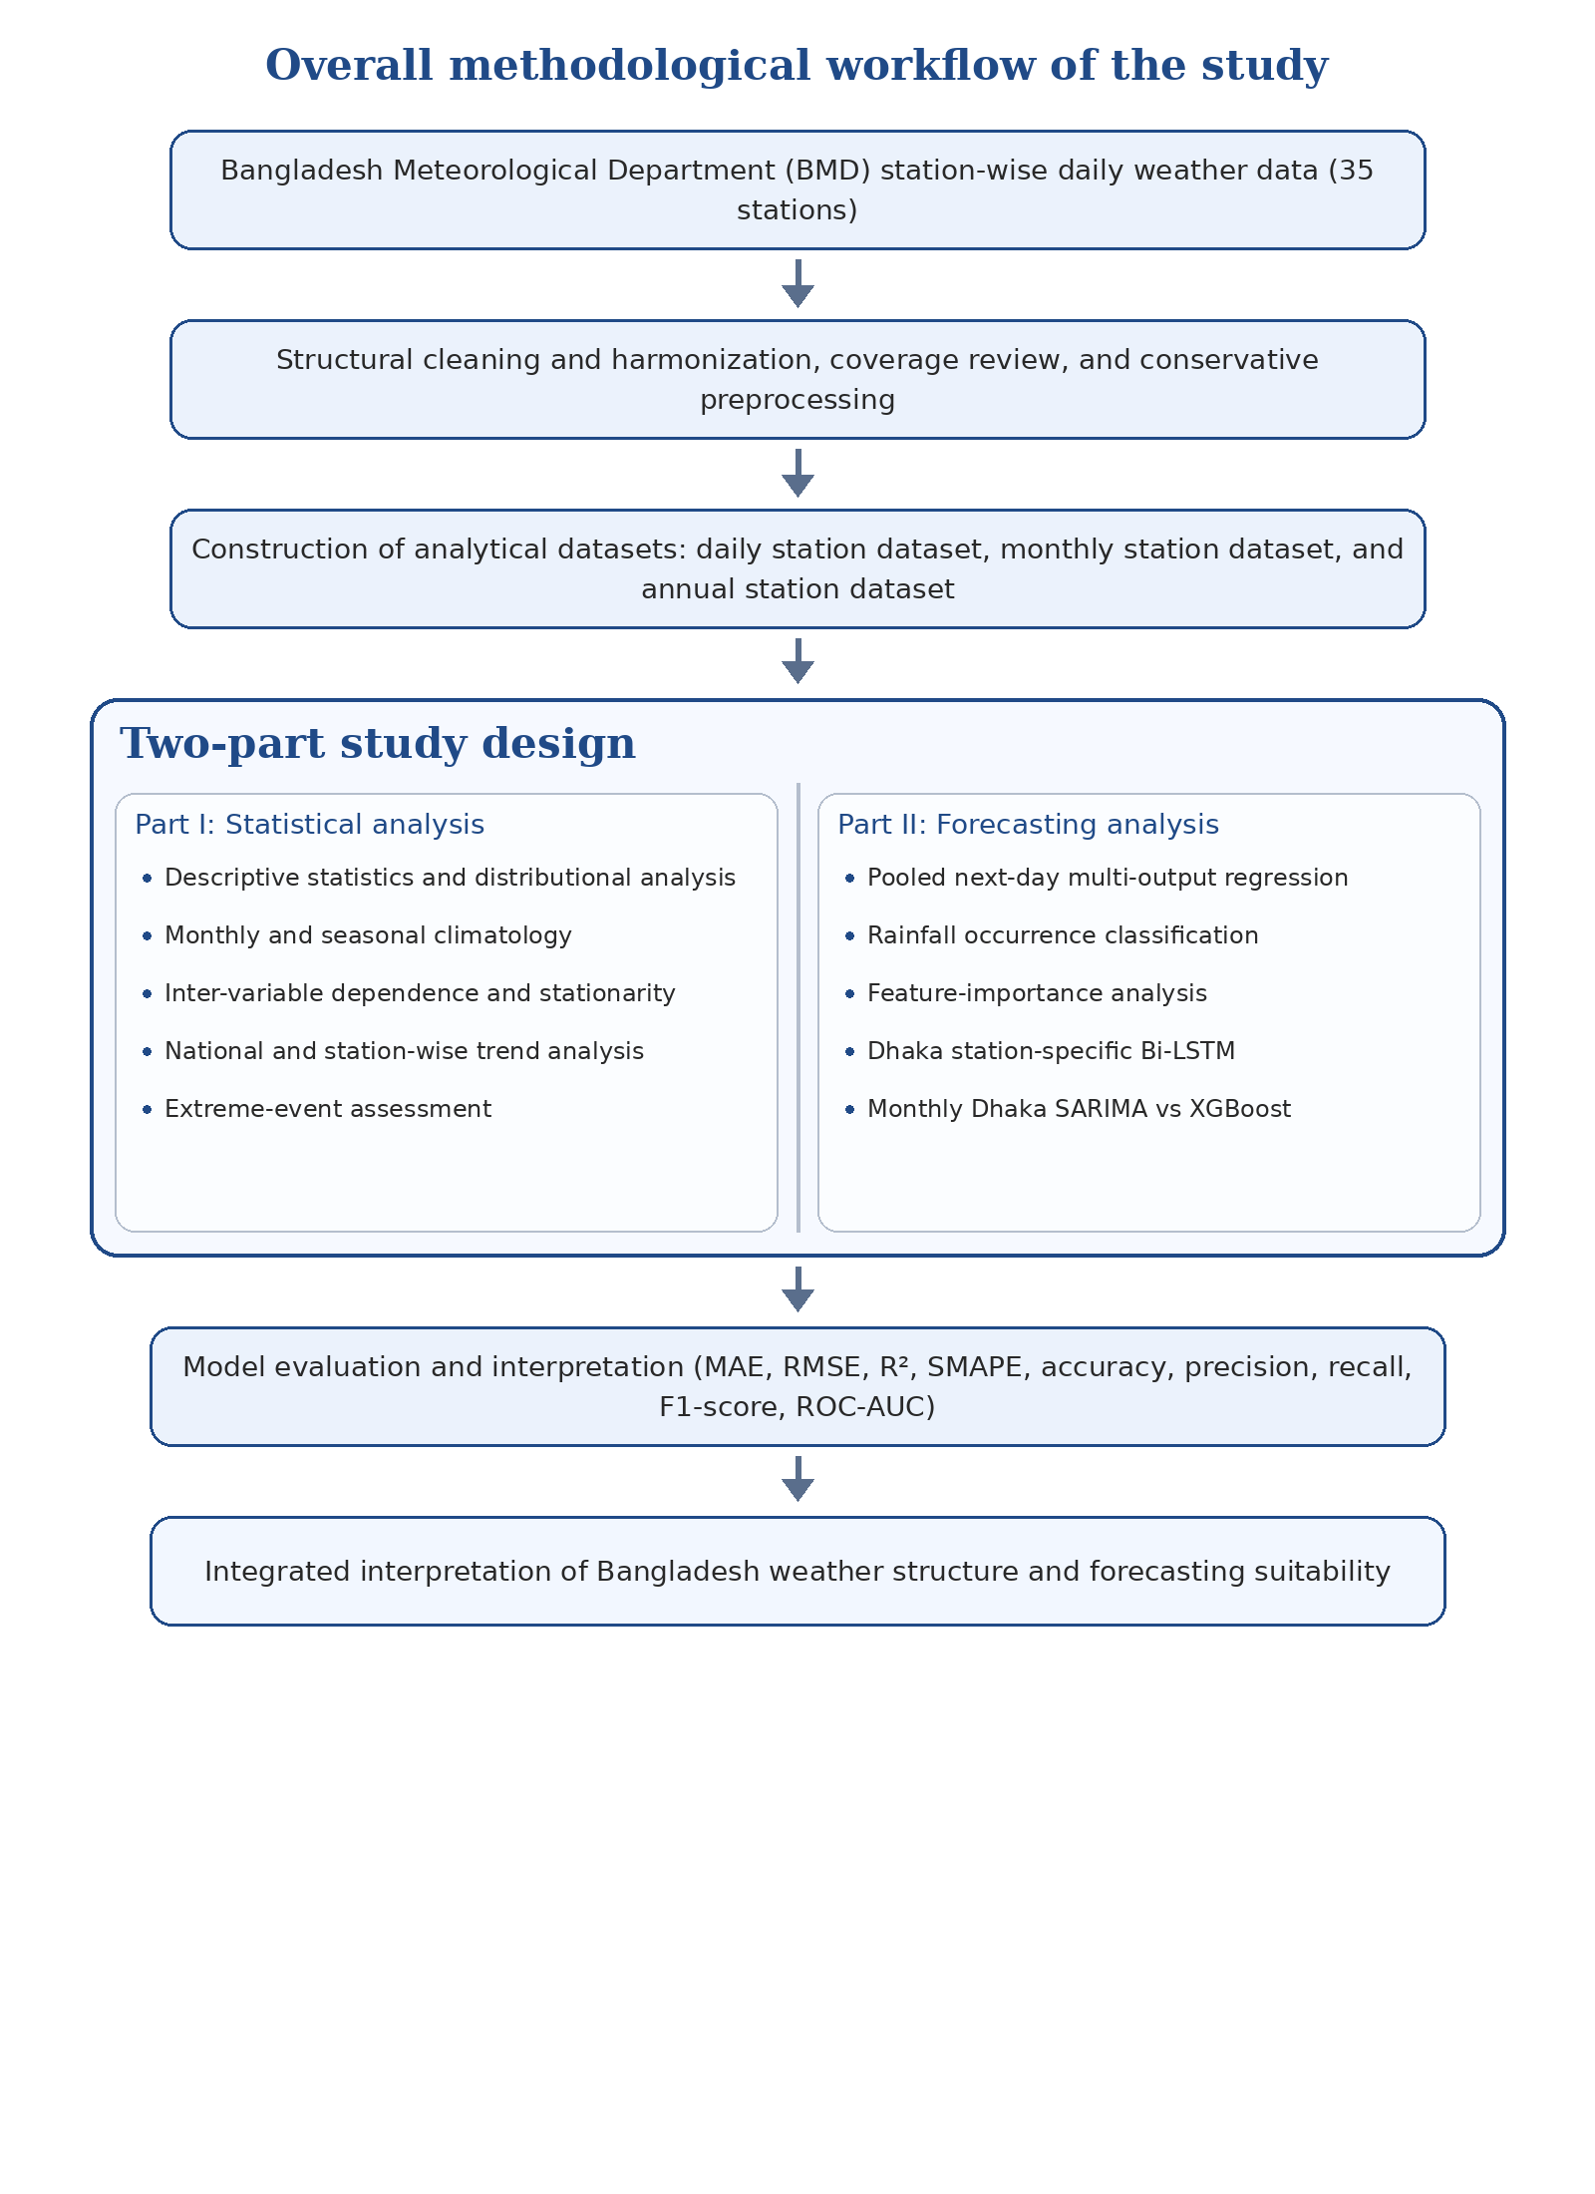
Figure 3.1. Overall methodological workflow of the study.
Table 3.1 condenses the full study design into one view. It shows that the thesis is not based on a single modelling exercise. Rather, it combines descriptive climate analysis and multiple forecasting tasks across different temporal scales, spatial scopes, and model classes.
Component | Dataset used | Time scale | Scope | Variables | Main methods | Purpose
Long-term statistical analysis | Daily, monthly, and annual station datasets | Multi-scale | National and station-wise | Rainfall, temperature, humidity, sunshine | Descriptive statistics, distributional analysis, climatology, correlation, trend analysis, stationarity checking, extreme-event analysis | To characterize the long-term statistical structure of Bangladesh weather
Pooled next-day forecasting | Daily modelling dataset | Daily, next-day | All eligible stations | Rainfall, temperature, humidity, sunshine | Persistence, 7-day rolling mean, Random Forest, ElasticNet, XGBoost | To compare baseline, linear, and nonlinear models under a common national framework
Rainfall occurrence classification | Daily modelling dataset | Daily, next-day | All eligible stations | Rain / no rain | Random Forest classifier | To separate event detection from rainfall-amount prediction
Station-specific sequence forecasting | Daily Dhaka dataset | Daily, next-day | Dhaka only | Rainfall, temperature, humidity, sunshine | Bi-LSTM | To examine whether station-level temporal sequencing adds useful predictive structure
Monthly station-specific forecasting | Monthly Dhaka dataset | Monthly | Dhaka only | Monthly rainfall, monthly temperature | SARIMA, XGBoost | To test whether model suitability changes when temporal aggregation shifts from daily pooled to monthly station-specific forecasting
Table 3.1. Summary of the overall analytical design of the thesis.

3.3 Data Source and Variable Structure
The empirical basis of the thesis is an official station-wise weather archive obtained from the Bangladesh Meteorological Department. The dataset contains daily observations from 35 weather stations distributed across Bangladesh and spans from the establishment year of each station up to 2023. This long temporal coverage and national spatial footprint make the dataset suitable for both climate interpretation and weather forecasting.
Four core meteorological variables were retained for analysis: rainfall, temperature, humidity, and sunshine. These variables were selected because they are climatologically meaningful, widely available across stations, and directly relevant to Bangladesh-focused forecasting studies. Rainfall and sunshine represent cumulative physical processes and therefore require careful treatment under aggregation, while temperature and humidity reflect average atmospheric conditions and are more naturally summarized by means. For the classification experiment, rainfall occurrence was operationalized as a binary next-day outcome in which recorded rainfall greater than 0.0 mm was treated as rain and 0.0 mm rainfall was treated as no rain. For the extreme-event component of the statistical analysis, fixed operational thresholds were applied consistently across stations and years so that annual counts remained comparable through time.

3.4 Data Organization and Analytical Datasets
Although the original source was a daily station-wise meteorological archive, the thesis did not rely on a single data table for all analyses. Instead, the cleaned records were reorganized into three analytical datasets, each designed for a different methodological purpose. This separation was necessary because long-term climate description, daily forecasting, and monthly time-series modelling impose different structural requirements on the data.
Dataset | Unit of observation | Variables | Aggregation rule | Main analytical use
Daily station dataset | Station-day | Rainfall, temperature, humidity, sunshine | Original cleaned daily observations | Distributional analysis, event detection, pooled forecasting, rainfall occurrence classification, and Dhaka Bi-LSTM
Monthly station dataset | Station-month | Rainfall, temperature, humidity, sunshine | Rainfall and sunshine accumulated; temperature and humidity averaged | Monthly climatology, smoother visualization, and Dhaka monthly forecasting
Annual station dataset | Station-year | Rainfall, temperature, humidity, sunshine | Rainfall and sunshine accumulated; temperature and humidity averaged | National and station-wise long-term trend analysis
Table 3.2. Analytical datasets constructed for the study.
The daily station dataset retained the temporal resolution required for distributional analysis, event detection, and next-day forecasting. The monthly station dataset was particularly important for climatological summaries and for the Dhaka SARIMA versus XGBoost comparison because monthly rainfall and monthly temperature exhibit clearer seasonal structure and lower high-frequency noise than their daily counterparts. The annual station dataset was used to support long-term trend assessment, where rainfall and sunshine were treated as yearly totals and temperature and humidity as yearly averages.

3.5 Data Cleaning and Preprocessing
Preprocessing was one of the most important methodological stages of the study. The raw records had to be reorganized into a consistent analytical form before statistical and forecasting procedures could be applied. In this thesis, preprocessing was treated as a formal methodological procedure rather than as a minor technical step.

Step | Purpose | Action taken
Structural harmonization | Ensure comparability of observations | Standardized station names and variable names, converted dates into a consistent datetime format, sorted records by station and date, and inspected duplicates
Range and consistency checking | Remove structural errors without distorting the series | Checked for impossible or clearly inconsistent values arising from coding or import problems while preserving the integrity of official observations
Missing-value review | Preserve realistic temporal structure | Quantified missingness by station and variable and avoided aggressive interpolation or reconstruction
Coverage filtering for forecasting | Maintain usable split continuity | Retained only those stations and periods that provided adequate usable coverage for the intended train-validation-test design
Temporal aggregation | Build scale-appropriate datasets | Constructed daily, monthly, and annual analytical datasets using variable-appropriate aggregation rules
Feature engineering | Represent short-run memory and medium-run context | Created lag features, rolling summaries, anomaly terms, seasonal indicators, and station-based climate context
Table 3.3. Data preparation and preprocessing workflow.
The preprocessing strategy was deliberately conservative. The objective was not to maximize sample size at any cost, but to preserve realistic temporal structure while removing structural problems that would invalidate analysis. This choice is especially important in weather time series, where careless interpolation can create artificial predictability or suppress genuine extremes.
After structural cleaning, daily records were aggregated to monthly and annual scales where required. For variables whose physical meaning is cumulative, such as rainfall and sunshine, totals were used. For variables representing average atmospheric state, such as temperature and humidity, means were used. This preserved physical interpretability while allowing different methods to be applied at the temporal scale most appropriate to the task.

3.6 Statistical Analysis Framework
The exploratory and statistical analysis stage served two purposes. First, it generated the empirical climate description reported later in Chapter 4. Second, it informed forecasting design by revealing skewness, seasonality, persistence, inter-variable dependence, and tail behavior. The statistical analysis therefore provided the descriptive basis on which later forecasting results could be interpreted.
Analytical component | Variables | Time scale | Purpose
Descriptive and distributional analysis | All four variables | Daily | To examine central tendency, spread, skewness, outliers, and rainfall zero-inflation
Monthly and seasonal climatology | All four variables | Monthly and seasonal | To describe the intra-annual structure of Bangladesh weather
Trend analysis | All four variables | Annual and long-horizon aggregated series | To assess broad directional change through time at national and station levels
Correlation analysis | All four variables | Daily and aggregated | To examine inter-variable dependence structure
Stationarity checking | Monthly Dhaka series | Monthly | To assess whether selected variables retained stochastic stability under monthly representation
Extreme-event analysis | Rainfall, temperature, humidity, sunshine | Annual counts of threshold-based events | To capture rare but climatologically important events that averages may conceal
Table 3.4. Statistical analysis framework used in Chapter 4.
This framework reflects the thesis’s broader methodological principle that forecasting performance should be interpreted in light of the statistical character of the underlying variables. Rainfall, for example, is highly intermittent and skewed, while temperature is smoother and more persistent. Treating these variables as if they posed identical modelling problems would weaken interpretation.

3.7 Forecasting Design and Comparative Modelling Framework
The forecasting architecture of the thesis was intentionally comparative. Rather than assuming that one model class would be best for all tasks, the study used baseline, linear, nonlinear, classification, sequence-based, and seasonal time-series methods in order to examine how model suitability changes with variable behaviour, spatial context, and temporal scale.
Model / method | Task type | Target(s) | Scope | Role in the thesis
Persistence | Regression baseline | Rainfall, temperature, humidity, sunshine | Pooled daily | Naive benchmark based on the most recent observed value
7-day rolling mean | Regression baseline | Rainfall, temperature, humidity, sunshine | Pooled daily | Smoothed short-memory benchmark
Random Forest regression | Regression | Rainfall, temperature, humidity, sunshine | Pooled daily | Nonlinear ensemble benchmark with feature-importance capability
ElasticNet regression | Regression | Rainfall, temperature, humidity, sunshine | Pooled daily | Regularized linear comparator
XGBoost regression | Regression | Rainfall, temperature, humidity, sunshine | Pooled daily | High-capacity boosted-tree model for structured tabular prediction
Random Forest classifier | Classification | Rain / no rain | Pooled daily | Rainfall occurrence modelling
Bi-LSTM | Sequence forecasting | Rainfall, temperature, humidity, sunshine | Dhaka only | Station-specific deep-learning extension
SARIMA | Seasonal time-series forecasting | Monthly rainfall, monthly temperature | Dhaka only | Classical seasonal benchmark for monthly station-specific forecasting
Monthly XGBoost | Machine-learning comparator | Monthly rainfall, monthly temperature | Dhaka only | Nonlinear comparator to SARIMA in the monthly setting
Table 3.5. Forecasting models and their roles in the study.
Because the forecasting tasks do not represent the same statistical problem, their results should be interpreted comparatively but not as if they were generated under identical analytical conditions. The pooled daily models identify shared predictive structure across stations, the rainfall occurrence classifier isolates the binary event component of rainfall, the Dhaka Bi-LSTM examines station-level temporal dependence, and the monthly SARIMA versus XGBoost comparison evaluates how conclusions change when forecasting is shifted to a lower-frequency single-station setting.
For the monthly Dhaka comparison, SARIMA specifications were selected separately for rainfall and temperature on the basis of seasonal differencing requirements, autocorrelation structure, residual adequacy, and holdout forecasting behaviour. The purpose of the monthly experiment was not to maximize model complexity, but to compare a classical seasonal stochastic specification with a machine-learning alternative under the same chronological forecasting logic.

3.8 Feature Engineering Strategy for Pooled Daily Forecasting
Feature engineering was used to represent both short-run memory and medium-run context in the pooled daily forecasting design. The later feature-importance results in Chapter 5 indicate that anomaly terms, monsoon regime, lagged humidity, and station climatology were among the influential predictors, which supports the inclusion of these feature families in the modelling design.
Feature family | Examples | Purpose
Lag features | Lagged rainfall, lagged temperature, lagged humidity, lagged sunshine | Capture short-run persistence
Rolling statistics | Rolling means and rolling standard deviations | Represent recent local temporal context
Anomaly features | Humidity anomaly, rainfall anomaly, sunshine anomaly | Measure departures from expected local conditions
Seasonal indicators | Monsoon indicator and cyclical seasonal encodings | Represent regime-dependent seasonal structure
Station climatology features | Station mean rainfall, station temperature climatology, station humidity climatology | Encode local climatic identity within the pooled national framework
Station identity | Station-specific encoding | Preserve spatial heterogeneity in pooled modelling
Table 3.6. Daily feature-engineering strategy for pooled forecasting.

3.9 Train-Validation-Test Design
A chronological split was used throughout the forecasting component because random partitioning would leak future information into model fitting and evaluation. This was especially important given the strong seasonality and temporal dependence present in Bangladesh weather data.
Forecasting component | Train period | Validation period | Test period | Additional note
Pooled daily multi-output forecasting | Up to 2017-12-31 | 2018-01-01 to 2020-12-31 | 2021-01-01 onward | 466,104 training records, 38,360 validation records, and 38,290 test records after coverage filtering
Rainfall occurrence classification | Same chronological split as pooled daily forecasting | Same | Same | Uses the same daily engineered feature framework and binary rainfall-occurrence coding
Dhaka Bi-LSTM | Earlier chronological segment of the Dhaka daily series | Later Dhaka segment used for validation and tuning | Most recent Dhaka segment reserved for evaluation | Fixed-length input sequences were generated from past observations, and temporal order was preserved throughout
Monthly Dhaka SARIMA vs XGBoost | Earlier monthly segment of the Dhaka series | Model-selection and diagnostic-check stage | Most recent monthly holdout segment | Monthly station-specific comparison of the final selected SARIMA and XGBoost configurations
The pooled daily design is the most fully specified part of the forecasting framework, with 466,104 training records, 38,360 validation records, and 38,290 test records after filtering to retain stations with sufficient usable coverage across all three splits. For the Dhaka-only experiments, the same chronological principle was retained: earlier observations were used for model fitting, later observations were used for model checking where relevant, and the most recent observations were reserved for final evaluation so that no future information entered the training stage.

3.10 Evaluation Metrics
Multiple evaluation criteria were used because no single metric captures all aspects of forecasting quality. For regression, MAE, RMSE, R², and SMAPE were used to assess average error magnitude, sensitivity to larger deviations, explanatory power, and scale-relative percentage error. For rainfall occurrence classification, accuracy, precision, recall, F1-score, ROC-AUC, and the confusion matrix were used to evaluate both overall discrimination and class-specific behaviour.
Metric | Task type | What it captures
MAE | Regression | Average absolute forecast error
RMSE | Regression | Error magnitude with stronger penalty for large misses
R² | Regression | Proportion of variance explained relative to a mean-only benchmark
SMAPE | Regression | Scale-relative percentage error
Accuracy | Classification | Overall proportion of correctly classified days
Precision | Classification | Reliability of predicted rainy days
Recall | Classification | Proportion of actual rainy days correctly detected
F1-score | Classification | Balance between precision and recall
ROC-AUC | Classification | Ability to separate rainy and non-rainy days across thresholds
Confusion matrix | Classification | Counts of true positives, true negatives, false positives, and false negatives for error interpretation
Table 3.8. Evaluation metrics used in the forecasting component.
In rainfall classification especially, accuracy alone can be misleading because dry days are common. Precision, recall, F1-score, ROC-AUC, and the confusion matrix therefore provide a more balanced picture of classifier performance than a single summary metric.

3.11 Software Environment and Reproducibility
Component | Tools / software | Role
Data manipulation and aggregation | Python, pandas, numpy | Cleaning, aggregation, and dataset construction
Visualization | matplotlib, seaborn | Statistical and model-performance graphics
Machine learning | scikit-learn, xgboost | Pooled regression and rainfall occurrence models
Classical time-series modelling | statsmodels | SARIMA modelling
Deep learning | TensorFlow / Keras | Bi-LSTM modelling
Workflow environment | Jupyter Notebook | Integrated analysis and reproducibility
Reproducibility structure | Exported intermediate datasets, result tables, and figures | Supports auditable and stage-wise rerunning of the analysis
Table 3.9. Software environment and reproducibility structure.

The study was implemented in Python within a Jupyter Notebook workflow. Intermediate analytical datasets and result tables were exported to dedicated files so that the workflow could be re-run and checked stage by stage. This file-based structure improved reproducibility by separating cleaned data, modelling datasets, result summaries, and final figures. The methodological sequence from source data to final results is therefore auditable and replicable in principle, subject to access to the same underlying BMD records.

3.12 Methodological Considerations and Limitations
Although the methodological design of the thesis is broad and carefully structured, several considerations should be acknowledged. First, the station histories are unequal in length, which means that long-term analysis benefits more strongly from older stations than from later stations. Second, forecasting performance is necessarily conditioned by the variables available in the dataset; no external atmospheric reanalysis, pressure field, or numerical weather prediction inputs were incorporated. Third, the pooled daily models and the station-specific Bi-LSTM do not answer identical questions, and their results should therefore be interpreted comparatively but not as if they were generated under a perfectly identical design. Fourth, monthly forecasting and daily forecasting operate on different statistical scales, so model comparison across those scales must be interpreted in terms of design sensitivity rather than direct superiority. These limitations are not flaws but boundary conditions of the study, and they are made explicit so that the conclusions of the thesis remain properly calibrated.

3.13 Chapter Summary
This chapter has described the methodological foundation of the thesis in a more visible and structured form. It explained the source and structure of the Bangladesh Meteorological Department weather data, the construction of daily, monthly, and annual analytical datasets, the preprocessing workflow, the statistical analysis framework, the forecasting design, the feature-engineering strategy, the baseline and comparative models, the train-validation-test logic, and the performance metrics used for evaluation. By structuring the study around both long-term climate interpretation and comparative forecasting, the methodology is designed to ensure that the results reported in the subsequent chapters are not only numerically sound but also statistically and climatologically interpretable.

CHAPTER 4

RESULTS OF STATISTICAL ANALYSIS
The statistical analysis was designed to characterize the structural behavior of the dataset before predictive modeling was attempted. This step was essential because Bangladesh weather is spatially diverse, seasonally structured, and highly nonlinear in its rainfall behavior. The dataset itself, as described by Zubair et al. (2024b), was assembled from 35 Bangladesh Meteorological Department stations and prepared specifically to support weather forecasting, climate analysis, and machine-learning applications. Accordingly, the present chapter focuses on distributional behavior, annual and seasonal variation, station-wise heterogeneity, inter-variable dependence, long-term trends, and extreme-event behavior, all of which provide the empirical basis for the modeling strategy adopted in Chapter 5.

4.1 Analytical dataset and station coverage
The statistical analysis was performed on 543,839 daily observations distributed across 35 weather stations in Bangladesh, covering the period from 1961 to 2023. The station coverage profile is displayed in Figure 4.1. The figure shows that the network did not begin uniformly across all locations. Bogura, Chittagong, Coxsbazar, Dhaka, and Sylhet contributed some of the earliest records, whereas stations such as Ambaganctg, Mongla, and Sudpur entered the dataset later. This uneven start-year distribution is methodologically important. Long-running stations exert greater influence on national annual aggregates, whereas shorter station histories can produce more volatile local trend estimates. Accordingly, the national summaries reported later in the chapter should be interpreted as broad system-level summaries derived from the stations available in each period rather than as perfectly coverage-invariant national estimates. Even with that caution, the temporal span and spatial footprint of the dataset still provide a strong basis for descriptive climate analysis and comparative forecasting, which is consistent with the research use of the dataset reported by Zubair et al. (2024a).
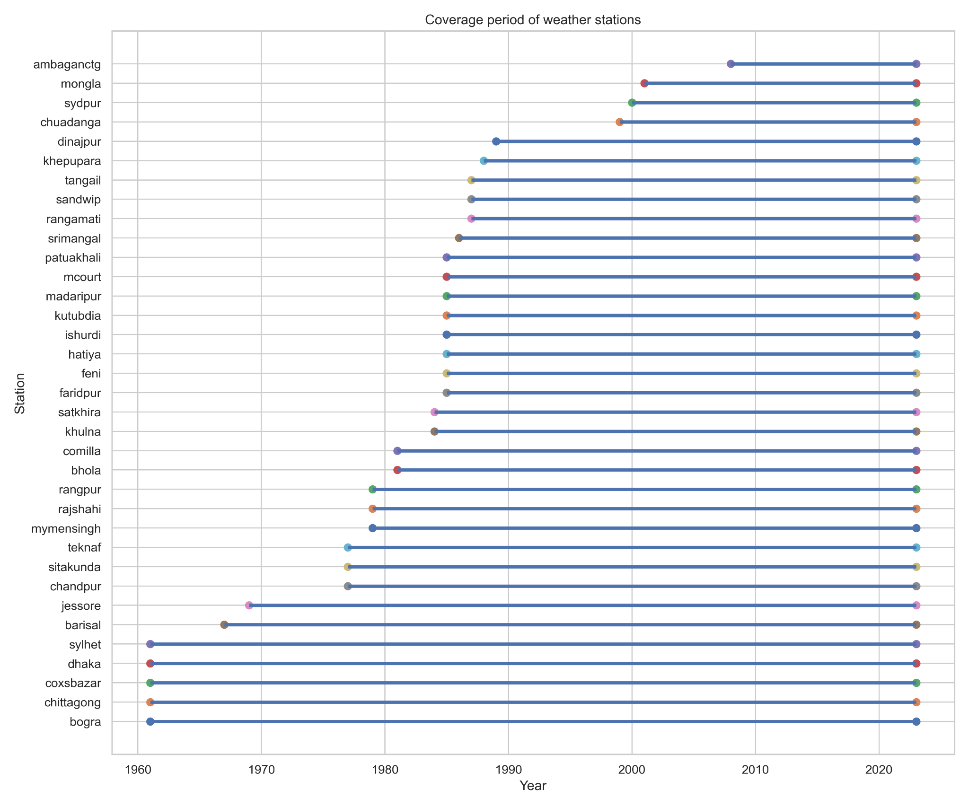
Figure 4.1. Coverage period of the 35 weather stations used in the statistical analysis.

4.2 Descriptive statistics and distributional characteristics
The overall descriptive statistics of the four primary variables are summarized in Table 4.1. Rainfall had a mean of 6.733 mm/day but a median of 0.000 mm/day, which immediately indicates a zero-heavy distribution dominated by non-rainy days. Its standard deviation of 19.367 mm/day and maximum of 590.0 mm further confirm the presence of occasional extreme wet days. Temperature, by contrast, was much more stable, with a mean of 25.571°C and a median of 26.900°C. Humidity remained persistently high, averaging 79.849%, while sunshine averaged 6.279 h/day. The skewness values deepen this interpretation: rainfall was strongly positively skewed (5.764), whereas temperature (-0.811), humidity (-0.853), and sunshine (-0.555) were moderately negatively skewed. In practical terms, this means that rainfall behaves as a rare-event variable embedded within a monsoon climate, while the other three variables fluctuate within narrower climatological bands. This contrast is especially important because it anticipates the modeling results of Chapter 5, where rainfall proves harder to forecast than temperature or humidity.
Table 4.1. Overall descriptive statistics of the daily weather variables.
Variable | Count | Mean | Median | Std. dev. | Minimum | Maximum | Skewness
Rainfall | 543839 | 6.733 | 0.0 | 19.367 | 0.0 | 590.0 | 5.764
Temperature | 543839 | 25.571 | 26.9 | 4.167 | 0.0 | 37.8 | -0.811
Humidity | 543839 | 79.849 | 81.0 | 8.938 | 10.0 | 100.0 | -0.853
Sunshine | 543839 | 6.279 | 7.2 | 3.349 | 0.0 | 22.2 | -0.555
The histogram and density panels in Figure 4.2 visually reinforce the numerical properties reported in Table 4.1. Rainfall shows a highly compressed mass near zero followed by a long upper tail, while temperature is concentrated mainly in the tropical mid-range. Humidity clusters near the upper-middle portion of its range, reflecting the humid atmospheric conditions typical of Bangladesh, and sunshine is concentrated in the moderate band but with a notable pile-up near zero. That pile-up near zero is climatologically meaningful, because it corresponds to heavily clouded or rainy conditions. Thus, Figure 4.2 is not just a simple descriptive panel; it reveals the different statistical regimes governing the four variables.
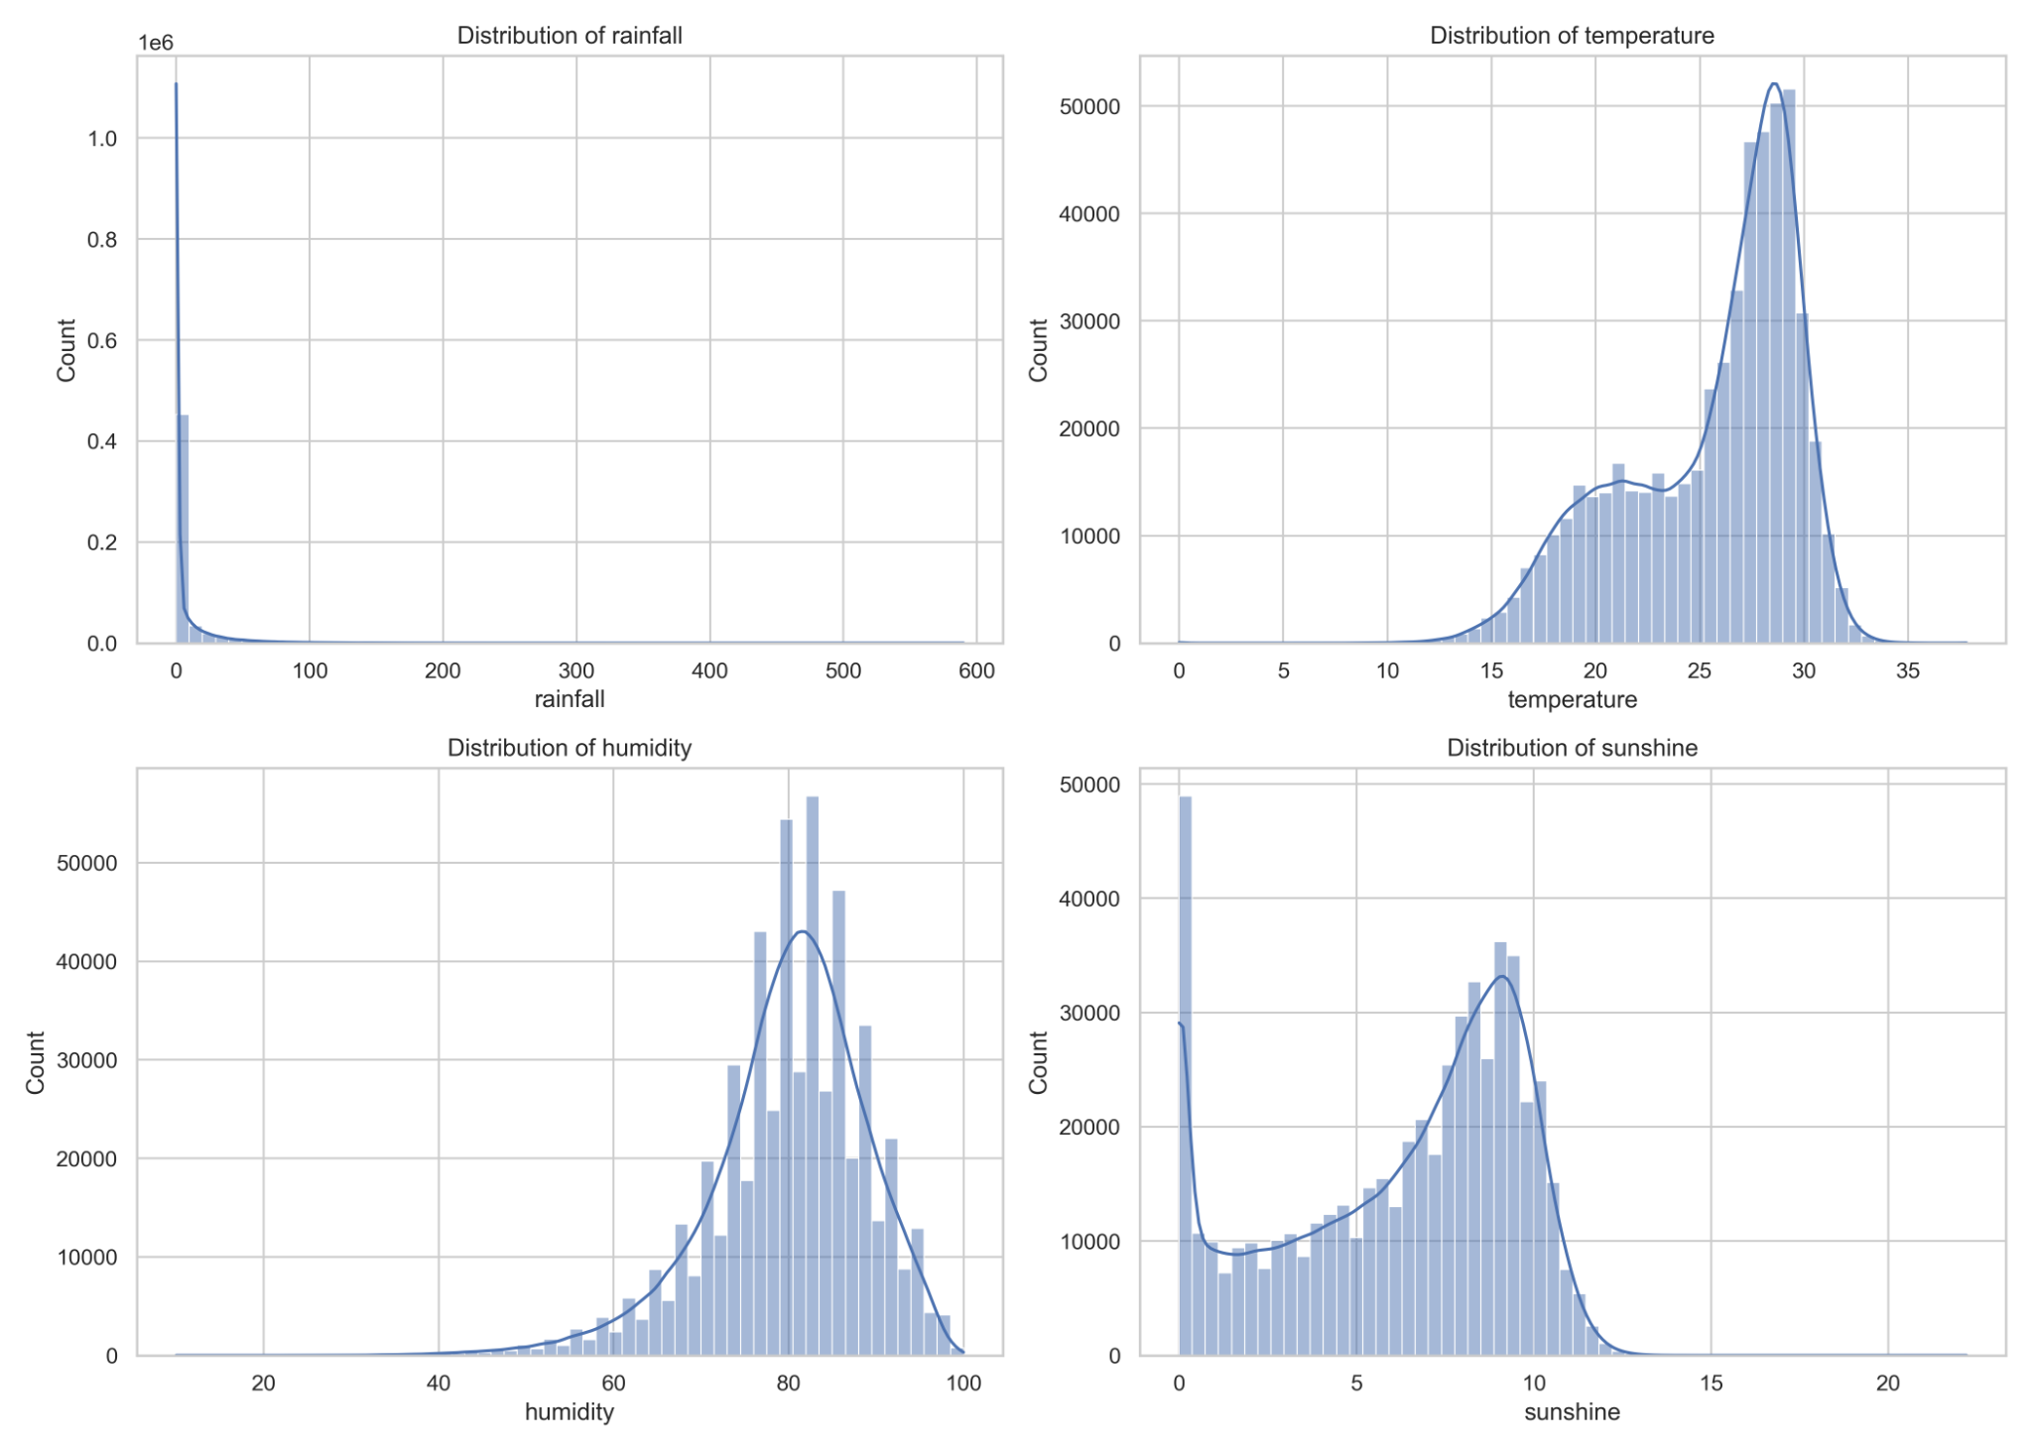

Figure 4.2. Frequency distributions of rainfall, temperature, humidity, and sunshine.
Figure 4.3 presents the rainfall series on a log(1 + rainfall) scale. The transformation compresses the long right tail and improves visibility of moderate positive rainfall values, but it does not eliminate the dominance of near-zero observations. This is a crucial result because it demonstrates that rainfall non-normality is structural rather than accidental. The implication is methodological as well as descriptive: models that perform well for smoother variables such as temperature may not automatically perform equally well for rainfall. This result also helps justify the separate rainfall occurrence classification implemented in Chapter 5, where rainfall is explicitly treated as a zero-inflated process.
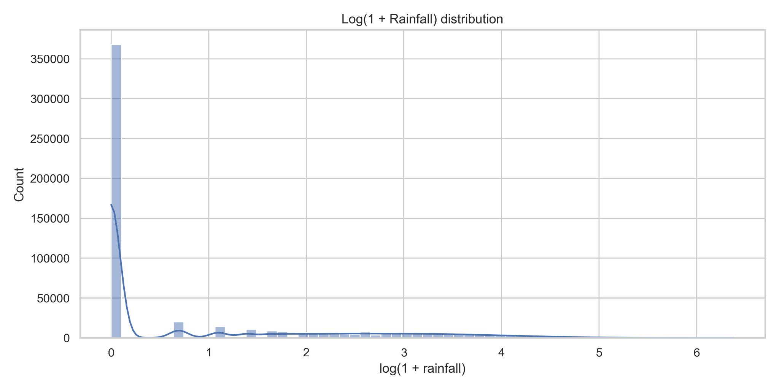
Figure 4.3. Distribution of log(1 + rainfall), illustrating the structural zero-dominance of rainfall.

4.3 Monthly climatology and seasonal contrasts
Bangladesh exhibited a highly organized monthly climatology, summarized in Table 4.2 and visualized in Figures 4.4 and 4.5. Rainfall rose from 7.33 mm in January to 537.45 mm in July, then declined sharply toward the end of the year, reaching 35.64 mm in November and 11.04 mm in December. This clearly identifies July as the wettest month and January as the driest. Temperature increased from 18.23°C in January to 28.71°C in May, remained high through the monsoon months, and then declined again in late autumn and winter. Humidity reached its seasonal minimum in March (70.59%) before increasing to a maximum in July (86.63%), whereas sunshine showed the reverse pattern, peaking in March (241.58 h/month) and reaching its annual minimum in July (120.63 h/month). The joint interpretation of these monthly means is straightforward but important: the monsoon season in Bangladesh is characterized not only by more rainfall, but by simultaneous increases in humidity and reductions in sunshine, while temperature remains elevated over a longer seasonal window.
Table 4.2. National monthly climatology derived from the station-averaged monthly dataset.
Month | Rainfall mean | Temperature mean | Humidity mean | Sunshine mean
January | 7.33 | 18.23 | 76.7 | 211.73
February | 19.79 | 21.39 | 72.01 | 216.03
March | 44.51 | 25.57 | 70.59 | 241.58
April | 114.95 | 28.09 | 75.12 | 229.54
May | 271.85 | 28.71 | 79.38 | 207.23
June | 473.29 | 28.67 | 84.95 | 127.98
July | 537.45 | 28.4 | 86.63 | 120.63
August | 420.8 | 28.54 | 86.03 | 141.37
September | 326.63 | 28.38 | 85.66 | 150.32
October | 195.88 | 27.24 | 83.17 | 206.17
November | 35.64 | 23.73 | 78.94 | 227.39
December | 11.04 | 19.73 | 78.49 | 213.49
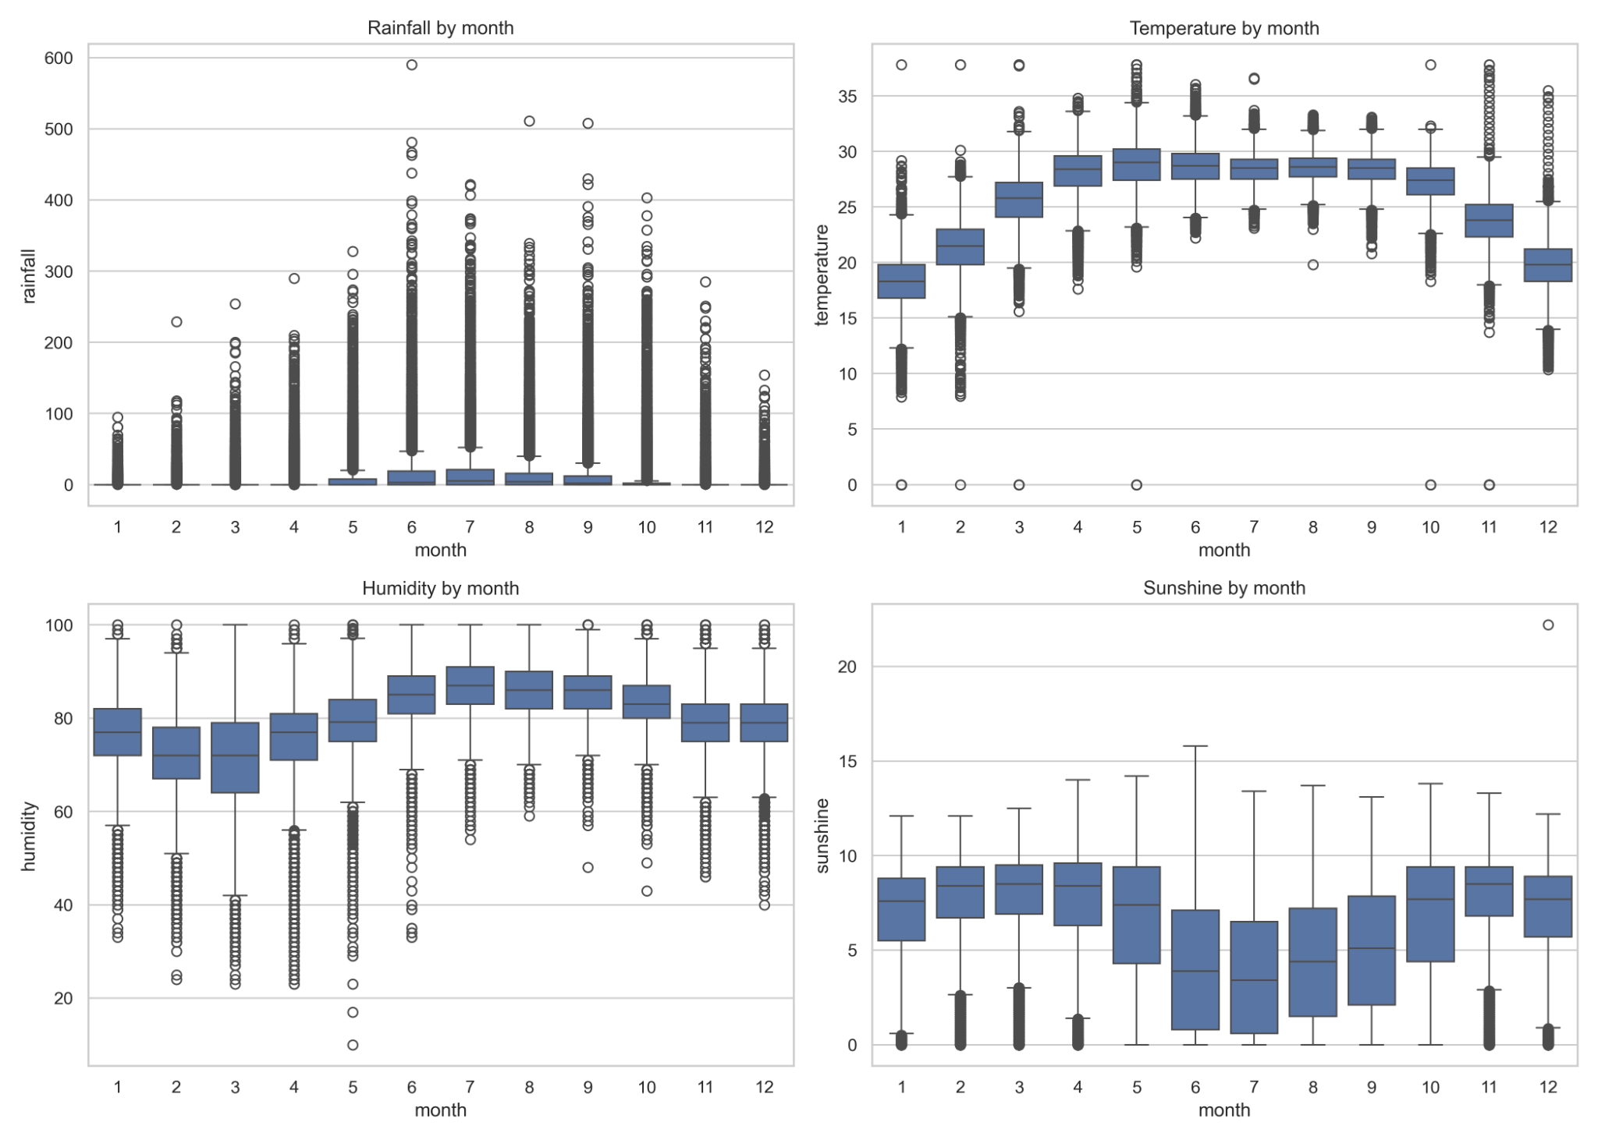
Figure 4.4. Monthly boxplots of rainfall, temperature, humidity, and sunshine.
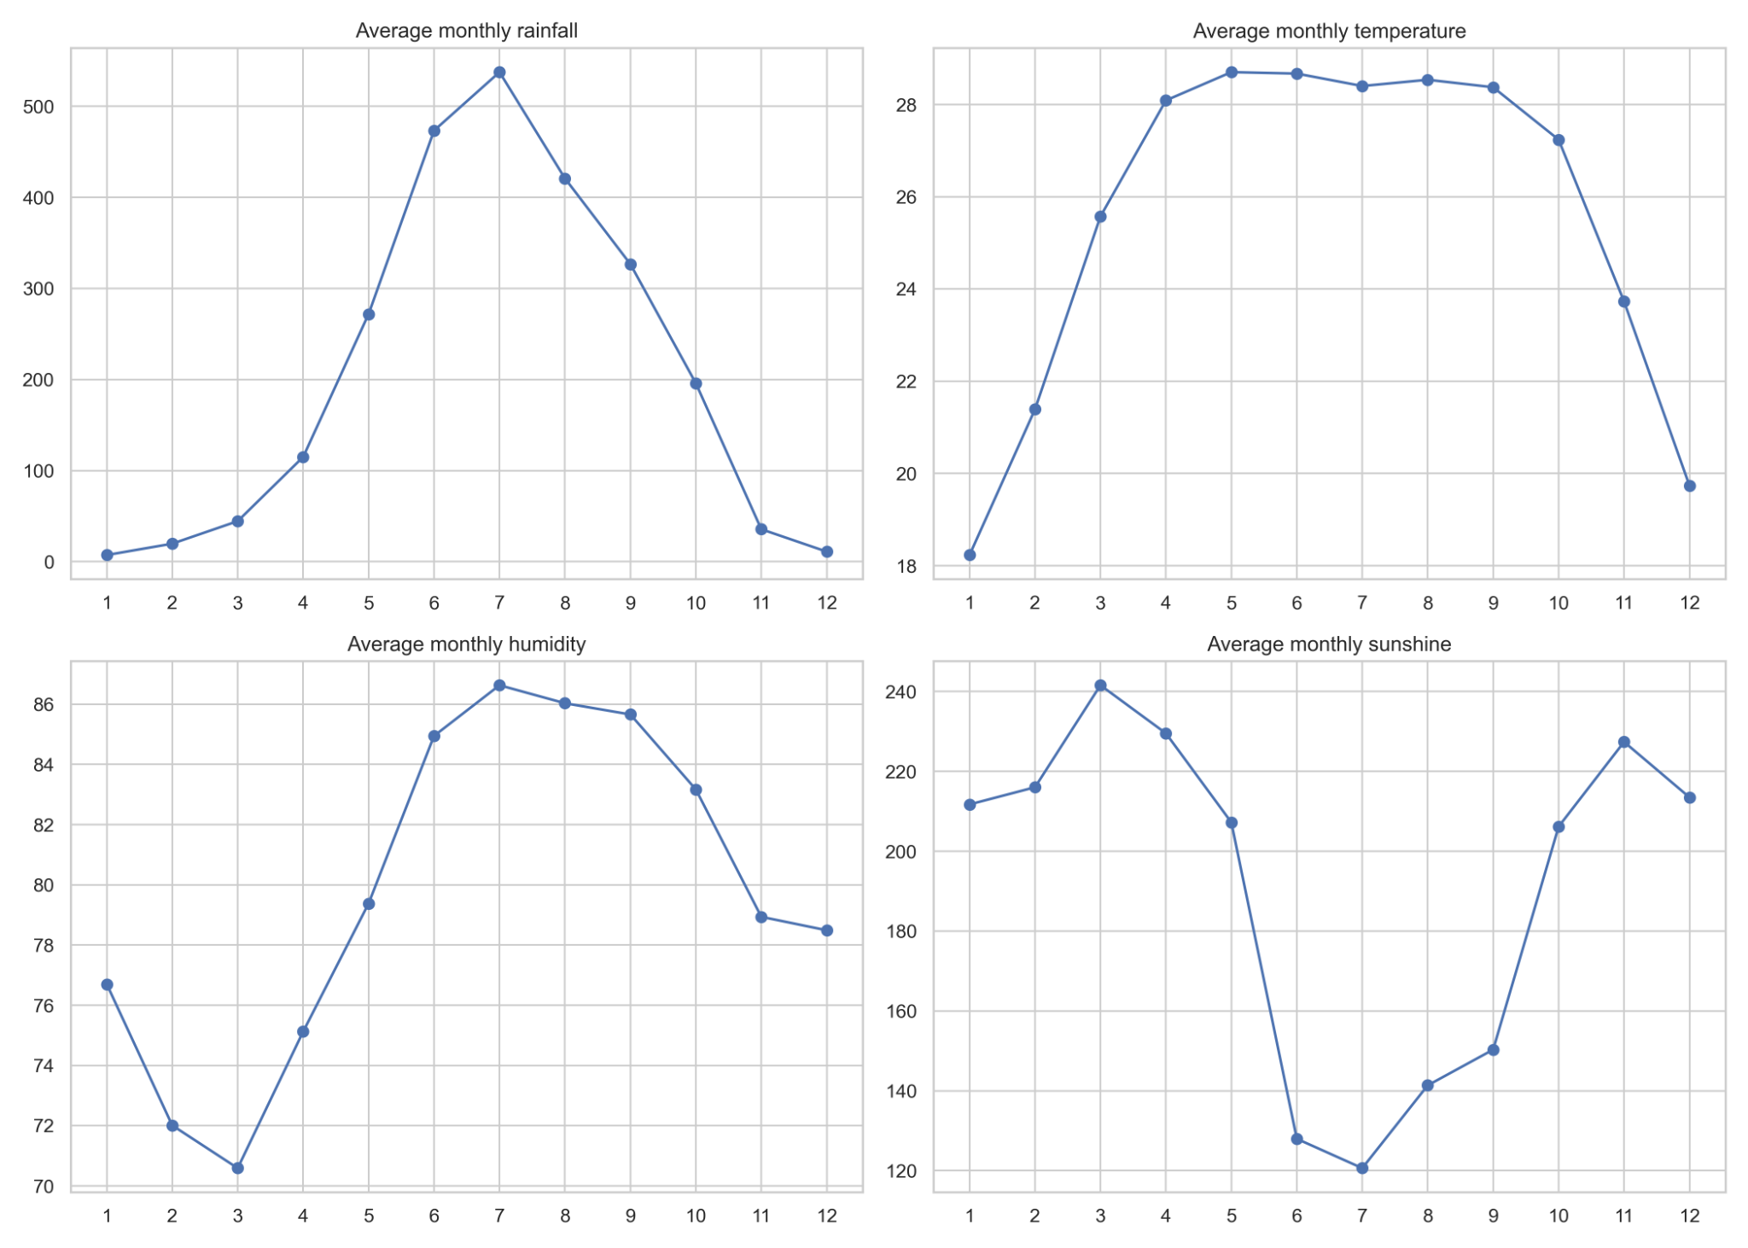
Figure 4.5. National monthly climatology of rainfall, temperature, humidity, and sunshine.
The daily boxplots in Figure 4.4 add another layer of interpretation by showing within-month variability. Rainfall had very narrow spreads in winter months but expanded sharply from May through October, especially in June, July, August, and September, where both interquartile range and outlier structure increased dramatically. This means that the rainy season is not only wetter on average but also far more volatile. Temperature shows a smoother transition, with high medians concentrated from April to September. Humidity displays a strong upward shift during monsoon and post-monsoon, whereas sunshine declines over the same interval. Taken together, the monthly lines and boxplots show that Bangladesh weather is seasonally synchronized but directionally differentiated: rainfall and humidity rise together, sunshine falls, and temperature rises earlier and remains elevated longer.
The seasonal aggregation in Table 4.3 condenses the same pattern into four climatological blocks. Monsoon recorded the highest mean rainfall (14.41 mm/day), highest humidity (85.82%), and lowest sunshine (4.43 h/day), while winter recorded the lowest rainfall (0.42 mm/day) and lowest temperature (19.73°C). Pre-monsoon stood out as the warm build-up season with a mean temperature of 27.45°C and relatively high sunshine, while post-monsoon remained humid but with far less rainfall than monsoon. The seasonal table therefore confirms that the statistical structure of Bangladesh weather is inseparable from its monsoon regime, a point repeatedly emphasized in Bangladesh-focused forecasting studies such as Zubair et al. (2024b) and Hasan et al. (2024).
Table 4.3. Seasonal descriptive summary of the daily weather variables.
Season | Rainfall mean | Temperature mean | Humidity mean | Sunshine mean
Monsoon | 14.41 | 28.5 | 85.82 | 4.43
Post-monsoon | 3.8 | 25.51 | 81.09 | 7.11
Pre-monsoon | 4.69 | 27.45 | 75.03 | 7.37
Winter | 0.42 | 19.73 | 75.85 | 7.11

4.4 Station-wise spatial heterogeneity
The station-wise spatial patterns demonstrate that Bangladesh cannot be treated as a meteorologically homogeneous area. Figure 4.6 shows that the highest monsoon rainfall concentrations were observed in eastern and southeastern stations, particularly Teknaf, Coxsbazar, Sandwip, and Sylhet, while western inland stations such as Rajshahi and Chuadanga remained comparatively drier. Figure 4.7 shows that temperature follows a more coherent seasonal cycle across the country, but warmer conditions were more pronounced in coastal and southwestern locations than in the northeastern hill-adjacent zone.
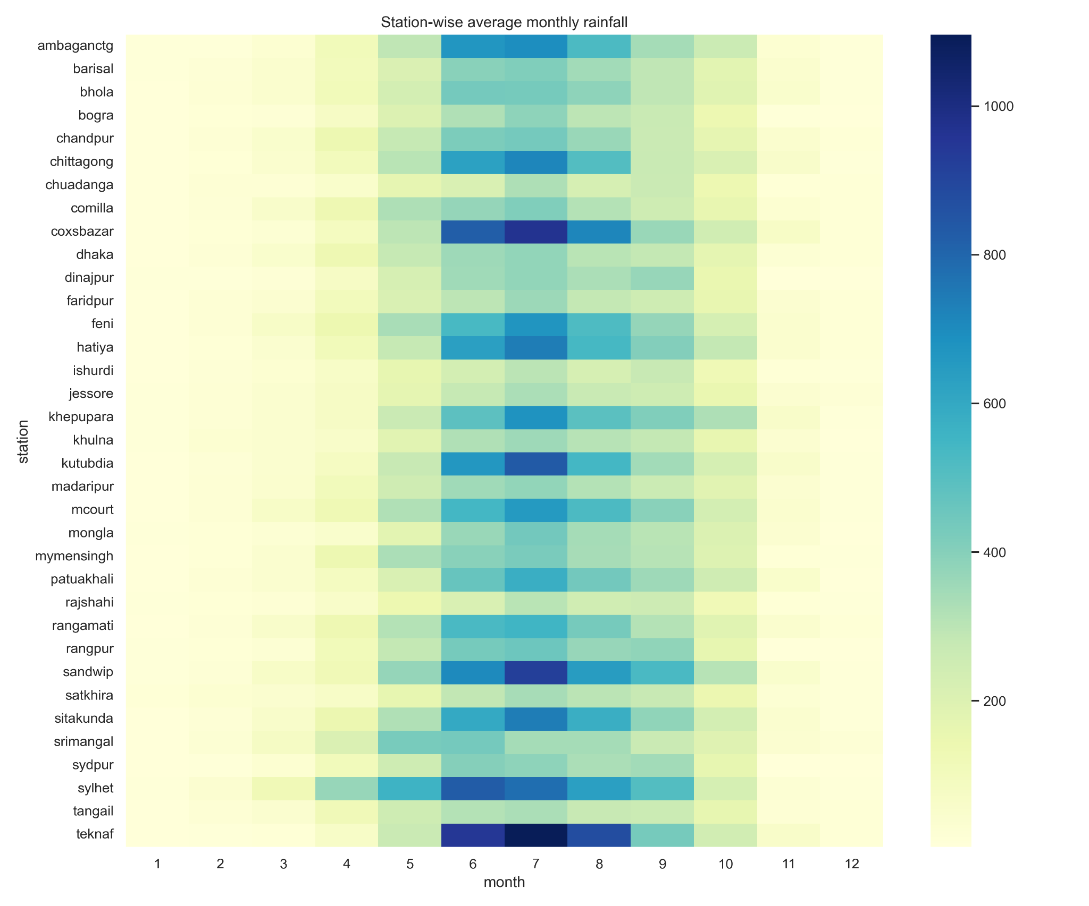
Figure 4.6. Station-wise average monthly rainfall heatmap.
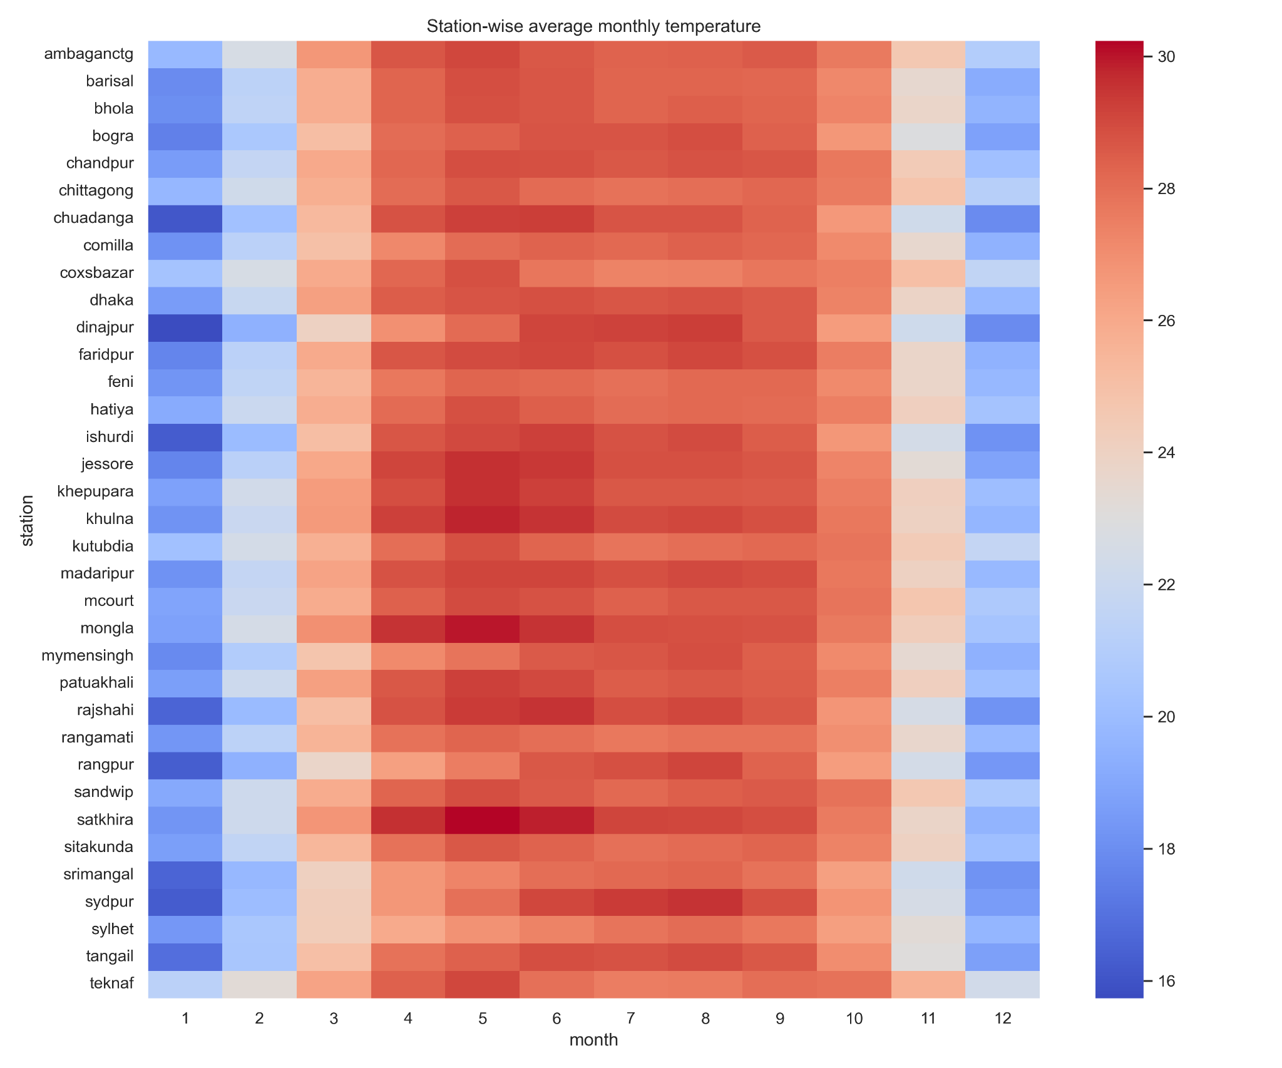
Figure 4.7. Station-wise average monthly temperature heatmap.
Table 4.4 summarizes the strongest station-level contrasts in long-term means. Sylhet recorded the highest rainfall mean (11.23 mm/day), whereas Rajshahi recorded the lowest (3.88 mm/day). Mongla recorded the highest temperature mean (26.35°C), while Srimangal recorded the lowest (24.48°C). Patuakhali had the highest humidity mean (84.06%), and Dhaka had the lowest (74.62%). Coxsbazar recorded the highest mean sunshine (7.12 h/day), while Bhola recorded the lowest (5.37 h/day). These contrasts are not trivial background variations. They indicate that pooled national statistics mask strong coastal–inland, east–west, and topographic climatic gradients. This spatial heterogeneity is one of the clearest arguments in favor of including station identity and station-specific information in the predictive models used later.

Table 4.4. Spatial extremes in long-term station means.
Variable | Highest station mean | Lowest station mean
Rainfall (mm/day) | Sylhet (11.23) | Rajshahi (3.88)
Temperature (°C) | Mongla (26.35) | Srimangal (24.48)
Humidity (%) | Patuakhali (84.06) | Dhaka (74.62)
Sunshine (h/day) | Coxsbazar (7.12) | Bhola (5.37)

4.5 Inter-variable dependence and stationarity
The Spearman correlation matrix in Figure 4.8 demonstrates that the weather variables are related, but not redundantly so. Rainfall had a moderate positive relationship with humidity (ρ = 0.54) and a moderate negative relationship with sunshine (ρ = -0.42), implying that wetter conditions are generally associated with more moisture and less solar exposure. The strongest relationship in the matrix was the negative association between humidity and sunshine (ρ = -0.62), which confirms the intuitive climatological link between moist air and reduced solar duration. Temperature had comparatively weak daily relationships with rainfall (ρ = 0.23), humidity (ρ = 0.15), and sunshine (ρ ≈ -0.01), indicating that temperature is governed by both seasonal forcing and shorter atmospheric processes rather than by one dominant daily covariate.
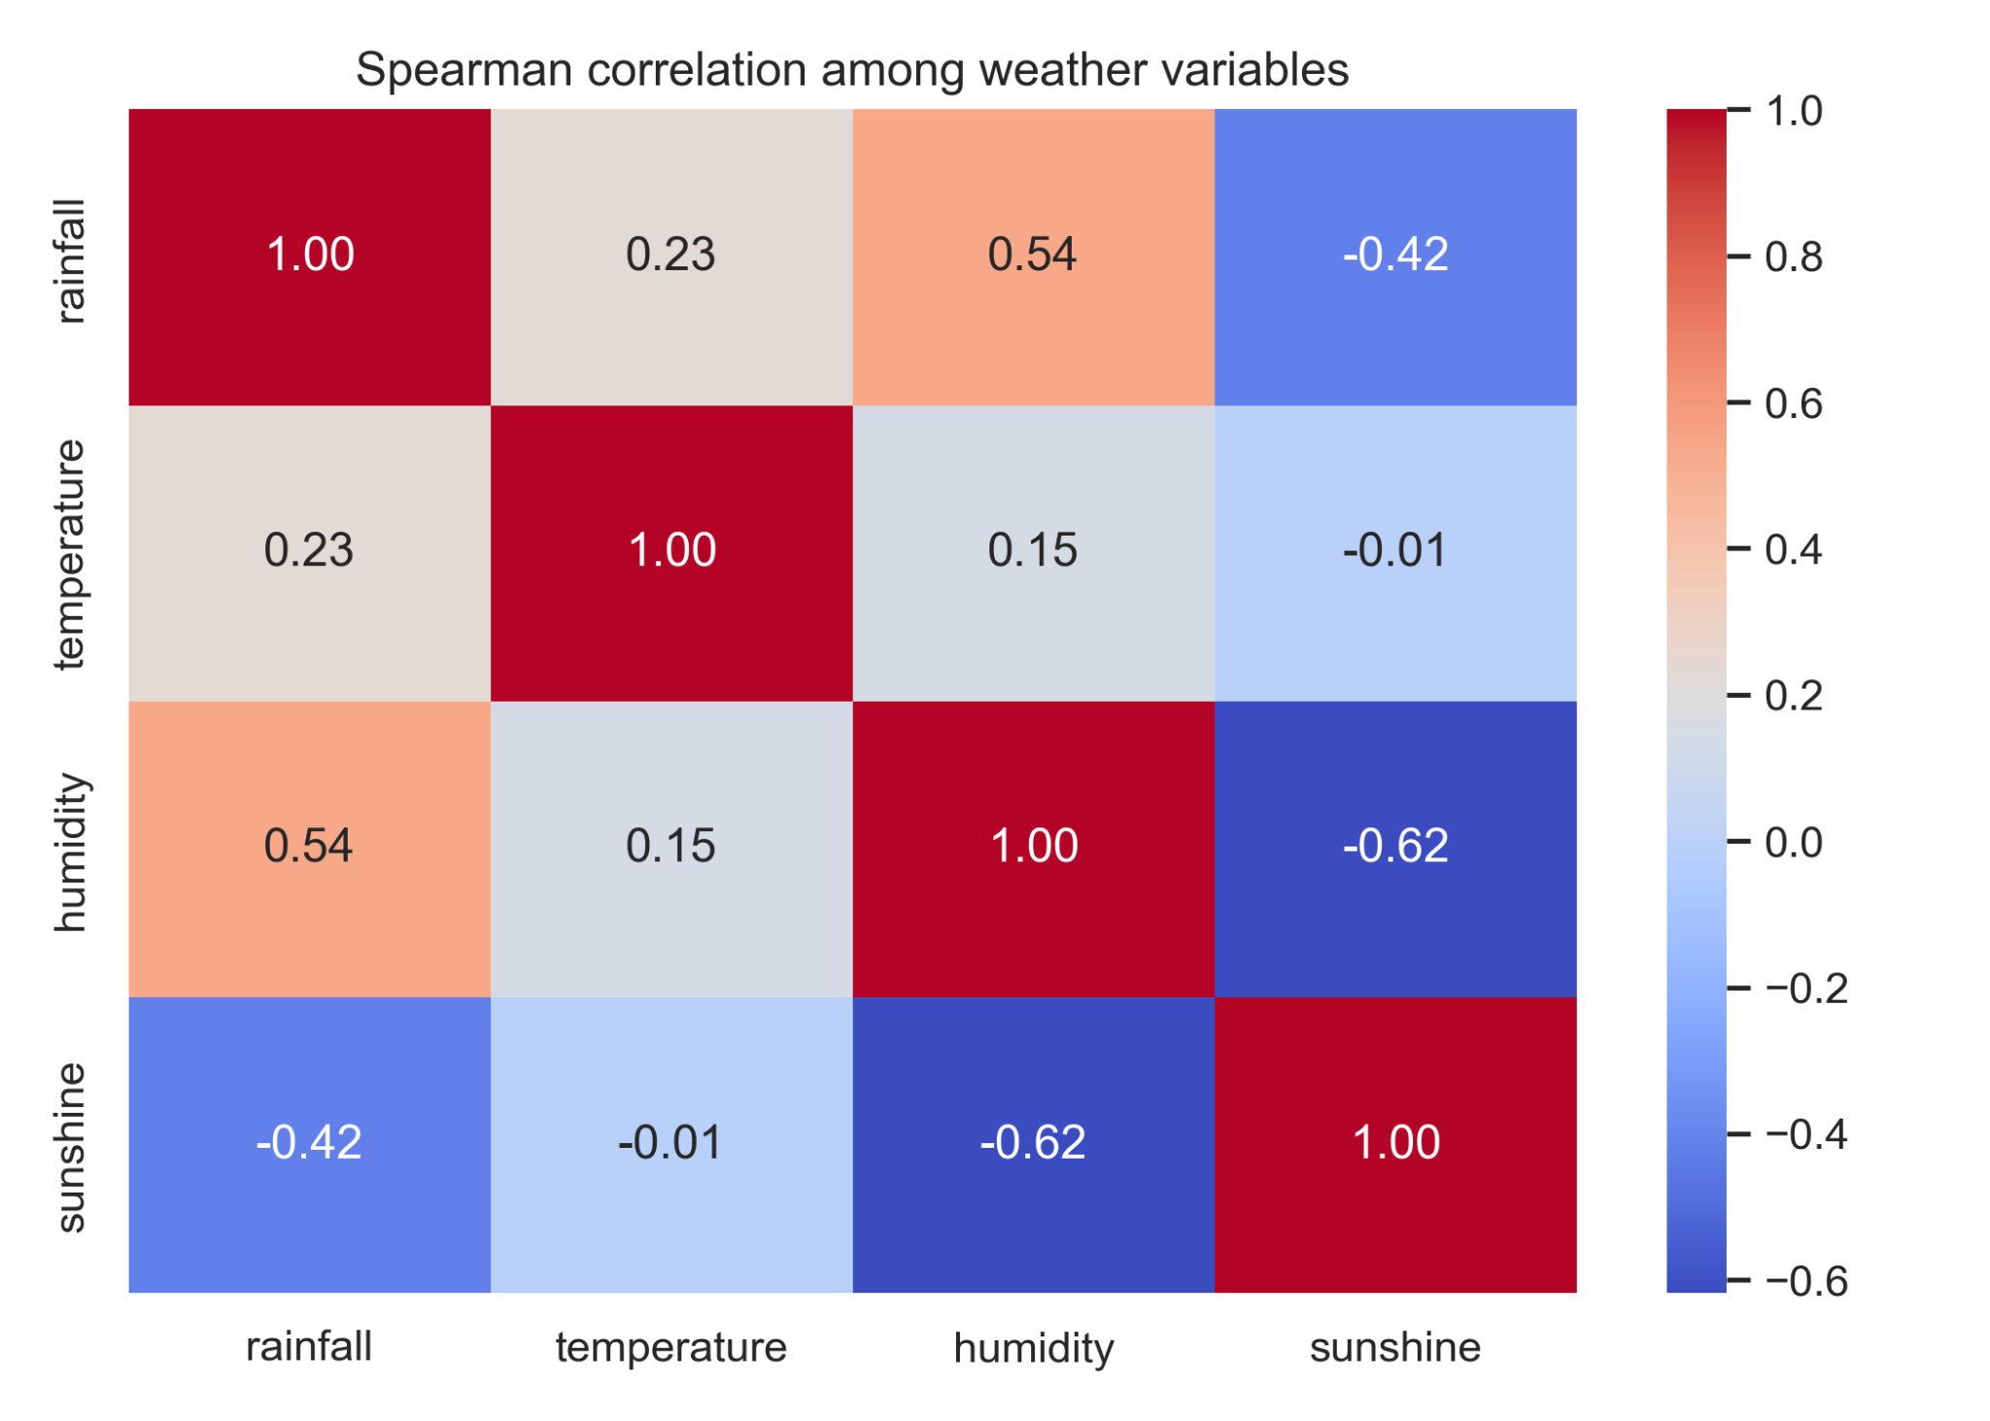
Figure 4.8. Spearman correlation matrix among rainfall, temperature, humidity, and sunshine.
The Augmented Dickey–Fuller results for the monthly Dhaka series are reported in Table 4.6. Rainfall, temperature, and humidity returned p-values below 0.05 and were therefore stationary at the 5% level in the monthly representation used here, whereas sunshine remained non-stationary. This mixed outcome is noteworthy. It shows that aggregation alone does not make all weather variables statistically equivalent. Instead, the need for transformation or specialized modeling may remain variable-specific. This interpretation is consistent with the broader time-series logic emphasized in Zubair et al. (2024b), where model configuration and preprocessing choices were tuned specifically to the weather variable set under analysis.

Table 4.5. Augmented Dickey–Fuller test results for the monthly Dhaka series.
Station | Variable | ADF statistic | p-value | Observations | Stationary at 5%
Dhaka | Rainfall | -6.687 | 4.201e-09 | 738 | Yes
Dhaka | Temperature | -3.237 | 0.01793 | 735 | Yes
Dhaka | Humidity | -3.295 | 0.01509 | 740 | Yes
Dhaka | Sunshine | -1.971 | 0.2993 | 742 | No

4.6 National annual variability and long-term trends
The annual national means, summarized in Table 4.6 and Figures 4.9–4.13, reveal four distinct long-term signals. These annual means were computed from the available station records in each year and should therefore be interpreted with awareness that network coverage changes across time. Within that coverage-aware framework, rainfall had the greatest year-to-year volatility, with a mean annual value of 2519.11 mm, a minimum of 1865.23 mm in 1979, and a maximum of 3091.44 mm in 1974. Temperature was much more constrained in range, averaging 25.48°C and varying from 24.89°C in 1965 to 26.23°C in 2023. Humidity averaged 79.31% and reached its maximum annual mean in 1998, while sunshine averaged 2394.64 hours and showed a clear long-term decline from the 1970s to the 2010s.
Table 4.6. National annual summary statistics and linear trend estimates.
Variable | Overall mean | Minimum (year) | Maximum (year) | Slope/year | Slope/decade | R² | p-value
Rainfall | 2519.11 | 1865.23 (1979) | 3091.44 (1974) | -6.968 | -69.685 | 0.147 | 0.001926
Temperature | 25.48 | 24.89 (1965) | 26.23 (2023) | 0.01 | 0.105 | 0.384 | 6.069e-08
Humidity | 79.31 | 75.21 (1979) | 82.07 (1998) | 0.046 | 0.464 | 0.337 | 6.237e-07
Sunshine | 2394.64 | 1987.21 (2015) | 2960.35 (1976) | -10.413 | -104.131 | 0.688 | 4.505e-17
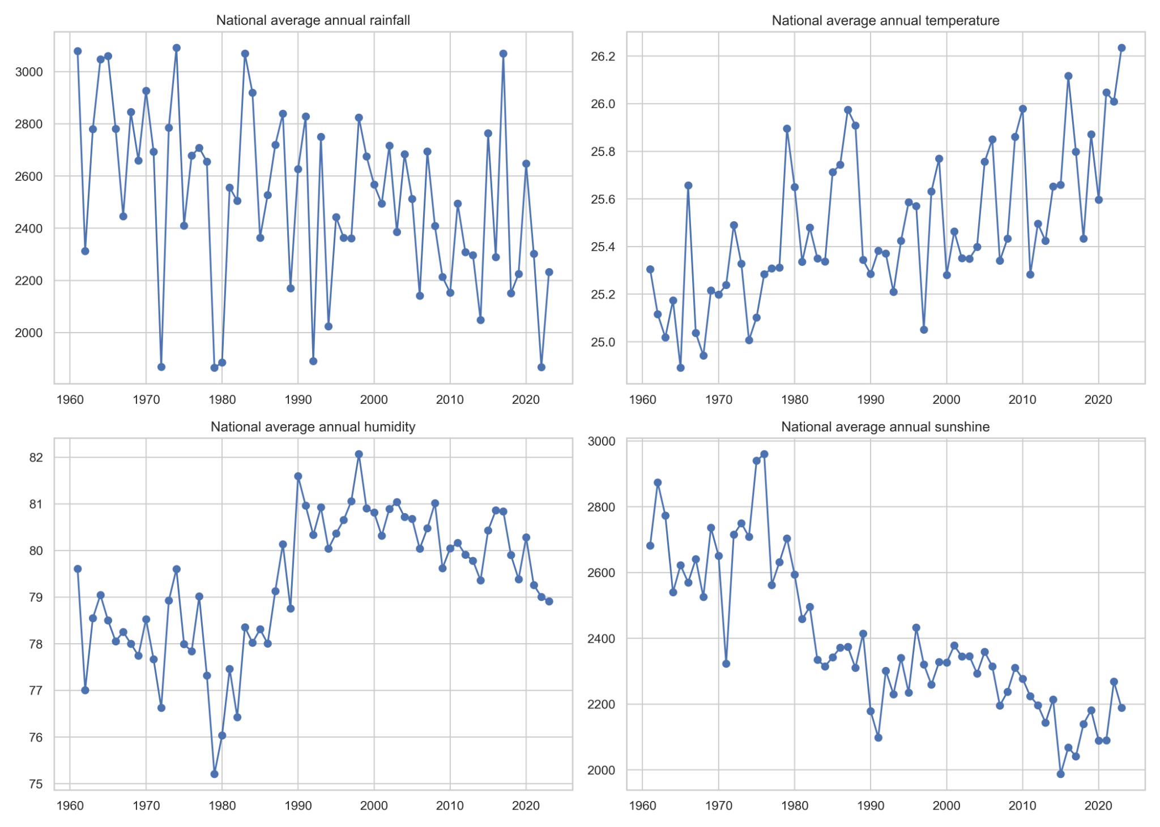
Figure 4.9. National annual means of rainfall, temperature, humidity, and sunshine.
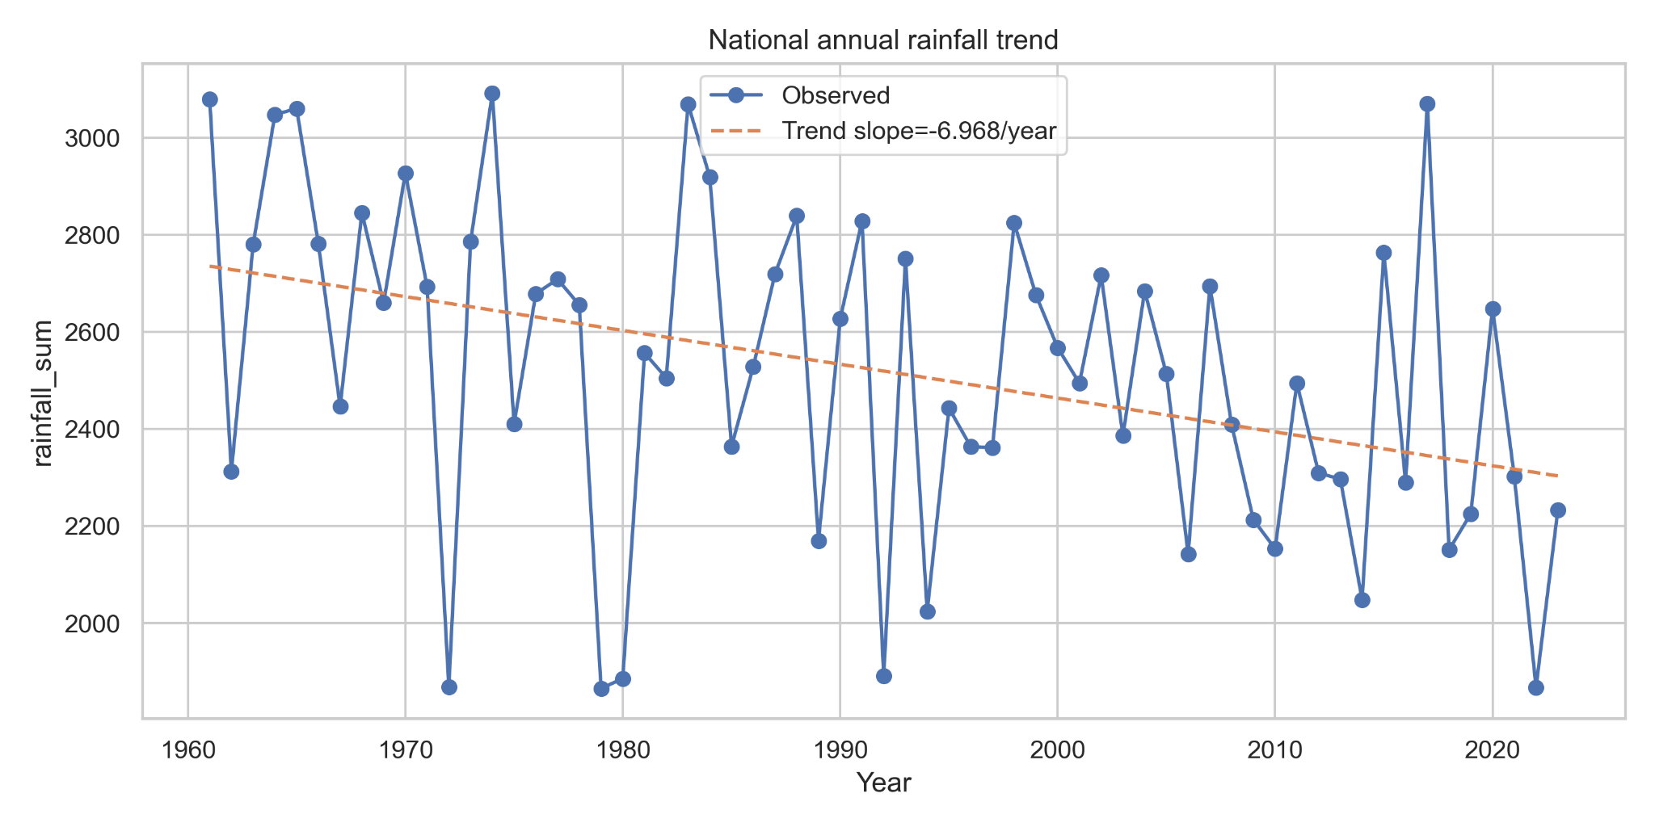
Figure 4.10. National annual rainfall trend with fitted linear slope.
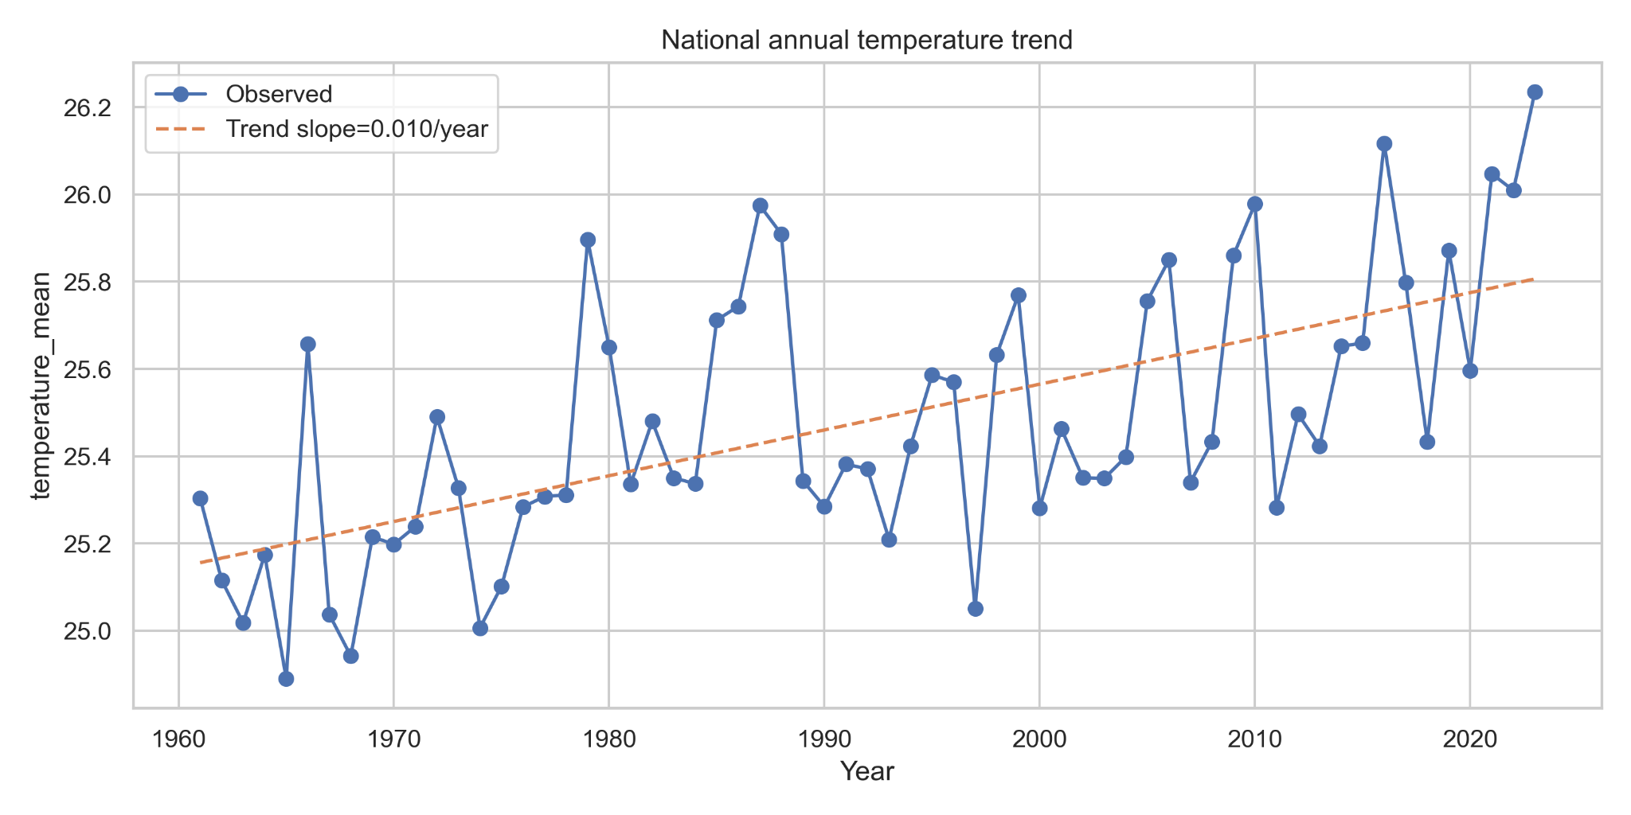
Figure 4.11. National annual temperature trend with fitted linear slope.
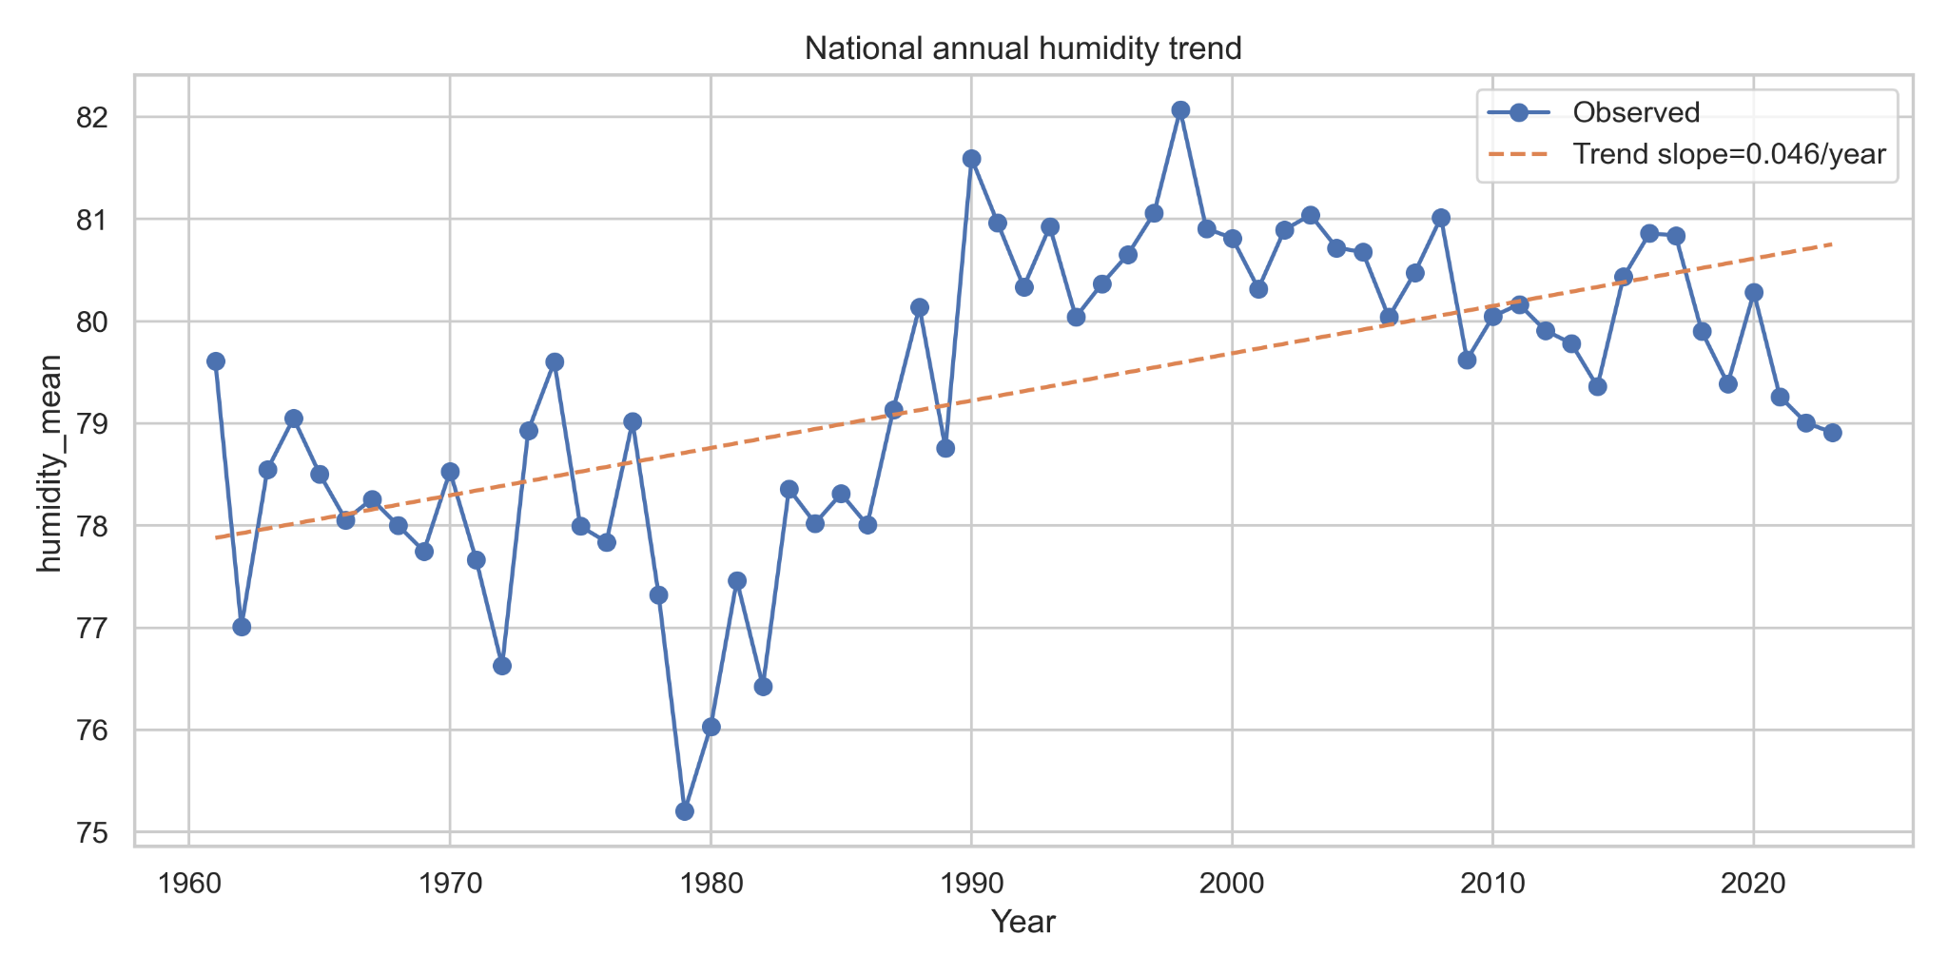
Figure 4.12. National annual humidity trend with fitted linear slope.
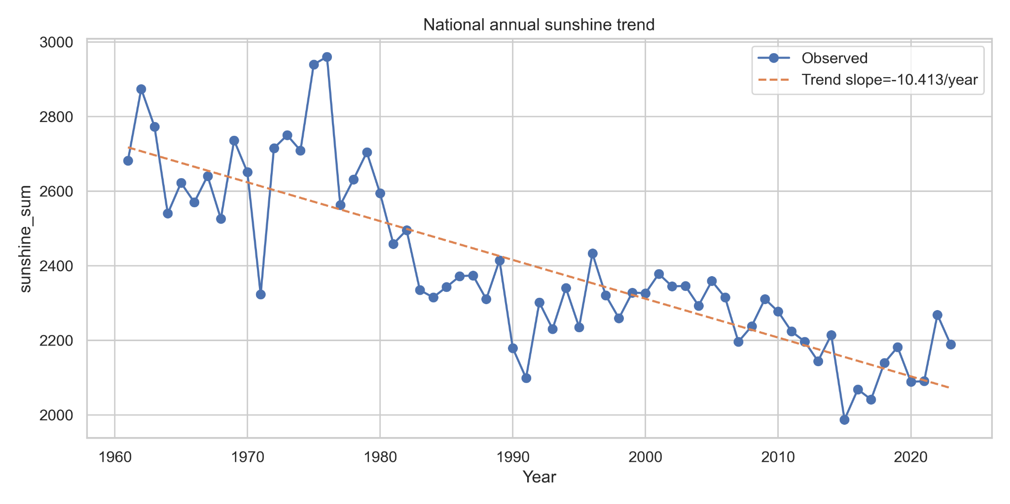
Figure 4.13. National annual sunshine trend with fitted linear slope.
The fitted trends indicate declining annual rainfall, increasing temperature, increasing humidity, and declining sunshine. Specifically, the slope estimates were -6.968 mm/year for rainfall, +0.010°C/year for temperature, +0.046 percentage points/year for humidity, and -10.413 h/year for sunshine. Within the available-stations aggregation used here, these signs suggest that Bangladesh has become modestly warmer and more humid over time, while annual rainfall totals and sunshine duration have declined. The pattern does not imply a simple one-directional intensification of all wetness indicators. Rather, it points to a more complex climatic reorganization in which atmospheric moisture appears to have increased even as sunshine and total rainfall trended downward. This type of complexity is one reason why flexible forecasting approaches have become attractive in Bangladesh weather research.

4.7 Station-wise trend heterogeneity
Station-wise trend summaries are presented in Table 4.7. Rainfall trends were predominantly negative, with 26 stations showing decreasing slopes and only 9 showing increasing slopes; however, only 7 rainfall trends were significant at the 5% level. Temperature showed the clearest broad-based warming pattern, increasing in 28 stations with 25 significant station-level trends. Humidity was more mixed, with 20 increasing and 15 decreasing stations, although 23 of those trends were statistically significant. Sunshine displayed the strongest spatial consistency in decline, with 30 stations showing decreasing trends and 29 of them significant.
The strongest positive rainfall trend occurred at Hatiya (+242.439 mm/decade), whereas the strongest significant negative rainfall trend occurred at Chuadanga (-174.946 mm/decade). For temperature, Sydpur showed the strongest warming (+0.370°C/decade), while Madaripur showed the strongest significant cooling (-0.325°C/decade). Humidity increased most rapidly in Madaripur and Mymensingh, while Rangamati showed the strongest decline. In sunshine, Patuakhali recorded the strongest positive slope, but Ambaganctg and Mongla recorded the steepest decreases. This station-level contrast is critical for interpretation: it shows that national annual trends summarize the system, but local climatic responses remain uneven. This strengthens the rationale for pooled models that still retain station identity as an input feature, as later demonstrated in the forecasting chapter.
Table 4.7. Summary of station-wise trend directions and strongest slopes.
Variable | Increasing stations | Decreasing stations | Significant stations (5%) | Strongest increase | Strongest decrease
Rainfall | 9 | 26 | 7 | Hatiya (242.439) | Sydpur (-202.583)
Temperature | 28 | 7 | 25 | Sydpur (0.370) | Madaripur (-0.325)
Humidity | 20 | 15 | 23 | Madaripur (1.973) | Rangamati (-1.383)
Sunshine | 5 | 30 | 29 | Patuakhali (105.657) | Ambaganctg (-214.882)

4.8 Seasonal long-term behavior
The seasonal trend decomposition in Figure 4.14 shows that the long-term changes observed in annual means are not uniformly distributed throughout the year. Monsoon rainfall remained much higher than rainfall in the other seasons and also displayed the greatest interannual variability. Pre-monsoon and post-monsoon rainfall fluctuated at lower magnitudes, while winter rainfall remained consistently low. Temperature increased across all seasons, but the highest seasonal values remained concentrated in monsoon and pre-monsoon. Humidity remained highest during monsoon, while sunshine remained lowest during monsoon and trended downward across the seasonal cycle. This indicates that climate change signals in Bangladesh are embedded within the seasonal system rather than operating outside it. In other words, the annual trend is not replacing seasonality; it is modifying the intensity and internal balance of the seasons.
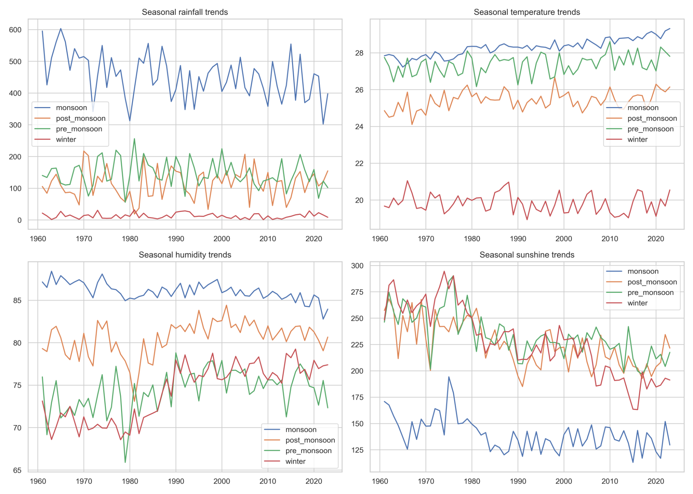
Figure 4.14. Seasonal long-term trends of rainfall, temperature, humidity, and sunshine.

4.9 Extreme-event behavior
Figure 4.15 summarizes the annual evolution of selected extreme-weather indices based on the threshold definitions stated earlier in Chapter 3. Heavy rain days increased from a low of 9.92 in 1980 to a peak of 21.89 in 2017, indicating that intense rainfall events remained active despite the long-term decline in mean annual rainfall. By contrast, very heavy rain days declined from 7.80 in 1961 to 2.46 in 2022, suggesting a reduction in the most severe rainfall class at the national level. Hot days were comparatively rare in the national mean series under the threshold used here, whereas high-humidity days increased from 78.77 in 1979 to 143.42 in 1998. Low-sunshine days also increased substantially, reaching 84.06 in 2015. These results deepen the interpretation of the annual trend analysis by showing that the climate signal is reflected not only in means, but also in the changing frequency of stressful atmospheric states. This is especially relevant in the Bangladeshi context, where weather predictability has direct agricultural, hydrological, and disaster-management implications.
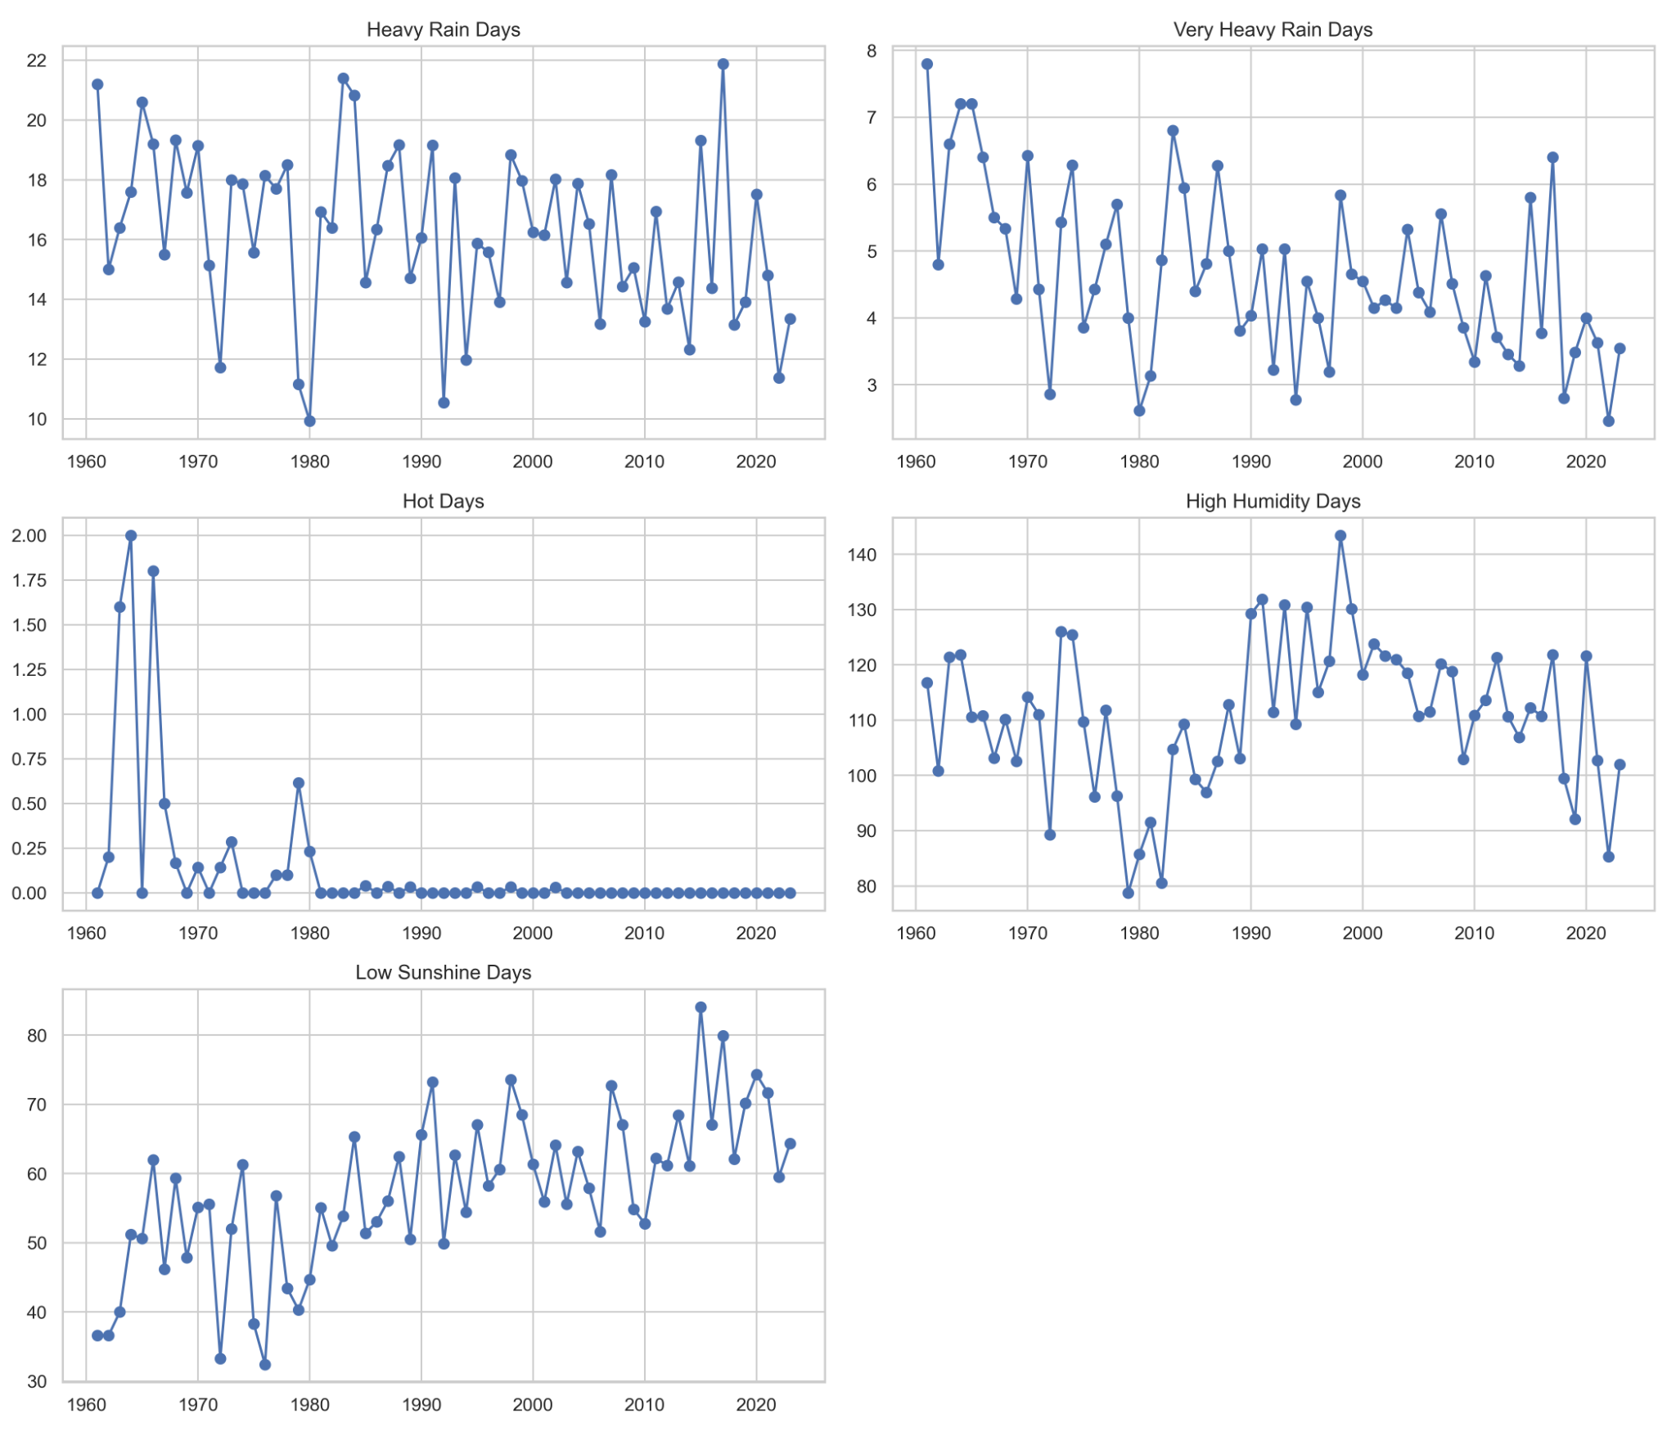
Figure 4.15. National annual trends of heavy rain days, very heavy rain days, hot days, high humidity days, and low sunshine days.

4.10 Chapter summary
The statistical analysis shows that Bangladesh weather exhibits a strong annual cycle, marked station-level heterogeneity, clear inter-variable dependence, and meaningful long-term change. Rainfall emerged as the most irregular variable statistically, with a highly skewed, zero-dominated, and seasonally concentrated structure. Temperature was the smoothest variable in descriptive terms, while humidity maintained a persistently high range and sunshine showed a clear declining tendency. The national and station-wise trend analyses further showed that climate signals are not spatially uniform, and the seasonal decomposition suggested that these changes operate through the monsoon system rather than in isolation. Together, these findings justify the predictive strategy adopted in Chapter 5, where forecasting performance is examined through pooled next-day multi-output regression, rainfall occurrence classification, station-specific Bi-LSTM modelling for Dhaka, and monthly SARIMA versus XGBoost comparison for Dhaka in order to assess how model suitability changes across variables, stations, and temporal scales.
CHAPTER 5

RESULTS OF FORECASTING AND MACHINE LEARNING ANALYSIS
This chapter presents the results of the forecasting and machine-learning stage of the study. It extends the statistical findings reported in Chapter 4 by evaluating the predictive performance of multiple models for rainfall, temperature, humidity, and sunshine under different forecasting formulations. In keeping with the methodological design set out earlier in the thesis, the chapter is organized around four complementary components: pooled next-day multi-output regression across stations, rainfall occurrence classification, station-specific sequence modelling through a Bi-LSTM model for Dhaka, and a monthly SARIMA versus XGBoost comparison for Dhaka. The results are interpreted not only in terms of numerical performance but also in relation to the statistical behaviour of the target variables, the spatial structure of the dataset, and the broader aims of the study.
The reporting framework follows a progression from simpler reference models to more specialized forecasting settings. Persistence and 7-day rolling-mean forecasts are used as baseline comparators for the pooled daily regression task, while Random Forest, ElasticNet, and XGBoost represent increasingly flexible tabular learning approaches. Rainfall occurrence is evaluated separately because the distinction between rainy and non-rainy days is analytically different from predicting rainfall amount. The Bi-LSTM section then examines whether station-specific sequence learning can recover useful predictive structure for a representative station, while the monthly SARIMA versus XGBoost comparison assesses how model suitability changes when forecasting is shifted from the daily pooled scale to a lower-frequency station-specific time-series setting. Throughout the chapter, emphasis is placed on interpretation of MAE, RMSE, R², SMAPE, confusion patterns, and feature contributions so that the results remain statistically meaningful, climatologically interpretable, and consistent with the thesis objectives.

5.1 Forecasting design and evaluation framework
The forecasting stage of the study was designed to examine model performance under four related but analytically distinct settings: pooled next-day multi-output regression across stations, rainfall occurrence classification, station-specific Bi-LSTM forecasting for Dhaka, and monthly SARIMA versus XGBoost comparison for Dhaka. This structure was adopted because the forecasting tasks do not represent the same statistical problem. The pooled daily models were intended to identify shared predictive structure across the national station network, the rainfall occurrence model isolated the binary event component of rainfall, the Dhaka Bi-LSTM experiment evaluated local sequential dependence in a single-station setting, and the monthly SARIMA versus XGBoost comparison examined whether model suitability changes when the forecasting scale moves from daily pooled prediction to lower-frequency station-specific time-series forecasting. This design is consistent with the objectives and research questions stated earlier in the thesis, especially the need to compare forecasting models across variable type, modelling framework, and temporal aggregation.
For the pooled daily forecasting task, the analysis focused on next-day prediction of rainfall, temperature, humidity, and sunshine. A chronological split was used so that the training period ended before 2018, the validation period covered 2018 to 2020, and the test period covered 2021 onward. After filtering to retain stations with sufficient data across all three splits, the pooled daily design contained 466,104 training records, 38,360 validation records, and 38,290 test records. This chronological design preserves the forecasting direction of time and avoids information leakage from future observations into model training. The pooled modelling framework also included station identity so that the models could learn national structure while still retaining local station context. Within this setting, persistence and 7-day rolling-mean models served as baseline comparators, while Random Forest, ElasticNet, and XGBoost represented progressively more flexible tabular learning approaches. A separate Random Forest classifier was then used for rainfall occurrence prediction, since the distinction between rainy and non-rainy days is analytically different from prediction of rainfall amount.
The station-specific Bi-LSTM experiment was conducted only for Dhaka and should therefore be interpreted as a complementary local sequence-modelling exercise rather than as a direct one-to-one replacement for the pooled national models. The monthly SARIMA versus XGBoost comparison was also restricted to Dhaka and to monthly rainfall and temperature, using the final monthly model configurations selected during development and evaluated on the reserved monthly holdout segment of the Dhaka series. In that monthly setting, SARIMA represented the classical seasonal time-series benchmark, whereas XGBoost served as the nonlinear machine-learning comparator applied to the same station-specific monthly forecasting problem. Accordingly, the forecasting chapter is comparative in a layered sense: it compares models within the same task, and it also compares how forecasting conclusions change when the task itself is reformulated.
The evaluation metrics were selected according to task type. For regression, MAE, RMSE, R², and SMAPE were used to assess average error magnitude, sensitivity to larger deviations, explanatory power, and percentage-scale deviation. For rainfall occurrence classification, accuracy, precision, recall, F1-score, and ROC-AUC were reported in order to evaluate both overall discrimination and class-specific predictive behaviour. Because rainfall, temperature, humidity, and sunshine differ substantially in statistical structure, the results that follow are interpreted not only in terms of overall numerical performance but also in relation to the descriptive findings reported in Chapter 4.

Table 5.0. Summary of forecasting experiments reported in Chapter 5.
Component | Scope | Target(s) | Time scale | Models / evaluation
Pooled regression | All eligible stations | Rainfall, temperature, humidity, sunshine | Daily, next-day | Persistence, 7-day rolling mean, Random Forest, ElasticNet, XGBoost; evaluated with MAE, RMSE, R², and SMAPE
Rainfall occurrence classification | All eligible stations | Rain / no rain | Daily, next-day | Random Forest classifier; evaluated with accuracy, precision, recall, F1-score, and ROC-AUC
Feature-importance analysis | All eligible stations | Model interpretability | Daily | Relative importance of predictors within the pooled Random Forest model, used for interpretability after the pooled performance comparison
Station-specific sequence modelling | Dhaka only | Rainfall, temperature, humidity, sunshine | Daily, next-day | Bi-LSTM; evaluated with MAE, RMSE, R², and SMAPE
Monthly station-specific comparison | Dhaka only | Monthly rainfall, monthly temperature | Monthly | Final monthly SARIMA and XGBoost configurations for Dhaka; evaluated with MAE, RMSE, R², and SMAPE

5.2 Pooled next-day multi-output regression results
The first empirical forecasting task examined pooled next-day multi-output regression across all eligible stations. This task was intended to test how far predictive performance could be improved beyond simple short-memory baselines when recent lagged behaviour, rolling summaries, seasonal indicators, anomaly terms, and station identity were used within a unified supervised-learning framework. The results are reported first at the model-comparison level and then interpreted by target variable.

5.2.1 Mean absolute error (MAE) comparison
Figure 5.1 presents the MAE comparison for the pooled regression models. The figure shows that rainfall remained the most difficult variable to forecast in terms of absolute error, whereas temperature was the easiest. For rainfall, the MAE declined from 8.295 under Persistence and 7.815 under the 7-day rolling mean to 5.417 for Random Forest and 5.245 for XGBoost. This reduction suggests that rainfall prediction benefited from nonlinear tree-based learning within the present feature framework. In contrast, temperature errors were already low in the baseline stage and fell further to 0.823 under XGBoost, indicating that the next-day temperature signal is comparatively stable and more predictable from recent meteorological history.
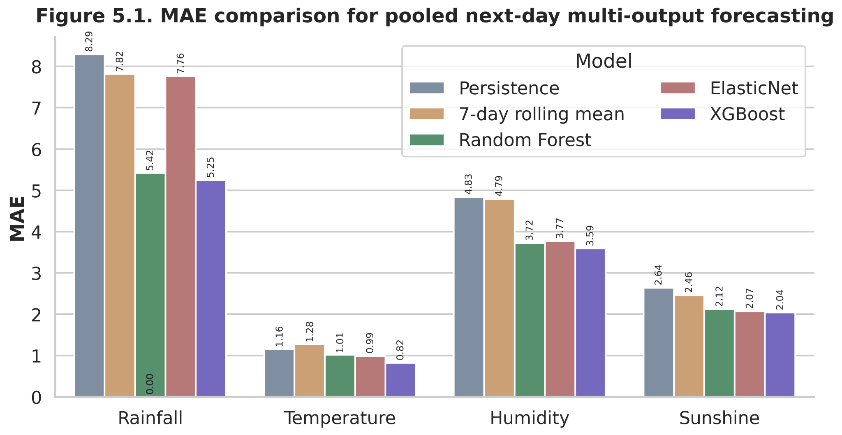
Figure 5.1. MAE comparison for pooled next-day multi-output forecasting.
The same figure also highlights the behaviour of humidity and sunshine. Humidity MAE decreased from 4.833 in the persistence model to 3.592 in XGBoost, while sunshine MAE declined from 2.641 to 2.039. These changes indicate that both variables contain forecastable structure, but their predictability is not equal. Humidity responds strongly to recent atmospheric state and seasonal regime, whereas sunshine appears more vulnerable to short-term cloud dynamics and rainfall-related suppression. ElasticNet remained competitive for temperature, humidity, and sunshine, which suggests that a meaningful linear signal persisted in these variables; however, for rainfall its error remained markedly higher than the tree-based models, indicating that linear regularization alone was not sufficient to represent rainfall intermittency and extreme-value behaviour.

5.2.2 Root mean squared error (RMSE) comparison
RMSE comparisons in Figure 5.2 reinforce the same ranking pattern but place greater weight on larger errors. This is particularly relevant for rainfall because squared error amplifies the effect of high-intensity misses. The best pooled rainfall model, XGBoost, achieved an RMSE of 13.524, compared with 22.399 for Persistence, 18.393 for the rolling mean, 13.751 for Random Forest, and 15.588 for ElasticNet. Relative to Persistence, XGBoost reduced rainfall RMSE by approximately 39.6%, and relative to the rolling baseline it reduced rainfall RMSE by 26.5%. These differences suggest that the boosted-tree model handled the nonlinear and highly skewed rainfall process more effectively than the baseline and linear alternatives under the present design.
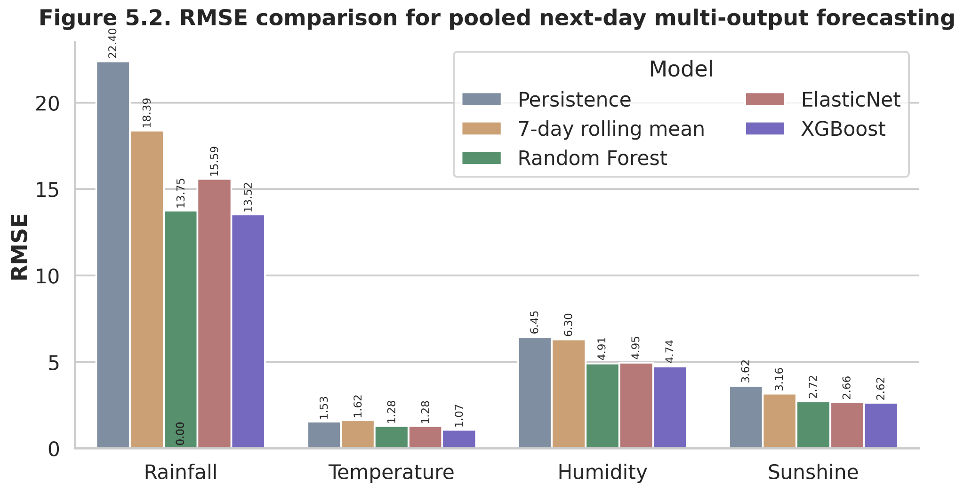
Figure 5.2. RMSE comparison for pooled next-day multi-output forecasting.
For temperature, XGBoost achieved an RMSE of 1.074, which represents about a 30.0% improvement over Persistence and about a 33.7% improvement over the rolling mean. This suggests that even though temperature was already relatively predictable in the baseline stage, machine learning still provided additional improvement. Humidity showed a similar but more moderate pattern, with XGBoost reducing RMSE to 4.741, while sunshine declined to 2.620. Notably, the margin between XGBoost, Random Forest, and ElasticNet for sunshine was relatively narrow, which suggests that sunshine was only moderately forecastable in the pooled setting. In practical terms, this means that the main advantage of the stronger models was not merely average improvement but also better control of larger forecast deviations.
Table 5.1. Pooled next-day multi-output regression performance.
Model | Target | MAE | RMSE | R² | SMAPE
XGBoost | Humidity | 3.592 | 4.741 | 0.697 | 4.641
Random Forest | Humidity | 3.724 | 4.914 | 0.674 | 4.819
ElasticNet | Humidity | 3.769 | 4.952 | 0.669 | 4.873
7-day rolling mean | Humidity | 4.787 | 6.299 | 0.465 | 6.191
Persistence | Humidity | 4.833 | 6.451 | 0.438 | 6.241
XGBoost | Rainfall | 5.245 | 13.524 | 0.429 | 165.057
Random Forest | Rainfall | 5.417 | 13.751 | 0.409 | 165.069
ElasticNet | Rainfall | 7.764 | 15.588 | 0.241 | 167.235
7-day rolling mean | Rainfall | 7.815 | 18.393 | -0.057 | 95.745
Persistence | Rainfall | 8.295 | 22.399 | -0.567 | 67.436
XGBoost | Sunshine | 2.039 | 2.62 | 0.353 | 50.754
ElasticNet | Sunshine | 2.072 | 2.664 | 0.332 | 50.839
Random Forest | Sunshine | 2.121 | 2.719 | 0.304 | 50.916
7-day rolling mean | Sunshine | 2.46 | 3.156 | 0.062 | 56.76
Persistence | Sunshine | 2.641 | 3.621 | -0.235 | 64.865
XGBoost | Temperature | 0.823 | 1.074 | 0.935 | 3.249
ElasticNet | Temperature | 0.991 | 1.28 | 0.907 | 3.976
Random Forest | Temperature | 1.014 | 1.283 | 0.907 | 4.025
Persistence | Temperature | 1.162 | 1.534 | 0.867 | 4.636
7-day rolling mean | Temperature | 1.277 | 1.621 | 0.851 | 5.127

5.2.3 Explanatory power of the models
The R² comparison in Figure 5.3 provides a compact summary of model fit quality. Temperature recorded the highest R² values across all models, ranging from 0.851 for the rolling mean to 0.935 for XGBoost, which indicates that a large share of next-day temperature variance was captured by the modeled predictors. Humidity occupied the middle range, with R² increasing from 0.438 in Persistence to 0.697 in XGBoost. Rainfall and sunshine were distinctly harder to model, improving from negative baseline R² values to 0.429 and 0.353 respectively under XGBoost. The negative baseline R² values for rainfall and sunshine are particularly informative because they show that simple carry-forward logic performed worse than a mean-reference benchmark for those variables.
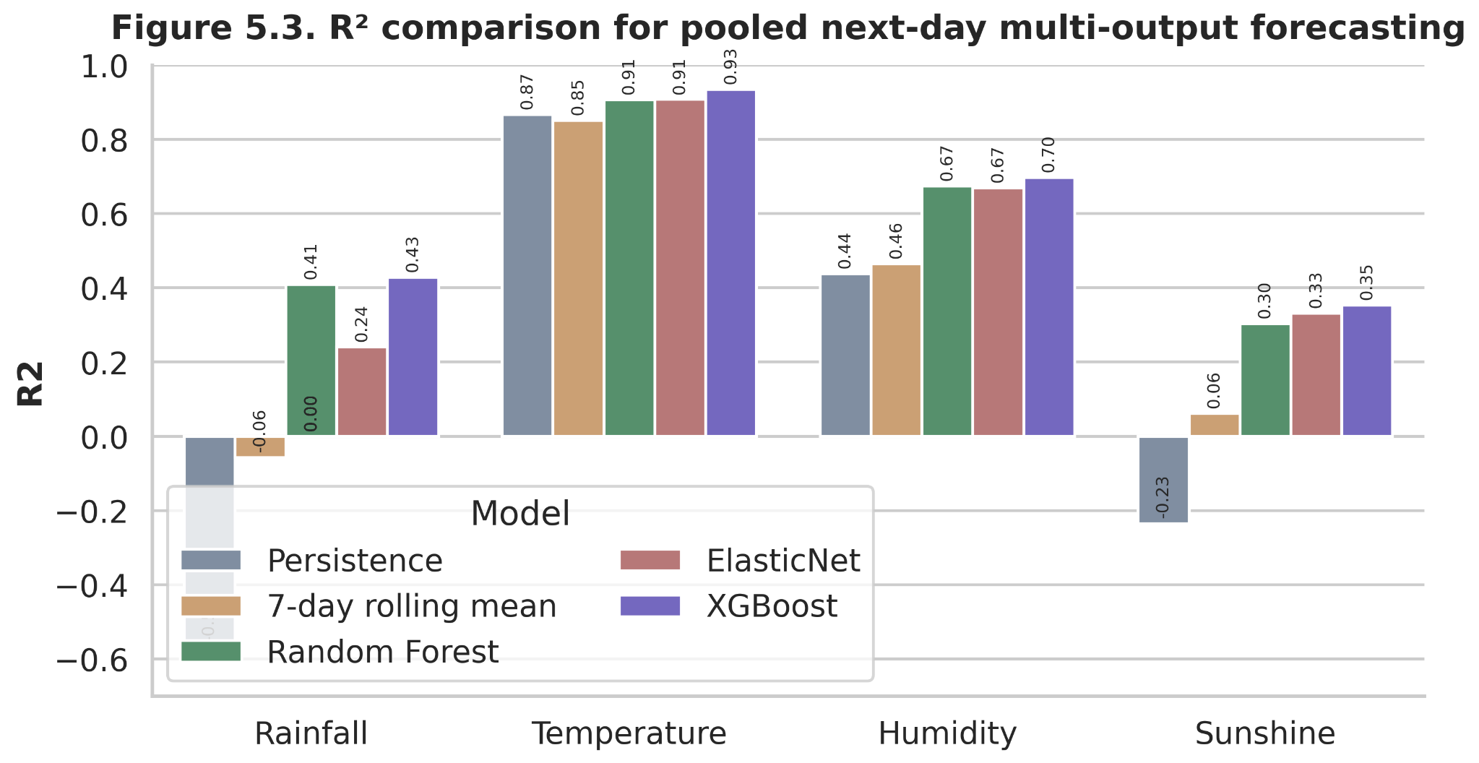
Figure 5.3. R² comparison for pooled next-day multi-output forecasting.
The R² pattern has important interpretive value. First, it shows that weather variables in Bangladesh are not equally predictable at the daily horizon. Second, it indicates that the major distinction among models lies not in temperature—where even simple models already perform strongly—but in variables with higher intermittency or atmospheric complexity, especially rainfall and sunshine. Third, it supports the broader methodological point that model choice matters most when the target variable is nonlinear, noisy, and strongly regime-dependent. The pooled regression results therefore rank the models and also provide a comparative indication of forecasting difficulty across the meteorological variables.

5.2.4 Heatmap synthesis and best pooled model by target
Figure 5.4 condenses the pooled model comparison into heatmap form and makes the ranking pattern immediately visible. The RMSE heatmap shows the lowest error concentration in the XGBoost row across all four targets, while the R² heatmap shows the strongest explanatory power in that same model. Table 5.2 and Figure 5.10 summarize the same result by identifying the best pooled model for each target on the basis of RMSE. In every case—rainfall, temperature, humidity, and sunshine—the selected model was XGBoost.
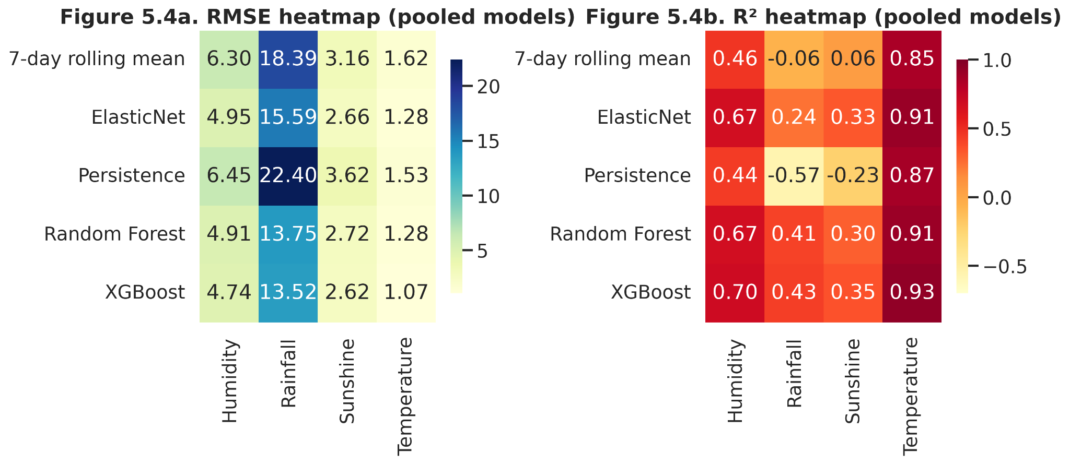
Figure 5.4. RMSE and R² heatmaps for pooled next-day multi-output forecasting.
Under the present pooled forecasting design, XGBoost was the best-performing model across all four targets on the basis of RMSE. For rainfall, its RMSE of 13.524 and R² of 0.429 were slightly better than those of Random Forest and clearly better than those of ElasticNet and the two baselines. For temperature, it achieved the strongest fit in the pooled experiment, with RMSE 1.074 and R² 0.935. For humidity and sunshine it also produced the best overall scores, although the margins over Random Forest and ElasticNet were smaller. This pattern suggests that the boosted-tree framework offered the most effective balance of flexibility and generalization within a dataset defined by lagged predictors, rolling summaries, anomaly terms, seasonal indicators, and station encodings.
Table 5.2. Best pooled model by target based on RMSE.
Target | Model | MAE | RMSE | R² | SMAPE
Humidity | XGBoost | 3.592 | 4.741 | 0.697 | 4.641
Rainfall | XGBoost | 5.245 | 13.524 | 0.429 | 165.057
Sunshine | XGBoost | 2.039 | 2.62 | 0.353 | 50.754
Temperature | XGBoost | 0.823 | 1.074 | 0.935 | 3.249

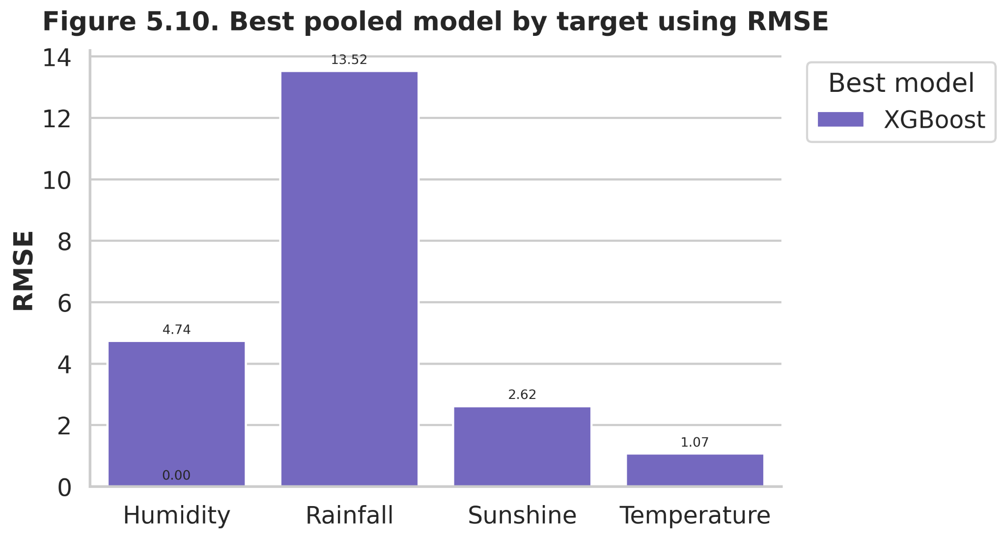
Figure 5.10. Best pooled model by target using RMSE.

5.3 Interpretation by target variable

5.3.1 Rainfall forecasting
Rainfall emerged as the most challenging regression target throughout the pooled experiment. Although XGBoost reduced MAE to 5.245 and RMSE to 13.524, the corresponding R² of 0.429 indicates only moderate explanatory power. This result is still informative in the context of daily rainfall forecasting. A gain from negative baseline R² values to a positive and substantive model fit shows that the learning framework recovered useful structure from a highly irregular signal. The relatively large SMAPE values in Table 5.1 are not surprising for rainfall because the denominator becomes unstable when many observations are near zero. Rainfall may therefore be interpreted as a comparatively difficult target whose forecasting performance improves with nonlinear ensemble methods but remains constrained by intermittency and event intensity.

5.3.2 Temperature forecasting
Temperature was the most predictable variable in the pooled daily setting. Even the baseline models produced strong results, with Persistence already reaching R² = 0.867. The machine-learning models further improved this fit, and XGBoost produced the best pooled performance with MAE 0.823, RMSE 1.074, and R² 0.935. This indicates that next-day temperature in Bangladesh has strong temporal continuity and responds in a comparatively more predictable way to recent lags, short-run moving summaries, and seasonal phase variables. The closeness of ElasticNet and Random Forest to XGBoost further suggests that temperature contains both linear and nonlinear predictability, but with comparatively limited random volatility at the one-day horizon.

5.3.3 Humidity forecasting
Humidity occupied an intermediate position between temperature and rainfall. The best pooled humidity forecast was again achieved by XGBoost, with MAE 3.592, RMSE 4.741, and R² 0.697. These values indicate a stronger predictive structure than that found for rainfall or sunshine, but weaker than that found for temperature. The result is meteorologically plausible. Humidity typically evolves more smoothly than rainfall and is more persistent from day to day, yet it is still influenced by cloud cover, rainfall events, and larger atmospheric conditions. The performance of ElasticNet and Random Forest was also competitive, which suggests that humidity contains both regular temporal continuity and nonlinear interaction effects.

5.3.4 Sunshine forecasting
Sunshine showed moderate but distinctly lower predictability than temperature and humidity. The strongest pooled model, XGBoost, achieved MAE 2.039, RMSE 2.620, and R² 0.353. This performance clearly exceeds the baselines, but it remains more modest than that of temperature and humidity. A plausible explanation is that sunshine responds to transient cloud conditions, rainfall suppression, and other atmospheric dynamics that are only partly captured by the available predictors. Sunshine therefore appears forecastable to a useful extent, but not as strongly as the smoother meteorological variables.

5.4 Rainfall occurrence classification
Rainfall occurrence was modelled separately from rainfall amount because the binary question of whether rain will occur on the next day is analytically different from the continuous question of how much rain will fall. This distinction is especially important in Bangladesh weather data because the descriptive analysis in Chapter 4 showed that rainfall is a zero-dominated variable. The classification results in Table 5.3 and Figures 5.5–5.6 therefore complement, rather than duplicate, the rainfall amount results reported earlier.
Table 5.3. Rainfall occurrence classification performance.
Model | Accuracy | Precision | Recall | F1-score | ROC-AUC
Random Forest classifier | 0.855 | 0.769 | 0.736 | 0.752 | 0.925

The classifier achieved an accuracy of 0.855, precision of 0.769, recall of 0.736, F1-score of 0.752, and ROC-AUC of 0.925. These values indicate that rainy and non-rainy days can be separated with good performance in the pooled framework. The ROC-AUC value is especially informative because it suggests strong overall discrimination across thresholds. The precision–recall balance is also important. Precision below accuracy indicates that some predicted rainy days were false alarms, but recall 0.736 shows that the model still detected a substantial majority of true rainy days. The classification results should not, however, be interpreted as solving the full rainfall problem, because identifying whether rain will occur is analytically different from estimating how much rain will fall.
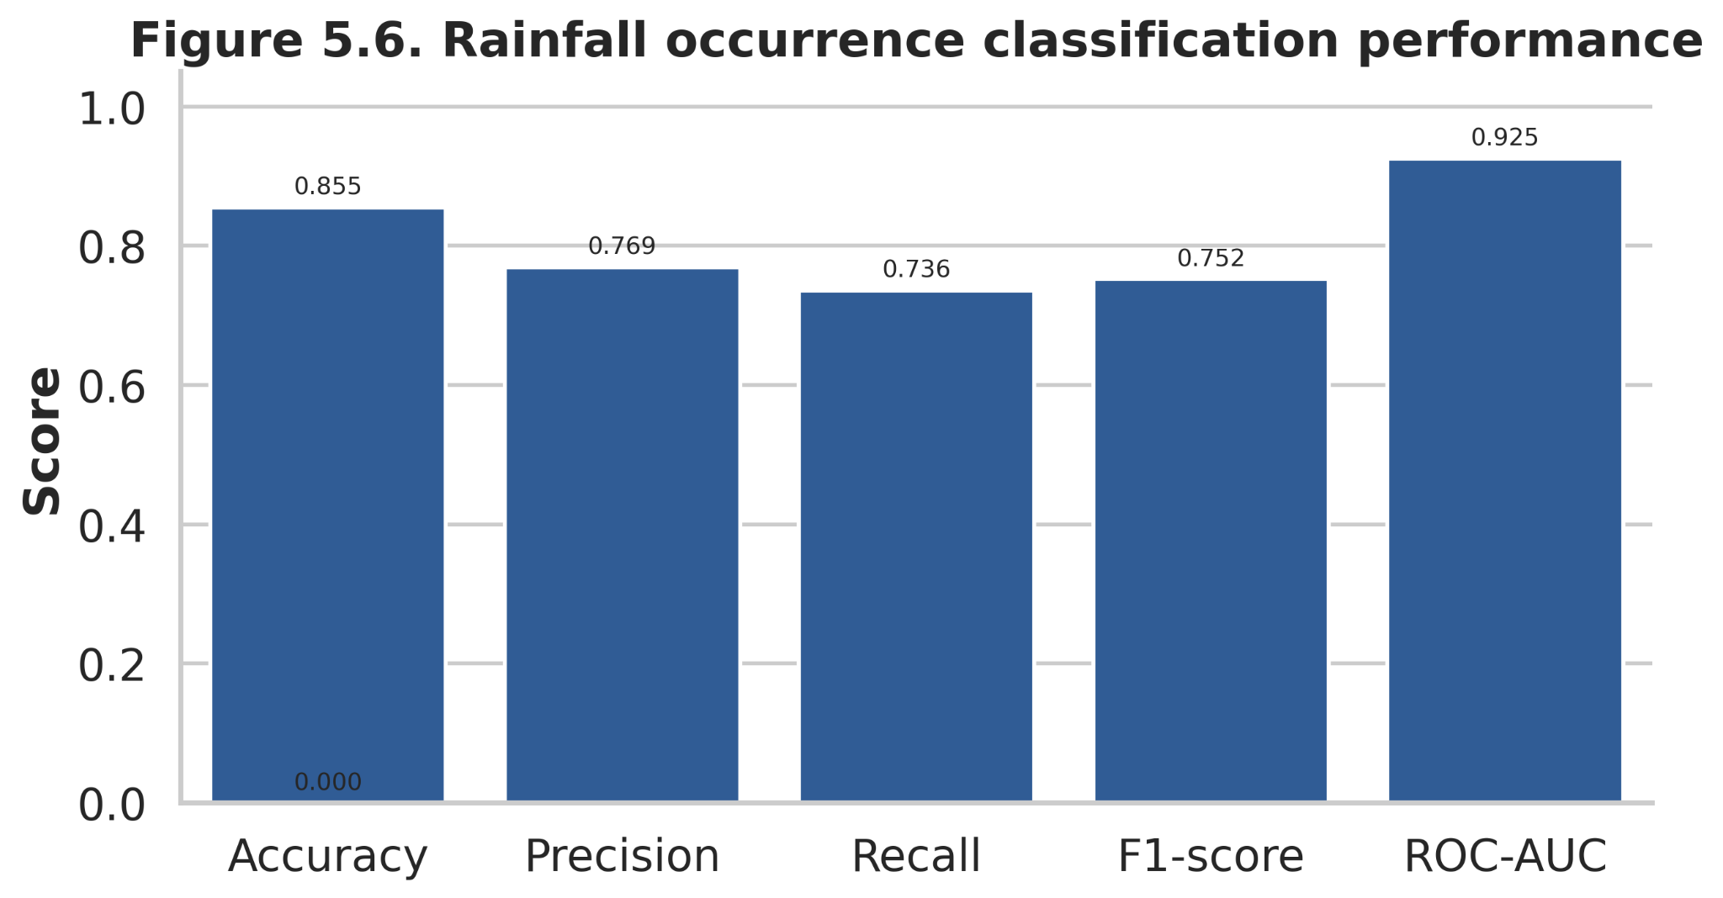
Figure 5.6. Rainfall occurrence classification performance.
The confusion matrix in Figure 5.5 provides a more detailed interpretation. The classifier correctly identified 24,359 no-rain days and 8,394 rainy days, while it misclassified 2,521 dry days as rainy and 3,016 rainy days as dry. Expressed as class-conditional rates, the model correctly recognized about 90.6% of no-rain days and about 73.6% of rainy days. This means the classifier was somewhat stronger at confirming dry conditions than at capturing all rainy events, but its sensitivity remained high enough to be practically useful. From an application standpoint, the remaining false negatives deserve attention because missed rainy days can be operationally costly; however, the classifier still retained a substantial event-detection capacity while avoiding excessive false alarms.
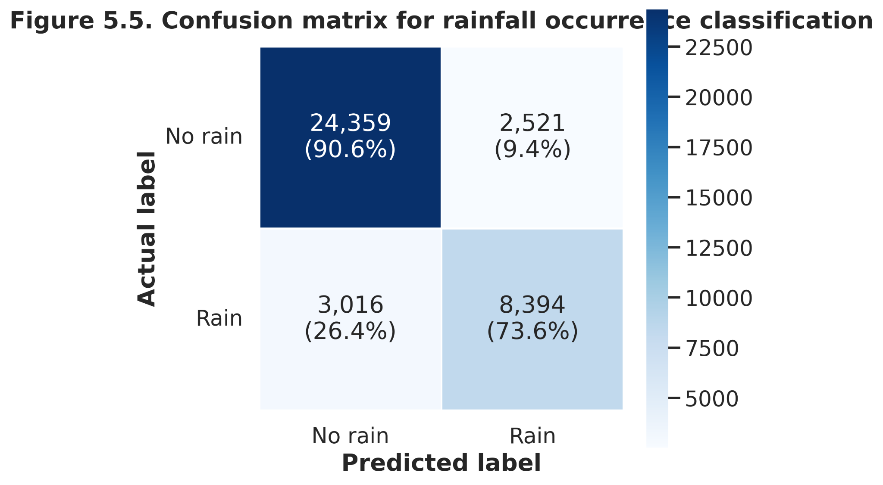
Figure 5.5. Confusion matrix for rainfall occurrence classification.

5.5 Feature-importance analysis in the pooled Random Forest model
Once the comparative performance of the pooled models had been established, the next step was to examine which predictors were driving that performance. For interpretive clarity, feature importance is reported from the pooled Random Forest model rather than from XGBoost, because the Random Forest framework provides a more straightforward tree-based importance summary while the overall performance ranking remains based on the full pooled model comparison. Figure 5.7 ranks the top fifteen input features according to their contribution in the pooled Random Forest model. The most important feature was humidity anomaly, followed by monsoon indicator, station temperature climatology, lagged humidity, and sunshine anomaly. Other influential predictors included rainfall anomaly, station humidity climatology, recent rolling humidity summaries, and seasonal encodings. This ranking indicates that pooled weather prediction in Bangladesh does not depend on a single dominant predictor. Rather, the forecasting system draws on a mixture of short-term meteorological memory, local climatic context, and seasonal regime.
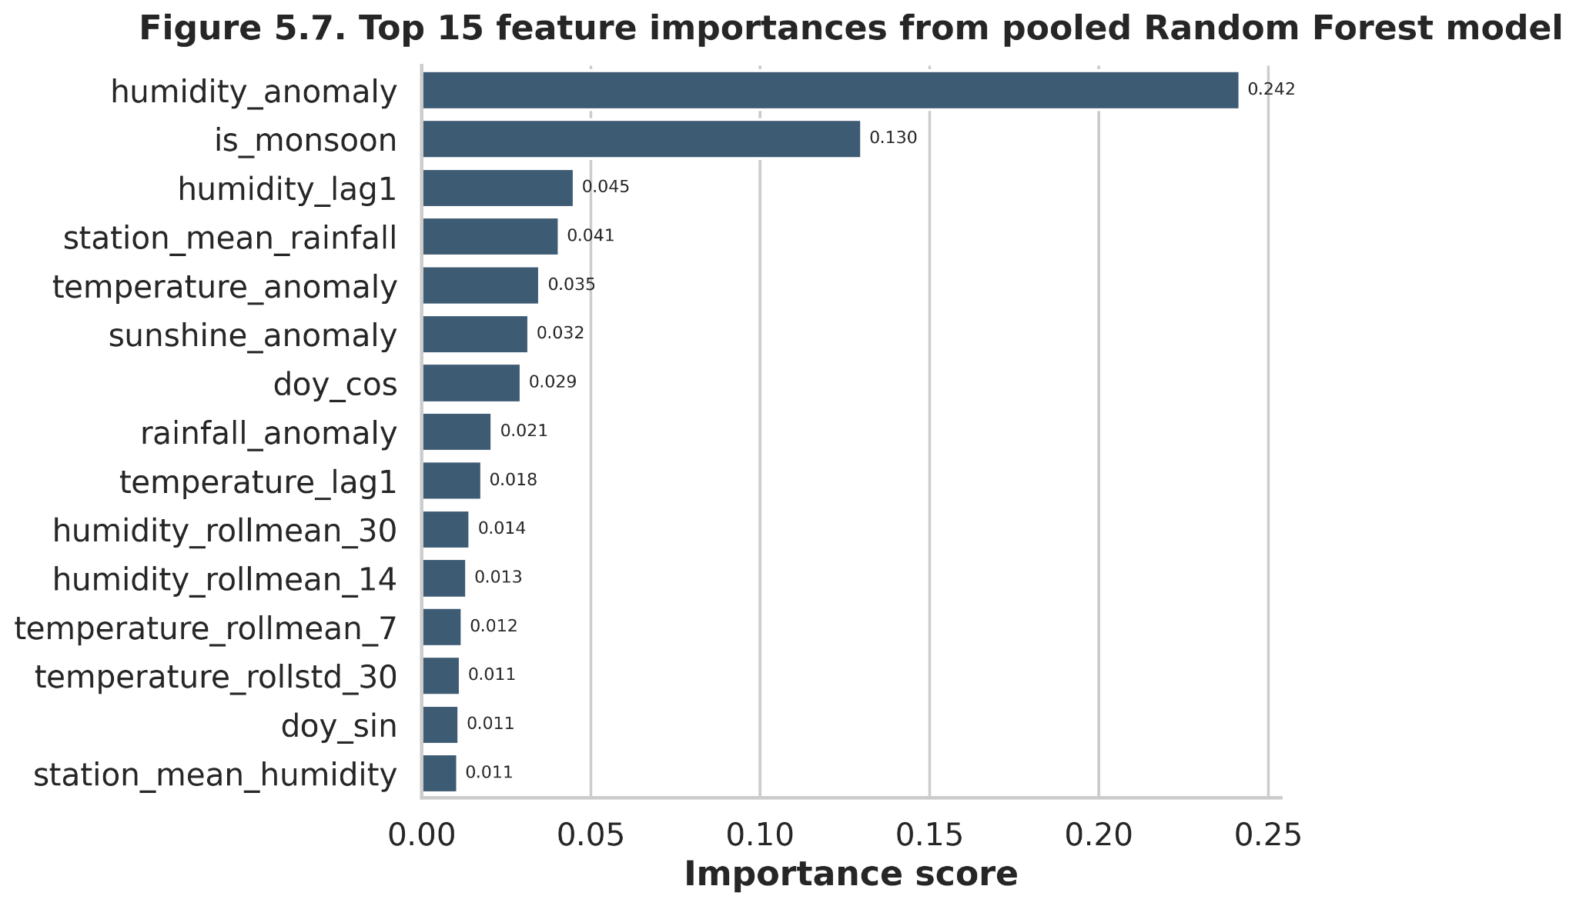
Figure 5.7. Top fifteen feature importances from the pooled Random Forest model.
The prominence of humidity anomaly suggests that short-term departures from expected atmospheric moisture conditions were especially informative for forecasting the next day’s weather profile. The importance of the monsoon indicator indicates that broad seasonal regime remains central even in short-horizon prediction. Station climatology variables are also highly ranked, which is consistent with the strong spatial heterogeneity documented in Chapter 4. Together, these patterns suggest that the best pooled forecasts are obtained when recent weather history is interpreted relative to both the current season and the local climatic identity of the station.

5.6 Station-specific Bi-LSTM forecasting for Dhaka
The pooled models examined national predictive structure by learning from all eligible stations jointly, but that approach does not fully address whether a sequence model can recover additional predictive structure when temporal dependence is learned directly within a single-station setting. To explore that question, the analysis next turns to Dhaka as a representative and data-rich station and evaluates a Bi-LSTM model trained only on Dhaka observations. This experiment should be interpreted as a focused station-specific extension rather than as a direct substitute for the pooled national models. The results, reported in Table 5.4 and Figure 5.9, show that the Dhaka Bi-LSTM performed particularly well for temperature and humidity, moderately for rainfall, and least well for sunshine.

Table 5.4. Station-specific Bi-LSTM performance for Dhaka.
Model | Target | MAE | RMSE | R² | SMAPE
Bi-LSTM (Dhaka) | Rainfall | 3.997 | 12.738 | 0.323 | 175.131
Bi-LSTM (Dhaka) | Temperature | 0.88 | 1.178 | 0.916 | 3.349
Bi-LSTM (Dhaka) | Humidity | 4.794 | 6.203 | 0.696 | 6.925
Bi-LSTM (Dhaka) | Sunshine | 1.831 | 2.478 | 0.194 | 49.241

The Bi-LSTM results show the same broad variable-specific hierarchy observed in the pooled models, although under a different modelling architecture. Temperature achieved MAE 0.880, RMSE 1.178, and R² 0.916, while humidity recorded MAE 4.794, RMSE 6.203, and R² 0.696. Rainfall achieved a lower MAE (3.997) than in the pooled XGBoost setting, but R² remained 0.323, indicating continued difficulty in explaining daily rainfall variability. Sunshine showed the weakest Bi-LSTM performance, with R² 0.194, despite having a lower absolute RMSE than rainfall. This pattern suggests that the sequence model captured smoother station-level dynamics more effectively than variables with stronger intermittency or cloud-driven volatility.
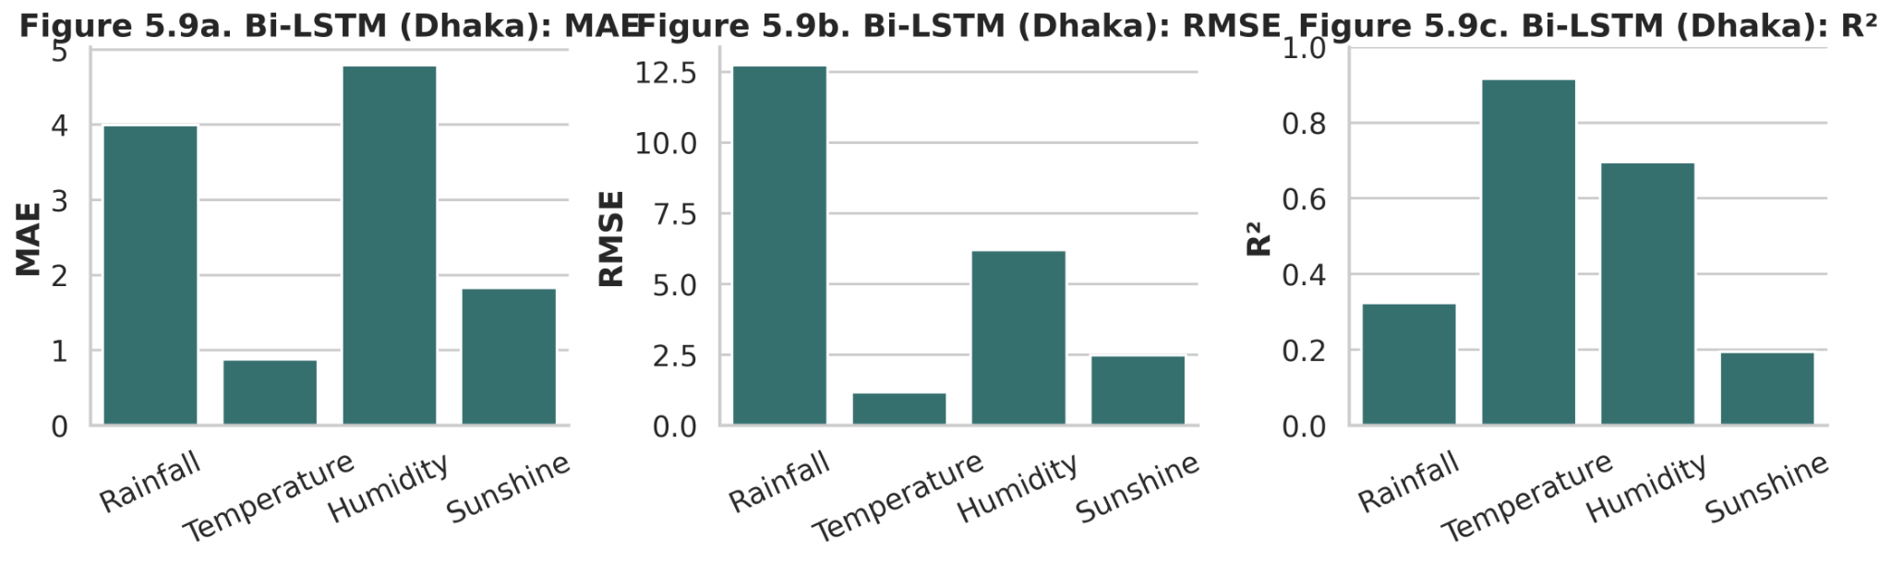
Figure 5.9. Bi-LSTM performance for Dhaka across MAE, RMSE, and R².
The Dhaka Bi-LSTM should be interpreted as a complementary result rather than as a direct replacement for the pooled regression models. It uses only one station and therefore serves a different analytical purpose. Its main value lies in showing that sequence learning can be effective for smoother variables at station level while still leaving more difficult variables such as rainfall only partially explained. This finding is methodologically useful because it prevents deep learning from being treated as a universally superior solution. Instead, the evidence suggests that modelling suitability depends on the structure of the target variable and on whether the forecasting problem is pooled or station-specific.

5.6.1 Integrated interpretation across the daily forecasting settings
The forecasting evidence from the daily experiments leads to a coherent overall interpretation. First, the models consistently separated the four target variables into different levels of predictability. Temperature was the easiest target, humidity showed moderate-to-strong predictability, sunshine was more variable, and rainfall was the most difficult in absolute forecasting terms. Second, nonlinear ensemble methods yielded the clearest gains where the forecasting task was hardest, most notably for rainfall and, to a lesser extent, sunshine and humidity. Third, the classification and regression results together indicate that the rainfall problem has two distinct layers: the occurrence of rain can be detected with good discrimination, but the amount of rain remains substantially harder to estimate.
The model hierarchy is also instructive from a methodological point of view. Persistence and rolling averages were useful because they established a baseline level of temporal continuity, especially for temperature and humidity. ElasticNet showed that a substantial fraction of the temperature and humidity signal can be captured by regularized linear structure. Random Forest improved on the baselines, indicating that nonlinear interactions matter. XGBoost then delivered the best pooled performance, suggesting that boosted decision trees were especially effective at exploiting the engineered feature space. The Bi-LSTM results, meanwhile, show that deep sequence learning is viable at station level, but they also indicate that even a recurrent architecture does not remove the underlying difficulty of forecasting rainfall and sunshine.
These patterns are broadly consistent with the weather-forecasting literature that motivated this study. Recent Bangladesh-focused and related forecasting studies have emphasized the challenge of nonlinear weather behaviour, the usefulness of ensemble and boosted methods for rainfall and temperature prediction, and the potential of Bi-LSTM architectures for sequential weather learning. The present findings are in line with that broader evidence base, while also adding a more explicit comparison across pooled regression, rainfall occurrence classification, and station-specific deep learning. The main contribution of the daily forecasting analysis therefore lies not simply in identifying a top-performing model, but in clarifying which model family appears most suitable for which forecasting task under the present design.

5.7 Monthly SARIMA versus XGBoost comparison for Dhaka
The final forecasting component of this chapter examines whether the comparative ranking of models changes when the forecasting scale shifts from pooled daily prediction to station-specific monthly prediction. For this purpose, monthly rainfall and temperature series for Dhaka were analysed using two contrasting modelling frameworks: Seasonal Autoregressive Integrated Moving Average (SARIMA) and XGBoost. This comparison is methodologically important because the earlier pooled daily results identified XGBoost as the strongest general regression model, whereas classical seasonal time-series models are often especially effective when the target series is strongly periodic and the analysis is restricted to a single station. The section therefore serves as a temporal-scale extension of the chapter rather than as a detached appendix-style exercise.
The purpose of this section is therefore twofold. First, it evaluates whether monthly rainfall and monthly temperature in Dhaka can be forecast more effectively by a structured seasonal time-series model or by a nonlinear machine-learning model. Second, it clarifies whether the conclusion drawn from the pooled daily setting should be generalized across forecasting scales. This issue is methodologically important because Bangladesh-focused studies have shown that model performance can vary depending on variable type, data aggregation, feature structure, and modelling strategy.

5.7.1 Monthly structure of rainfall and temperature in Dhaka
Figure 5.11 presents the full monthly rainfall and temperature series for Dhaka. The rainfall series is highly irregular, with repeated dry or near-dry months followed by abrupt monsoon peaks that can exceed 800 mm. This indicates that even after monthly aggregation, rainfall remains a volatile variable with strong seasonality but considerable variation in wet-season magnitude from year to year. The temperature series, by contrast, is much smoother and follows a highly regular annual cycle, with repeated warm-season maxima and cool-season minima. The contrast between the two series is important for model interpretation. Rainfall requires a model that can accommodate seasonal recurrence while still tolerating large deviations in peak intensity, whereas monthly temperature is a more stable and strongly periodic process.
This visual contrast also helps explain why monthly rainfall and temperature should not be expected to respond identically to the same forecasting method. Monthly temperature has a strong deterministic seasonal rhythm and relatively limited dispersion around that rhythm, which generally favours seasonal autoregressive models. Monthly rainfall, however, is seasonal but less smooth because the monsoon pulse changes in timing and strength across years. The monthly Dhaka series shown in Figure 5.11 therefore provides a useful test case for examining whether a classical seasonal model can exploit the dominant temporal signal more effectively than a nonlinear machine-learning model at this scale.
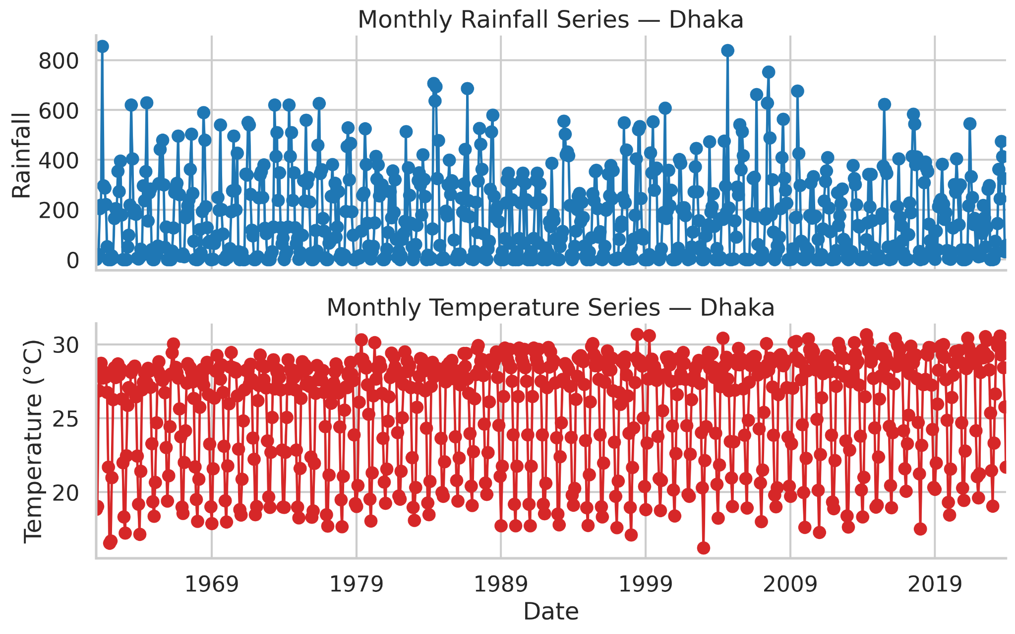
Figure 5.11. Historical monthly rainfall and monthly temperature series for Dhaka.

5.7.2 Comparative monthly forecasting performance
The comparative performance of SARIMA and XGBoost is summarized in Table 5.5 and visually reinforced in Figures 5.12 and 5.15. For monthly rainfall, SARIMA achieved an MAE of 76.023, an RMSE of 107.232, and an R² of 0.482, whereas XGBoost recorded an MAE of 83.116, an RMSE of 114.558, and an R² of 0.409. For monthly temperature, SARIMA again performed better, producing an MAE of 0.669, an RMSE of 0.808, and an R² of 0.952, compared with XGBoost values of 0.819, 0.999, and 0.920, respectively. Within the present monthly Dhaka comparison, SARIMA therefore outperformed XGBoost for both variables across the primary accuracy criteria used in the chapter.
The practical meaning of these differences is straightforward. Lower MAE and RMSE values indicate that SARIMA generated smaller absolute and squared forecast errors, while the higher R² values show that it explained a larger proportion of the observed monthly variability. Figure 5.12 presents the same result visually: SARIMA has the lower bars for both rainfall and temperature under MAE and RMSE, and the higher bars under R². Figure 5.15, which isolates RMSE in heatmap form, further supports the comparison by showing that SARIMA produced the lower error in both targets, with the larger absolute improvement occurring in rainfall.

Table 5.5. Monthly SARIMA and XGBoost forecasting performance for Dhaka.
Model | Target | MAE | RMSE | R² | SMAPE
SARIMA | Monthly Rainfall | 76.023 | 107.232 | 0.482 | 91.687
SARIMA | Monthly Temperature | 0.669 | 0.808 | 0.952 | 2.583
XGBoost | Monthly Rainfall | 83.116 | 114.558 | 0.409 | 76.683
XGBoost | Monthly Temperature | 0.819 | 0.999 | 0.92 | 3.037

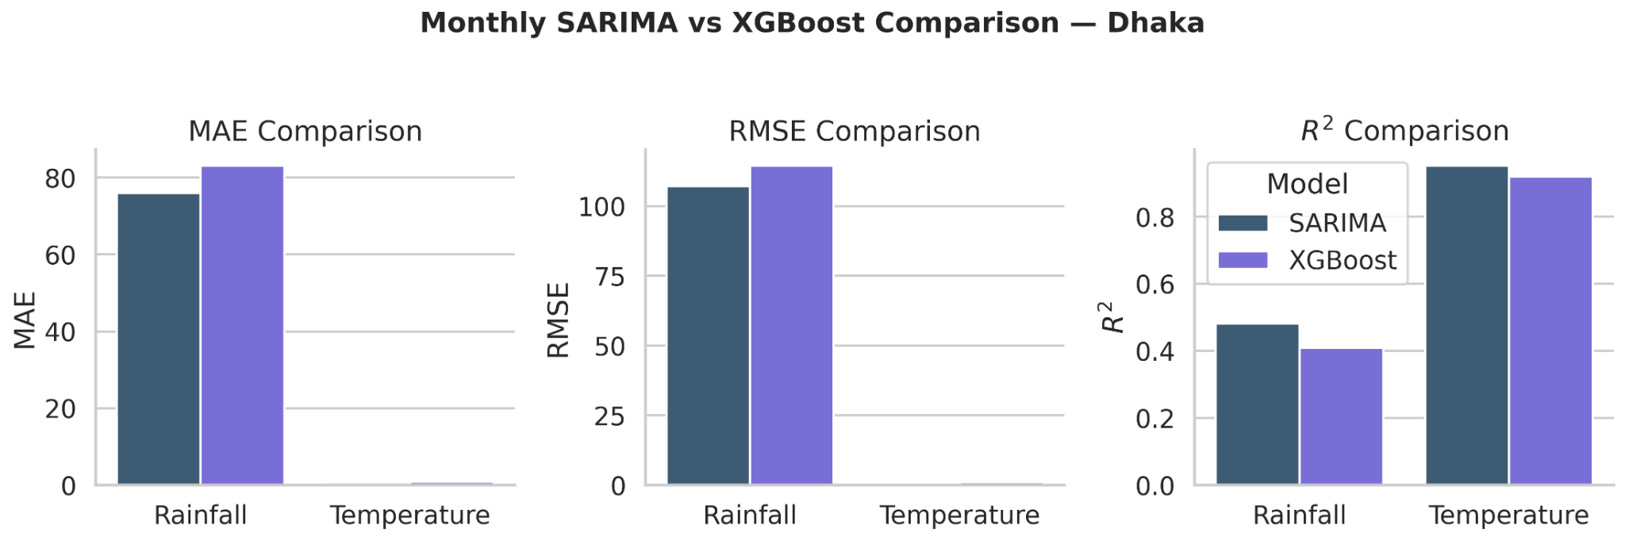
Figure 5.12. MAE, RMSE, and R² comparison between monthly SARIMA and XGBoost forecasts for Dhaka.
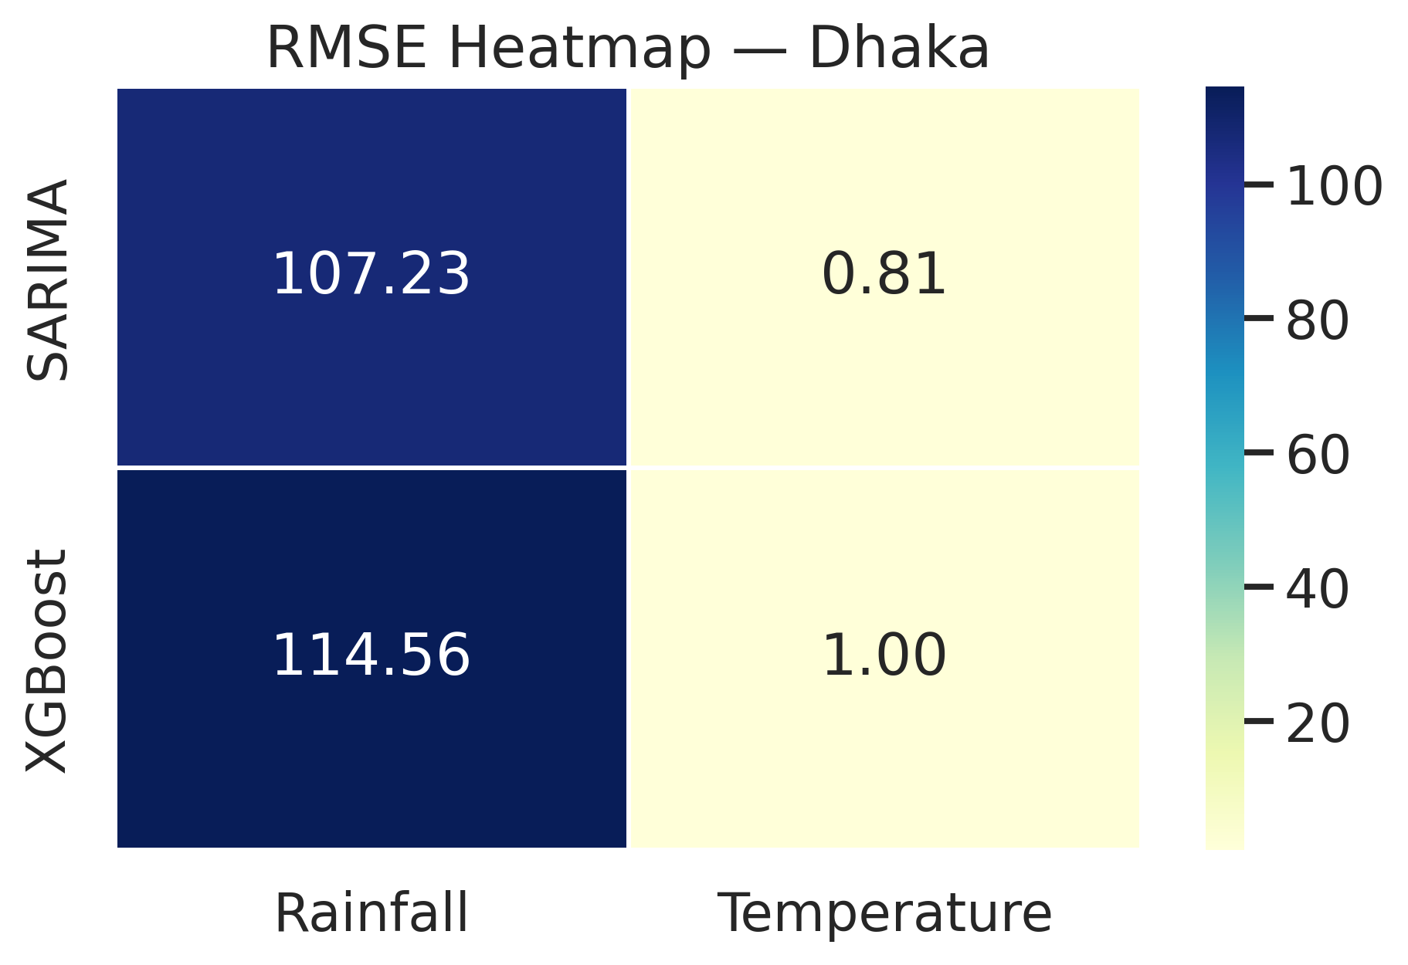
Figure 5.15. RMSE heatmap for monthly SARIMA and XGBoost forecasts in Dhaka.

5.7.3 Interpretation of monthly rainfall forecasts
Figure 5.13 compares the observed monthly rainfall with the corresponding SARIMA and XGBoost forecasts over the test period. Both models captured the broad seasonal rhythm of rainfall: low values in the dry season, rapid accumulation toward the monsoon, and decline after the wet-season peak. However, the visual fit was not equally strong. SARIMA generally tracked the timing of the rise and fall of monsoon rainfall more closely and remained nearer to the observed trajectory across much of the test interval. XGBoost, by contrast, generated a smoother forecast curve and tended either to underestimate some of the higher monthly peaks or to distribute rainfall too evenly across adjacent months.
The rainfall series highlights a key forecasting difficulty. The observed curve contains very sharp monthly spikes that reflect strong monsoon pulses, yet those peaks are not repeated with identical magnitude every year. Neither model fully reproduced the most extreme peaks, but SARIMA was better at preserving the seasonal structure while keeping overall error lower. This explains why SARIMA achieved the lower rainfall RMSE of 107.232 compared with 114.558 for XGBoost. In interpretive terms, the rainfall result suggests that, for monthly Dhaka rainfall, the dominant forecasting signal lies more in stable seasonal dependence than in complex nonlinear feature interactions. In this comparison, a seasonal stochastic model was therefore better matched to the character of the series than the machine-learning alternative applied here.
This finding is notable because it contrasts with the pooled daily results reported earlier in the chapter, where XGBoost was the best-performing model for daily rainfall prediction. The change in model ranking indicates that scale matters. At the daily all-station level, nonlinear machine-learning methods appear to benefit from richer cross-station variation and short-horizon feature interactions. At the monthly single-station level, however, the forecasting problem becomes more strongly governed by recurring seasonal dependence, and that favors SARIMA.
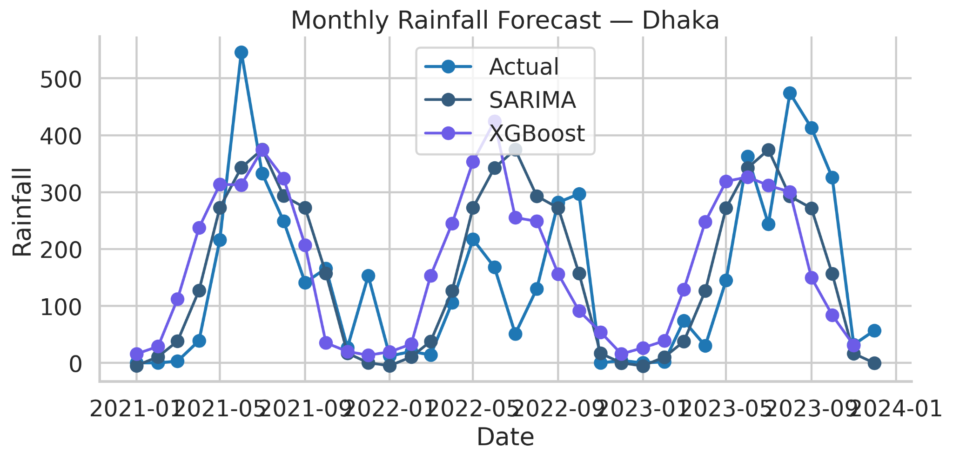
Figure 5.13. Monthly rainfall forecast comparison for Dhaka: actual series versus SARIMA and XGBoost predictions.

5.7.4 Interpretation of monthly temperature forecasts
The temperature comparison in Figure 5.14 shows a clearer separation between the two monthly models. Both models successfully reproduced the broad annual cycle, including the rise toward the warm months and the decline toward winter. However, SARIMA remained consistently closer to the observed curve, especially around the seasonal turning points. The forecast line from SARIMA nearly overlaps the actual series during several transition periods, indicating that it captured not only the overall seasonal level but also the timing of the monthly temperature shifts with high precision. XGBoost also followed the general cycle, but its predictions were more smoothed and showed slightly larger deviations during periods of warming and cooling.
The numerical results support the visual interpretation. SARIMA achieved an RMSE of 0.808 and an R² of 0.952 for monthly temperature, whereas XGBoost recorded an RMSE of 0.999 and an R² of 0.920. These are both strong results, but SARIMA performed better. The difference is practically important because monthly temperature in Dhaka is one of the most seasonally regular targets in the dataset. It therefore aligns naturally with the assumptions of a seasonal autoregressive model, which is designed to exploit persistent periodic structure. The result indicates that machine learning is not automatically the best option for every forecasting task; when the target is smooth, periodic, and station-specific, a properly specified seasonal time-series model may produce more accurate forecasts.
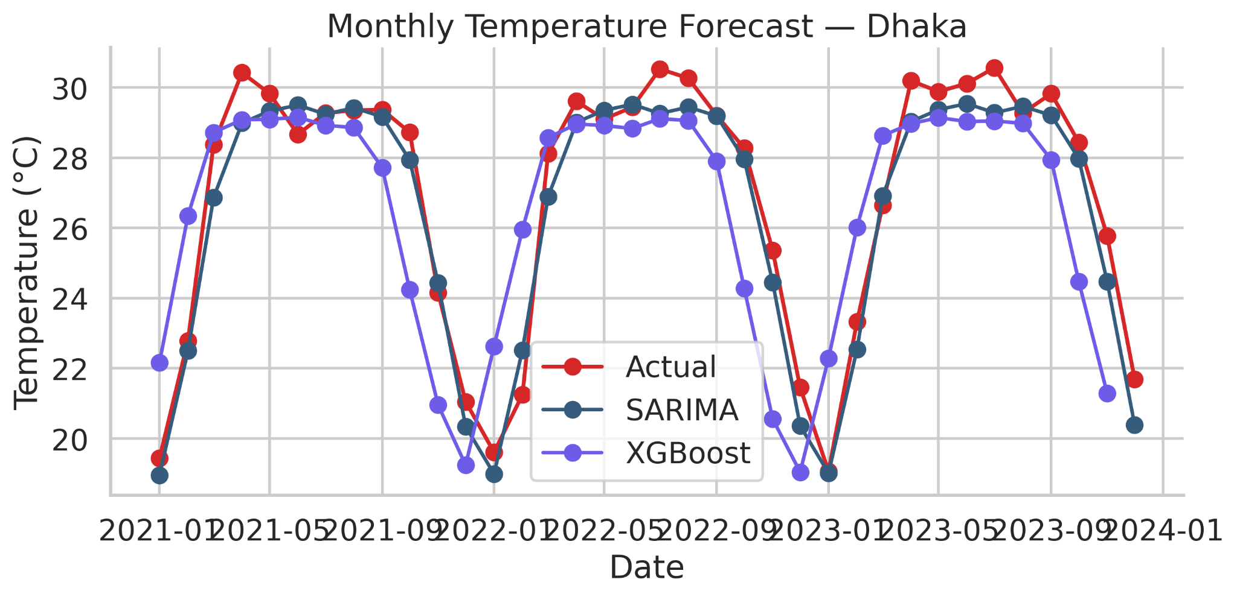
Figure 5.14. Monthly temperature forecast comparison for Dhaka: actual series versus SARIMA and XGBoost predictions.

5.7.5 Best monthly model by target and implications for Chapter 5
Table 5.6 identifies the best monthly model by target on the basis of RMSE. In both cases—monthly rainfall and monthly temperature—the best model was SARIMA. For rainfall, the best-model row records an RMSE of 107.232 and an R² of 0.482. For temperature, the best-model row records an RMSE of 0.808 and an R² of 0.952. Within the monthly Dhaka comparison, SARIMA therefore performed better than XGBoost for both targets.
The implications of this finding are important for the broader logic of Chapter 5. Earlier sections of the chapter showed that XGBoost was the strongest pooled next-day model across rainfall, temperature, humidity, and sunshine. The present monthly station-specific experiment qualifies that conclusion in a useful way. It suggests that model superiority is scale-dependent rather than universal. XGBoost remains the strongest model in the pooled daily feature-rich setting, but when the problem is reformulated as a monthly single-station seasonal forecasting task, SARIMA becomes the better choice. This strengthens the chapter analytically because it shows that model selection should be guided by data structure, temporal aggregation, and target behaviour rather than by model popularity alone.
Table 5.6. Best monthly model by target for Dhaka based on RMSE.
Target | Model | MAE | RMSE | R² | SMAPE
Monthly Rainfall | SARIMA | 76.023 | 107.232 | 0.482 | 91.687
Monthly Temperature | SARIMA | 0.669 | 0.808 | 0.952 | 2.583

5.7.6 Synthesis of the monthly comparison
Taken together, the monthly Dhaka comparison indicates that the forecasting conclusions of this thesis should be interpreted with attention to temporal scale and forecast design. XGBoost was the strongest performer in the pooled daily experiments because that setting rewarded nonlinear modelling of complex short-horizon and cross-station relationships. The monthly Dhaka experiment, however, produced a different hierarchy: SARIMA performed better for both rainfall and temperature, and especially strongly for temperature. A likely reason is that monthly aggregation suppresses much of the day-to-day noise and leaves a series that is more strongly structured by seasonality and temporal dependence.
This result is consistent with the broader forecasting literature. Bangladesh-focused and related studies have shown that machine-learning and deep-learning methods can be effective when the target relationships are nonlinear and data-rich, while classical seasonal time-series models remain relevant for structured climatic series. The present section supports both positions simultaneously: machine learning is powerful, but not universally dominant; classical time-series methods remain competitive and, in this monthly Dhaka case, more suitable.

5.8 Chapter summary
This chapter evaluated forecasting performance under four complementary settings: pooled next-day multi-output regression, rainfall occurrence classification, station-specific Bi-LSTM modelling for Dhaka, and monthly SARIMA versus XGBoost comparison for Dhaka. In the pooled daily regression task, XGBoost was the best-performing model across all four targets, achieving the lowest RMSE for rainfall, temperature, humidity, and sunshine. The results also showed that the weather variables differ markedly in forecasting difficulty: temperature was the most predictable target, humidity showed moderate-to-strong predictability, sunshine was more variable, and rainfall remained the most difficult continuous target because of its intermittency and extreme-value behaviour.
The rainfall occurrence classifier demonstrated that rainy versus non-rainy days can be discriminated with good performance, which reinforces the idea that rainfall forecasting contains two distinct layers: occurrence and amount. Feature-importance analysis further indicated that anomaly terms, seasonal regime, and station-related climatological information were among the most influential predictors in the pooled framework. The Dhaka Bi-LSTM results suggested that station-specific sequence modelling is especially effective for smoother variables such as temperature and humidity, while rainfall and sunshine remain more resistant to precise daily prediction even in a recurrent framework. Finally, the monthly Dhaka comparison showed that model suitability is sensitive to temporal aggregation, with the evidence in this study indicating that SARIMA was more suitable than XGBoost for the monthly station-specific forecasting task considered here. Taken together, the results support the broader thesis argument that forecasting performance in Bangladesh depends not only on the model class used, but also on the statistical properties of the target variable, the spatial structure of the dataset, and the temporal scale of the forecasting problem. The concluding chapter can therefore draw together the statistical and forecasting evidence, discuss the main limitations of the present design, and state the broader implications of the thesis more directly.

CHAPTER SIX

CONCLUSION, IMPLICATIONS, LIMITATIONS, AND RECOMMENDATIONS

6.1 Introduction
This chapter brings together the main results of the thesis and places them in relation to the original problem statement, objectives, and research questions. The study was designed to examine Bangladesh weather through two connected analytical lenses: long-term statistical analysis of rainfall, temperature, humidity, and sunshine, and comparative evaluation of forecasting models under different temporal and spatial settings. The purpose of this chapter is therefore not only to summarize the results, but also to clarify what those results mean for climate interpretation, forecasting design, and future weather research in Bangladesh.
To achieve that purpose, the chapter proceeds through a synthesis of the study, the major findings, direct answers to the research questions, the main contributions of the work, its practical implications, its limitations, and recommendations for future research and application. In this way, the concluding chapter links the empirical results back to the broader significance of the thesis.

6.2 Summary of the Study
The thesis was motivated by a central gap in Bangladesh-focused weather research. Although the literature has grown in recent years, much of it has remained analytically divided: some studies emphasize long-term climatic trends, while others focus primarily on forecasting performance. Comparatively fewer studies place the statistical structure of Bangladesh weather and the comparative behaviour of forecasting models within one integrated framework.
To address this issue, the study used station-wise daily meteorological data from 35 Bangladesh Meteorological Department stations, covering rainfall, temperature, humidity, and sunshine from the establishment of each station up to 2023. The methodology was organized around two major components. The first component was long-term statistical analysis, including descriptive statistics, monthly and seasonal climatology, station-wise heterogeneity, correlation analysis, stationarity checking for selected monthly series, national and station-wise trend analysis, and threshold-based extreme-event assessment. The second component was comparative forecasting, including pooled next-day multi-output regression, rainfall-occurrence classification, a Dhaka-specific Bi-LSTM experiment, and a monthly SARIMA versus XGBoost comparison for Dhaka.
The underlying logic of the thesis was that forecasting performance should be interpreted in light of the statistical character of the variables being predicted. Variables such as rainfall, temperature, humidity, and sunshine do not pose identical modelling problems. Some are smoother and more persistent, while others are intermittent, skewed, or highly seasonal. The thesis therefore treated weather forecasting as a variable-sensitive and scale-sensitive comparative problem rather than as a single-model contest.

6.3 Major Findings of the Thesis

6.3.1 Findings from the statistical analysis
The statistical analysis showed that Bangladesh weather is shaped by a strong annual cycle and by substantial station-level heterogeneity. Rainfall emerged as the most irregular variable, with a highly skewed and zero-dominated daily distribution, strong monsoon concentration, and considerable year-to-year volatility. Temperature was the smoothest variable in descriptive terms, while humidity remained persistently high across much of the year and sunshine showed clearer long-term decline than the other variables.
Monthly and seasonal climatology confirmed that the monsoon system organizes the joint behaviour of all four variables. Rainfall and humidity increased sharply during the wet season, sunshine declined, and temperature remained elevated over a broader warm-season interval. The spatial results further showed that Bangladesh cannot be treated as meteorologically homogeneous. Eastern and southeastern stations were wetter, western inland stations were drier, and long-term station means differed meaningfully across all four variables.
Trend analysis indicated declining annual rainfall, increasing temperature, increasing humidity, and declining sunshine within the available-stations aggregation used in the study. At the same time, station-wise trend summaries showed that these changes were not spatially uniform. Extreme-event analysis added an important qualification by showing that the climate signal is reflected not only in means, but also in changing counts of stressful atmospheric states such as heavy-rain and low-sunshine conditions.

6.3.2 Findings from the forecasting analysis
The forecasting analysis showed that the weather variables of Bangladesh differ substantially in forecasting difficulty, especially at daily scale. Within the pooled next-day multi-output setting, XGBoost produced the lowest RMSE for rainfall, temperature, humidity, and sunshine, making it the best-performing pooled model under the design used in this thesis. Temperature was the most predictable target, humidity showed moderate-to-strong short-horizon predictability, sunshine showed more modest forecastability, and rainfall remained the most difficult continuous target because of its intermittency and extreme-value behaviour.
The rainfall-occurrence classifier showed that rainy and non-rainy days can be identified with good discrimination performance, which supports the interpretation that rainfall forecasting contains two related but distinct components: occurrence and amount. Feature-importance analysis suggested that anomaly variables, monsoon regime, lagged humidity, and station-related climatological information were among the most influential predictors in the pooled framework, highlighting the importance of combining short-run temporal memory with local climatic context.
The Dhaka Bi-LSTM experiment suggested that station-specific sequence modelling is especially useful for smoother variables such as temperature and humidity, while rainfall and sunshine remain more resistant to precise daily prediction even within a recurrent framework. The monthly Dhaka comparison added a critical scale-sensitive result: although XGBoost performed best in the pooled daily setting, SARIMA performed better than XGBoost for both monthly rainfall and monthly temperature in Dhaka. This indicates that model superiority is not universal; it changes with temporal aggregation, target behaviour, and modelling context.

6.4 Answers to the Research Questions
The research questions posed in Chapter One can now be answered directly in light of the evidence generated in Chapters Four and Five.
Research question | Answer based on the thesis findings
1. What are the major long-term statistical characteristics of rainfall, temperature, humidity, and sunshine in Bangladesh? | Bangladesh weather exhibits strong seasonality, substantial station-level heterogeneity, and variable-specific statistical structure. Rainfall is the most skewed and intermittent variable; temperature is smoother and more persistent; humidity remains high across much of the year; sunshine shows clearer long-run decline.
2. How do the variables differ in seasonality, spatial heterogeneity, trend behaviour, and extreme-event structure? | Rainfall and humidity increase strongly during monsoon, sunshine decreases, and temperature remains elevated over a broader warm-season window. Spatially, wetter eastern and southeastern stations contrast with drier western inland stations. Trend and extreme-event patterns are not spatially uniform.
3. Which forecasting models perform best for pooled next-day multi-output prediction? | Within the pooled daily design used in this thesis, XGBoost produced the best overall performance across rainfall, temperature, humidity, and sunshine.
4. Can rainfall occurrence be predicted effectively as a binary classification problem? | Yes. Rainfall occurrence can be predicted with good discrimination performance, and the classification results support treating rain/no-rain detection as distinct from rainfall-amount prediction.

Table 6.1 (continued)
Research question | Answer based on the thesis findings
5. How does a station-specific Bi-LSTM behave for a representative station such as Dhaka? | The Dhaka Bi-LSTM performs comparatively well for smoother variables such as temperature and humidity, but rainfall and sunshine remain harder to predict precisely at daily scale.
6. Does SARIMA remain competitive, or even superior, in monthly station-specific forecasting? | Yes. In the Dhaka monthly comparison of this thesis, SARIMA performed better than XGBoost for both monthly rainfall and monthly temperature, indicating that classical seasonal models remain important when the target is smooth and strongly periodic.
7. How should the forecasting results be interpreted in light of the statistical behaviour of the variables? | Forecasting performance should be interpreted as scale-sensitive and variable-sensitive. Smoother and more persistent variables are easier to forecast; zero-dominated and intermittent variables remain more difficult; and model suitability changes with temporal scale, spatial context, and target structure.
Table 6.1. Summary answers to the research questions.

6.5 Contributions of the Study

6.5.1 Empirical contribution
Empirically, the thesis provides a broad station-wise account of Bangladesh weather across four major variables rather than restricting the analysis to rainfall and temperature alone. By examining rainfall, temperature, humidity, and sunshine together, the study offers a fuller descriptive picture of Bangladesh weather than many earlier Bangladesh-focused works.

6.5.2 Methodological contribution
Methodologically, the thesis contributes an integrated framework that links descriptive climate analysis with comparative forecasting. Instead of treating data description as merely preliminary and forecasting as the only substantive task, the study shows that the statistical character of the variables helps explain why some models perform better than others. The combined use of pooled daily regression, rainfall-occurrence classification, station-specific deep learning, and monthly classical-versus-machine-learning comparison provides a more nuanced view of model suitability than would be possible from a single-model or single-scale design.

6.5.3 Contextual contribution to Bangladesh weather research
In the specific context of Bangladesh weather research, the thesis highlights two issues that deserve greater attention: station heterogeneity and temporal-scale sensitivity. The results suggest that national pooled modelling is useful, but that local station-specific behaviour and lower-frequency seasonal dependence can alter forecasting conclusions in important ways. This helps clarify why a model that performs best in one setting may not remain best in another.

6.6 Practical Implications
The findings of the thesis have several practical implications for climate-sensitive planning and weather-related decision support in Bangladesh. First, the long-term statistical results are relevant to agriculture, water-resource planning, flood awareness, and weather-dependent transport operations. The evidence of strong seasonality, persistently high humidity, declining sunshine, and spatially uneven climatic behaviour suggests that weather information should be interpreted locally rather than only through national averages.
Second, the forecasting results suggest that decision-support tools in Bangladesh should not rely on a single modelling philosophy. For pooled daily prediction in a structured, feature-rich dataset, boosted-tree machine learning appears highly effective. For rainfall, occurrence and amount should be treated as related but distinct forecasting tasks. For lower-frequency station-specific forecasting, classical seasonal models remain relevant and may even be preferable when the target series is smooth and strongly periodic.
Third, the study supports the use of station identity and local climatic context in weather modelling. Bangladesh is sufficiently heterogeneous that location-specific information carries predictive value beyond short-run weather memory alone. In practical terms, this suggests that weather-support systems should be designed with sensitivity to local station behaviour rather than assuming complete national uniformity.

6.7 Limitations of the Study
Several limitations should be acknowledged. First, the station records are unequal in length, which means that long-term national summaries are influenced more strongly by older stations than by later stations. Although the thesis explicitly recognized this issue and interpreted annual aggregates with caution, the resulting national trend estimates should still be understood as coverage-aware summaries rather than perfectly invariant national measures.
Second, the forecasting component was limited to the information available in the station-wise meteorological dataset. No atmospheric pressure fields, external reanalysis data, satellite features, or numerical weather prediction outputs were incorporated. The models were therefore evaluated as data-driven forecasting systems built from the observed station variables themselves rather than as hybrid systems combining local observations with broader meteorological predictors.
Third, the different forecasting components were not intended to answer the same question under identical design conditions. The pooled daily models, rainfall-occurrence classifier, Dhaka Bi-LSTM, and monthly Dhaka comparison each address a different formulation of the forecasting problem. Their results should therefore be read as complementary rather than perfectly interchangeable.
Fourth, the deep-learning and monthly forecasting components were restricted to Dhaka as a representative and data-rich station. This choice was methodologically justified, but it also means that those findings should not be generalized automatically to all stations in Bangladesh without broader station-wise validation.

6.8 Recommendations for Future Research and Application
Several directions for future work follow naturally from the present thesis. The first is to extend the station-specific forecasting analysis beyond Dhaka. A larger station-wise comparison would clarify whether the performance patterns observed in Dhaka hold more broadly across coastal, inland, and high-rainfall zones.
The second is to strengthen the trend-analysis component through additional robustness checks such as common-period aggregation, anomaly-based national summaries, or nonparametric trend procedures. Such extensions would help refine the interpretation of long-term climate change in the presence of unequal station histories.
The third is to incorporate richer predictor information into the forecasting framework. Future studies could combine station observations with pressure fields, wind variables, satellite-derived products, reanalysis features, or numerical weather prediction outputs in order to examine whether rainfall and sunshine forecasting can be improved beyond the levels observed here.
The fourth is to develop uncertainty-aware forecasting rather than relying only on point prediction. Prediction intervals, quantile forecasts, or probabilistic rainfall forecasts would make the modelling framework more useful for real-world decision support, especially in agriculture and disaster preparedness.
Finally, future research could build an applied advisory layer on top of the statistical and forecasting framework developed in this thesis. Such an extension might include crop-sensitive decision support, local early-warning tools, or station-level climate summaries designed for non-specialist users. The present thesis does not itself implement such a system, but it provides an empirical basis on which those downstream applications could be built.

6.9 Concluding Remarks
This thesis set out to examine Bangladesh weather through a framework that joins long-term climate statistics with comparative forecasting. The results showed that the main weather variables of Bangladesh differ substantially in statistical behaviour, that those differences matter for model performance, and that forecasting conclusions depend strongly on temporal scale and modelling context. Rainfall remained the most difficult variable statistically and predictively, temperature was the smoothest and most predictable, humidity showed meaningful short-horizon structure, and sunshine reflected both seasonal organization and long-term decline. In the forecasting component, XGBoost performed best in the pooled daily setting, while SARIMA proved more suitable in the monthly Dhaka comparison.
Taken together, these findings support the central conclusion of the thesis: there is no universally best model for Bangladesh weather. Appropriate model choice depends on the statistical nature of the target variable, the temporal scale of the analysis, and the spatial structure of the dataset. For that reason, descriptive climate interpretation and predictive modelling should not be treated as separate tasks. When they are read together, forecasting becomes more interpretable, climate analysis becomes more methodologically useful, and the resulting evidence becomes more valuable for both future research and climate-sensitive application.

REFERENCES
Bosu, H., Rashid, T., Mannan, A., & Meandad, J. (2020). Trends of rainfall and temperature in Bangladesh: A comparative analysis of CMIP5 results and meteorological station data. Dhaka University Journal of Earth and Environmental Sciences, 9(2), 9–18. https://doi.org/10.3329/dujees.v9i2.55085
Chowdhury, A. R., Samad, M. A., Hassan, S. M. Q., & Mallik, M. A. K. (2024). Seasonal forecast of monsoon rainfall over Bangladesh using machine learning. The Atmosphere, 10. https://live8.bmd.gov.bd/file/2024/08/14/pdf/171452.pdf
FAO. (n.d.). Planning an extended climate and weather forecasting system for hazard preparedness in agriculture. Food and Agriculture Organization of the United Nations. https://www.fao.org/family-farming/detail/en/c/1619898/
Hasan, M. M., Hasan, M. J., & Rahman, P. B. (2024). Comparison of RNN-LSTM, TFDF and stacking model approach for weather forecasting in Bangladesh using historical data from 1963 to 2022. PLOS ONE, 19(9), e0310446. https://doi.org/10.1371/journal.pone.0310446
Hussain, A., Aslam, A., Tripura, S., Dhanawat, V., & Shinde, V. (2024). Weather forecasting using machine learning techniques: Rainfall and temperature analysis. Journal of Advances in Information Technology, 15(12), 1329–1338. https://doi.org/10.12720/jait.15.12.1329-1338
Hyndman, R. J., & Athanasopoulos, G. (2021). Forecasting: Principles and practice (3rd ed.). OTexts. https://otexts.com/fpp3/
IPCC. (2022). Climate Change 2022: Impacts, adaptation and vulnerability. Contribution of Working Group II to the Sixth Assessment Report of the Intergovernmental Panel on Climate Change (Chapter 10: Asia). Cambridge University Press. https://www.ipcc.ch/report/ar6/wg2/chapter/chapter-10/
Roy, S. K., Morshed, A., Mojumder, P., Hasan, M. M., & Islam, A. K. M. S. (2024). Innovative trend analysis technique with fuzzy logic and K-means clustering approach for identification of homogenous rainfall region: A long-term rainfall data analysis over Bangladesh. Quaternary Science Advances, 15, 100227. https://doi.org/10.1016/j.qsa.2024.100227
Siddique, M. A. B., Mahalder, B., Haque, M. M., & Ahammad, A. K. S. (2025). Forecasting air temperature and rainfall in Mymensingh, Bangladesh with ARIMA: Implications for aquaculture management. Egyptian Journal of Aquatic Research, 51(3), 294–303. https://doi.org/10.1016/j.ejar.2025.02.009
Suhan, M. S. I., & Adhikary, S. K. (2025). Exploring climate change trends in temperature and rainfall across the southeastern coastal area of Bangladesh. Journal of Engineering Science, 15(2), 51–67. https://doi.org/10.3329/jes.v15i2.82162
World Bank Group. (2021). Bangladesh—Climate Risk Country Profile. Climate Change Knowledge Portal. https://climateknowledgeportal.worldbank.org/country/bangladesh
World Meteorological Organization. (2025). Forecasting the future: The role of artificial intelligence in transforming weather prediction and policy. https://wmo.int/media/magazine-article/forecasting-future-role-of-artificial-intelligence-transforming-weather-prediction-and-policy
Zubair, M., Salim, M. S., Rahman, M. M., Basher, M. J. I., Imran, S., & Sarker, I. H. (2024a). Agricultural recommendation system based on deep learning: A multivariate weather forecasting approach. arXiv. https://arxiv.org/abs/2401.11410
Zubair, M., Mahee, M. N. I., Reza, K. M., Salim, M. S., & Ahmed, N. (2024b). Climate data dynamics: A high-volume real world structured weather dataset. Data in Brief, 57, 111156. https://doi.org/10.1016/j.dib.2024.111156

